**Certified Kubernetes Administrator – CKA**

11.08.2025 Day – 1

Version: 1.31 – 1.32

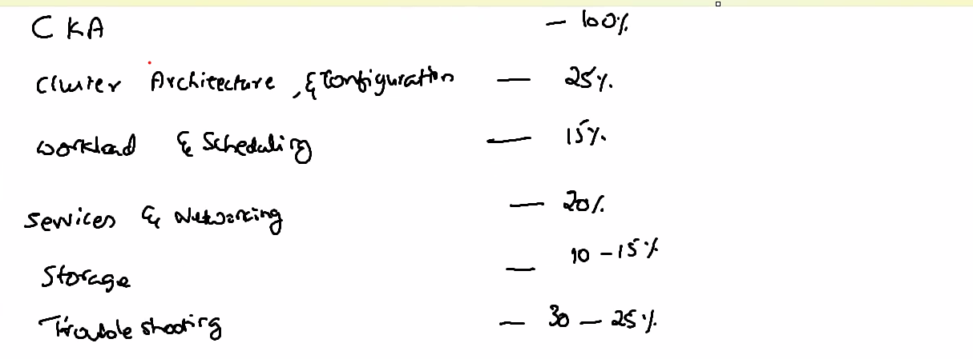

CKA is under Linux Foundation - CNCF

Killer.sh - Lab

Killer Koda – Lab Environment For class

Coupon will be delivered within 5 days

Valid for 365 Days

2 Attempts

Range from 12 Qns to 19 Qns – Practical Oriented Questions

Access for VS Code, Terminal, Kubernetes Documentation for Certification – 2.5 hours’ Time to clear the Exam

Activity will be Recorded – Given to 5 Invigilator across Countries –

3 days’ time to get result

2 Mock Test

Once you activate the certification coupon you will get 2 mock test for practice

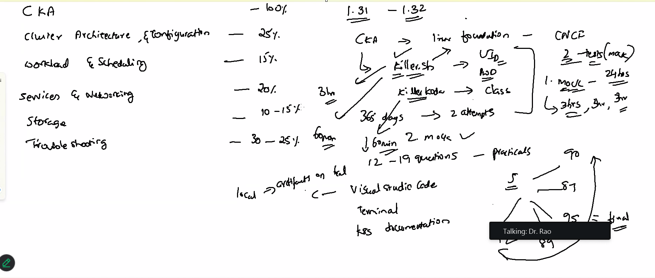

Kubernetes is a Greek Word = Also Called as Captain of Ship – K8’s

Developer create application with Dependencies and package them as Containers

Containers will be given for deployment

Containers require some features for high availability

Container management Tools – Some call it as Orchestor Tools are the one who maintains and manage all the containers which has been created – on a huge cluster

Kubernetes is developed by GoLang from Google’s language – Even Docker is also done by GoLang

Kubernetes CNCF license

Automates the deployment, Scaling , Managing the Containerized applications on a group of servers

So many Tools available in the market such as :

Kubernetes

Docker Swarm

Apache Mesos Marathon

Dockers create Containers but who bothers about Deployment, Scheduling, Scaling -Load balancing, Batch Executions, Roll Backs, Monitoring – which cannot be done using a normal dockers that’s the reason we came out with Orchestration Tools – Docker can do all these with the help of Orchestration Tools.

Kubernetes is comparatively faster than Swarm, Apache Mesos

K8 is accepted as Default Orchestration Tools in Cloud – OCI, AWS, Google Cloud

**K8 Comes with Good amount of features**

* Automatic Bin Packing
* Service Discovery & Load Balancing
* Storage Orchestration
* Self-Healing
* Automated Rollouts and Rollbacks
* Secrets & Config Management
* Batch Execution
* Horizontal Scaling

**Automatic Bin Packing**

Automatically place the containers based on Resource CPU, Memory without sacrificing availability of the services is called Automatic Bin Packing

**3 Features of Pod:**

Logical Kubernetes Object

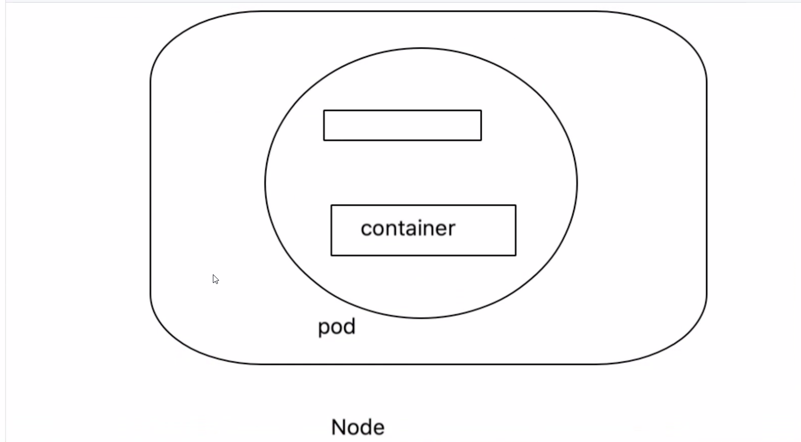

Pod will have Container or Containers and they also have storage object

Data will be stored outside the pod

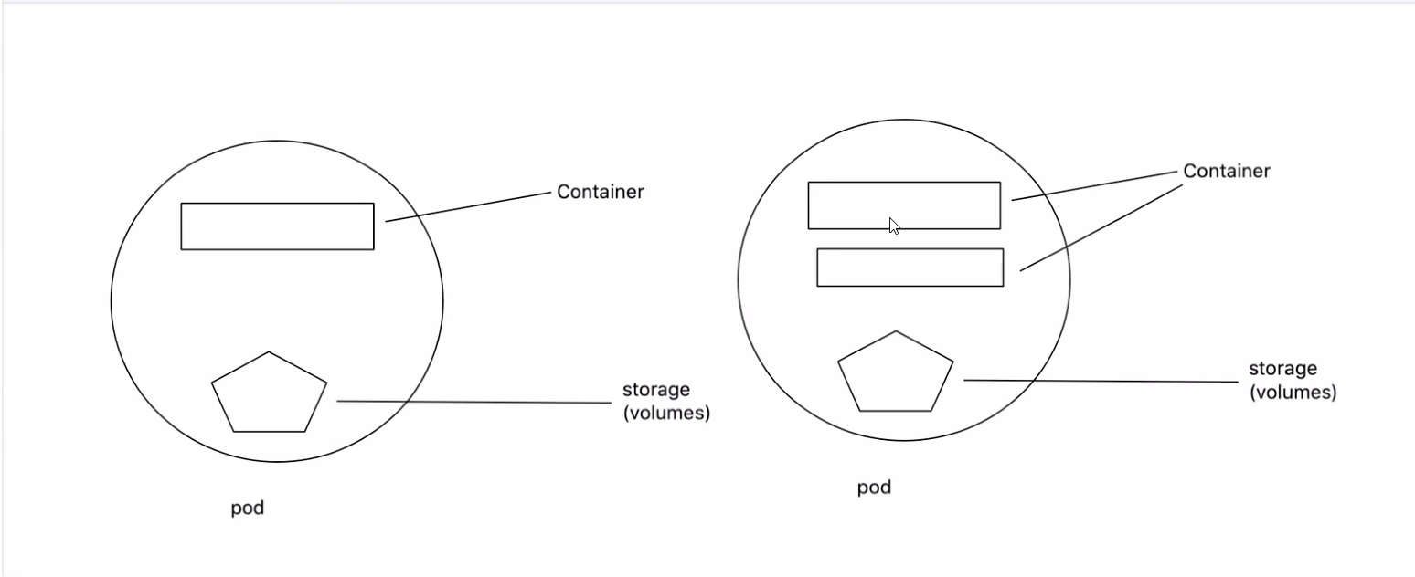

By default, every Pod will have separate IP address

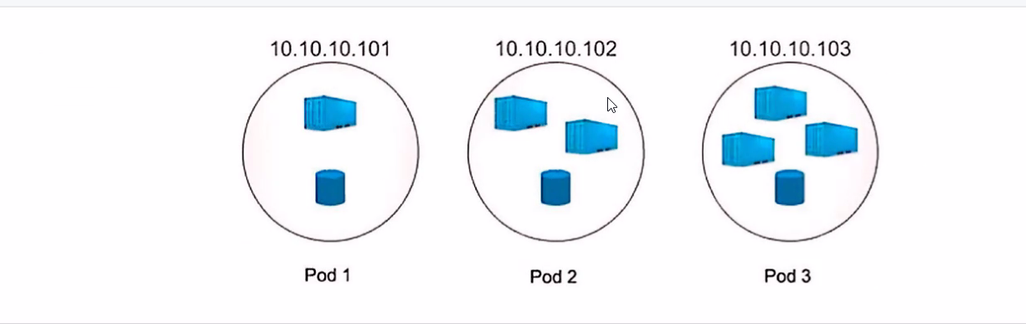

**Service Discovery & Load Balancing**

K8 will organize all the containers

K8 has control over the network

Application will be inside the container and container will be placed inside the pods

Pod to pod communication will be known to K8

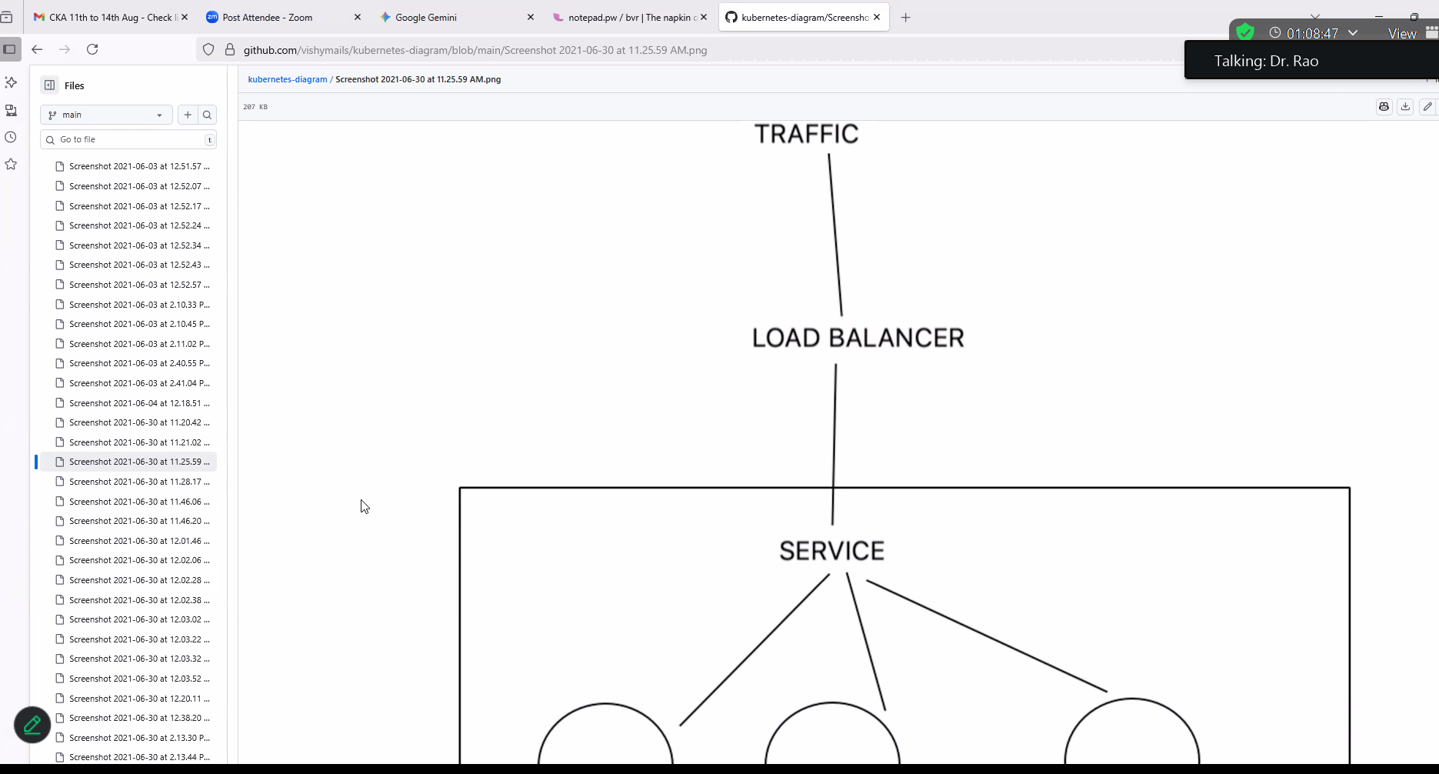

One storage volume can be enough for a Pod

**Default Behavior of Kubernetes: - Self Healing:**

Container Fails = it Restart the Containers

Node Dies = It replaces and Reschedules containers on other nodes

Container does not respond to Health Checks = It kills the containers, and it spins up another container

Rollouts – Without any Downtime – Deploy the change of the application

Rollback – Reverts the changes to its Previous

While ensuring it does not kills all the containers while rolling out or roll back and it ensures there is no downtime during this process is called **Automated Rollback / Rollouts**

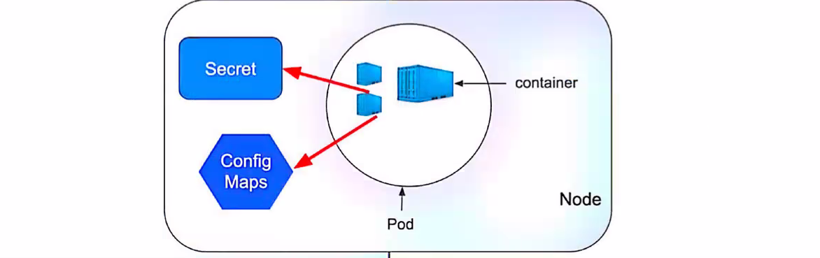

Secret = Sensitive Data – Username / Password. Private Key, Certificate –

Instead of storing inside the application – stores it in etcd database – sits inside etcd database – that becomes the core information for your whole cluster

Secret objects can be accessed inside the other pods and are reusable

Most sensitive Data stores under Secrets

Config Maps = K8 objects creates a key value pair – Separate config information from Pods and Containers

**Secrets and Config Maps – Cannot be more than 1 MB Size**

**Batch Execution** – Run to Completion jobs is used for Batch Processing

Each Job can create 1 or More Pods

Job Controller will Reschedule pods on another nods if Pods fails

Once job is completed pod will be moved to Completed State instead of Running

**Horizontal Scaling:**

Scale Up and Scale Down

Replication Controller get the No of Pods to Run, and it ensures to Make them available.

Kubernetes works on Master and Slave Architecture

Kubernetes is Agent Based

Agent Based service :

Control Plane - - - - - - - > Worker Node

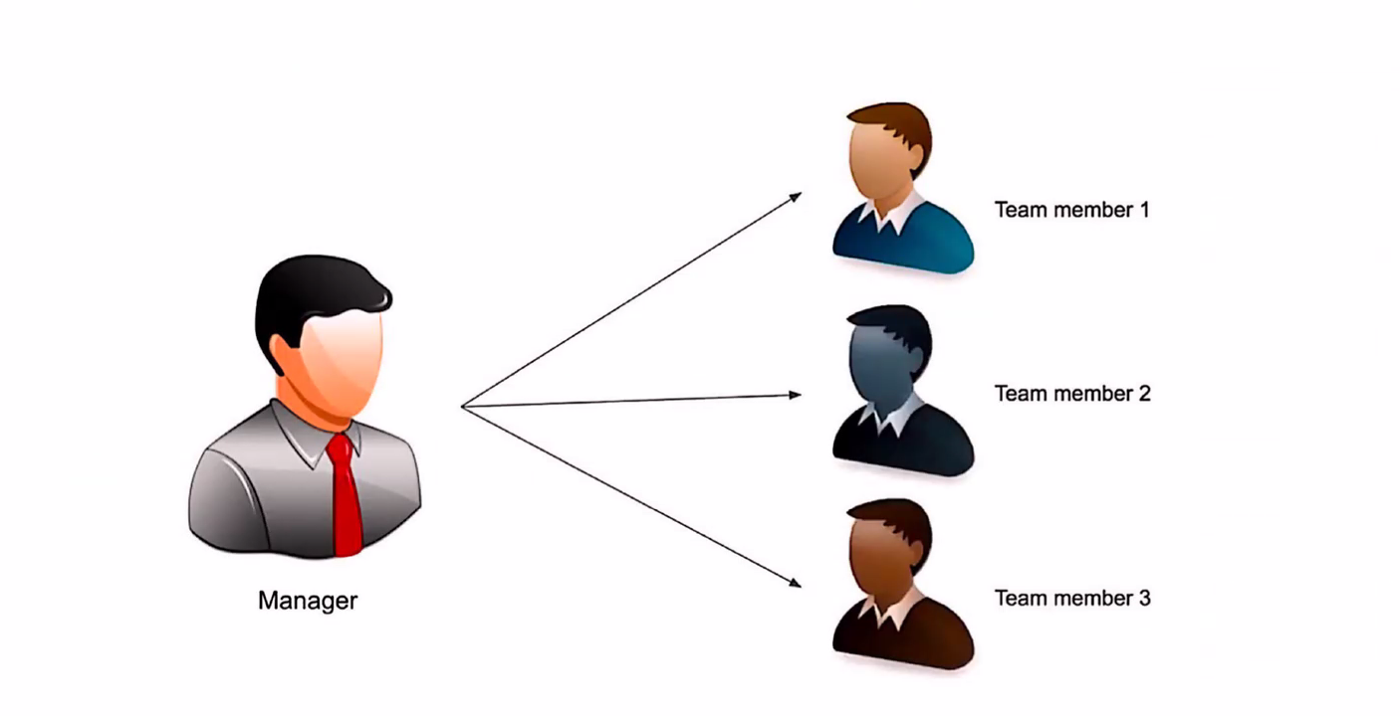

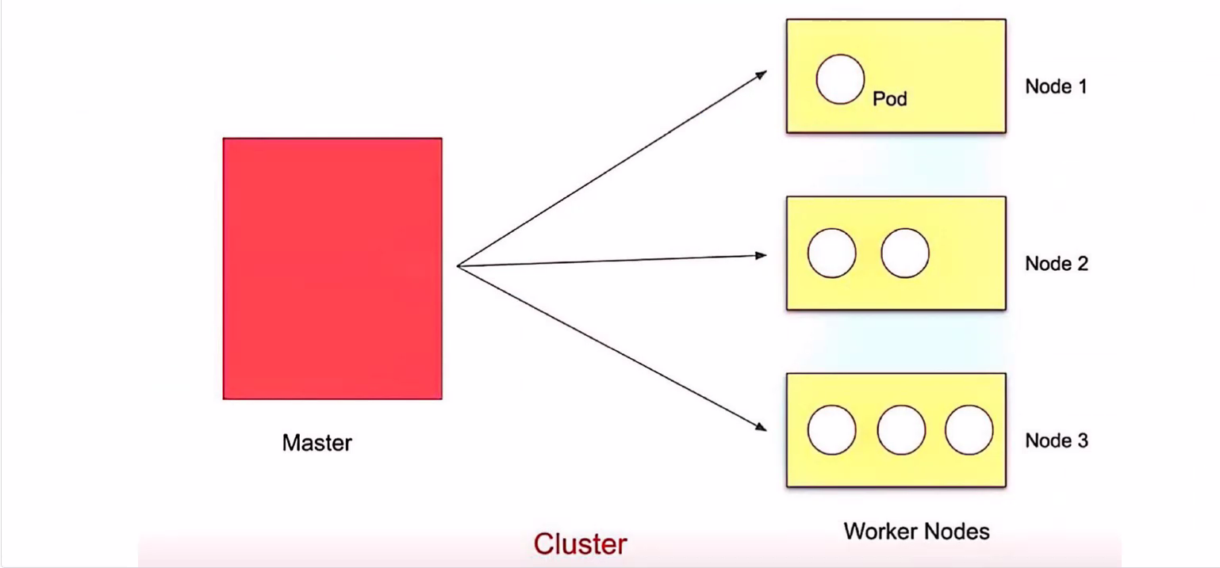

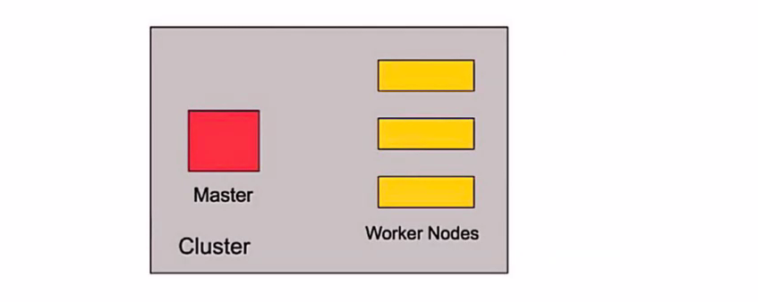

By default, we get a cluster when we install Kubernetes

We get a Master and worker Node – A cluster will have a minimum One Master and One Worker Nodes

In Earlier days worker nodes also called Minions

We cannot have Multiple master nodes in active state but remaining will be in passive state will be come active when active master node dies

We can create a pod in worker nodes

We can have 5000 Nodes In a single cluster

**Single Cluster limitation:**

Nodes = 5000

Pods = 150000

Containers = 300000

Pods per node: 125 – 100 depends on the version

K8 comes with

* **Master Node** also called as **Control Plane**
* **Worker Node**

**4 Components in Master Node:**

1. API Server
2. Controller Manager
3. Scheduler
4. ETCD Database

**3 Components in Worker Node:**

1. Kubelet
2. KubeProxy
3. Container Runtime
4. Addons

Master Node: -

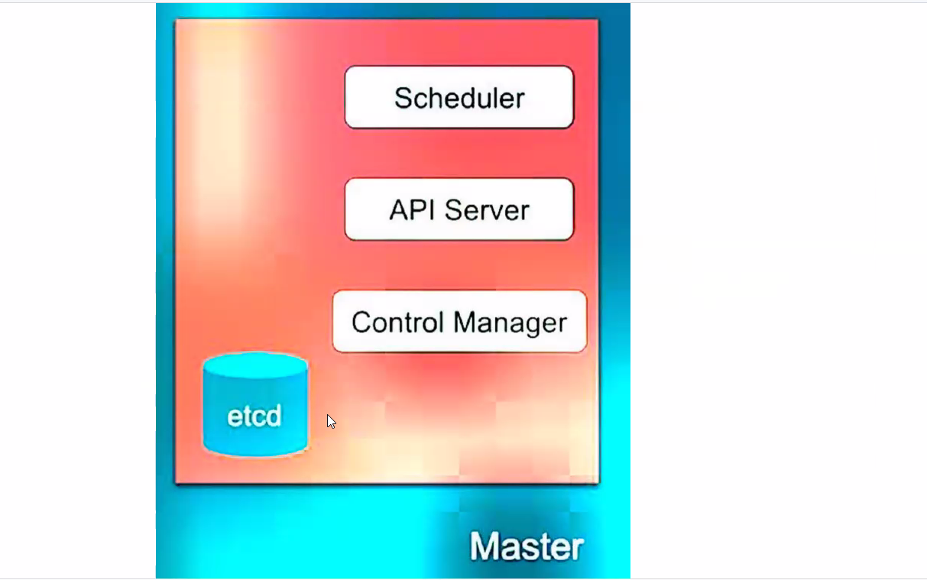

Mainly Responsible for Managing whole Cluster

Monitors Pods inside Cluster

If Node fails moves the workload of Failed node to another worker node

**API Server** = Managing all communications – happens over jSON over HTTP API’s = allows applications to communicate with one another – It’s a front end of k8 control Plane – Take help of Kubectl command and the UI available to communicate with API servers = Exposes API for every operation = kubectl is a tool to interact with API service creted with GoLang Technology = Only Responsible person to communication with ETCD database

**Controller Manager** = Mainly Runs Controllers = Responsible to act when a node becomes unavailable

Scheduler = Schedule Pods on across Multiple Nods – watches newly created pod that has no node assigned = allocation done by Scheduler

**ETCD** = Open Source Distributed Key Value Pair DB from Core OS = It’s a single instance application – takes only one application connection at a time = taking a backup of etcd database is equal to taking a backup of whole Custer itself

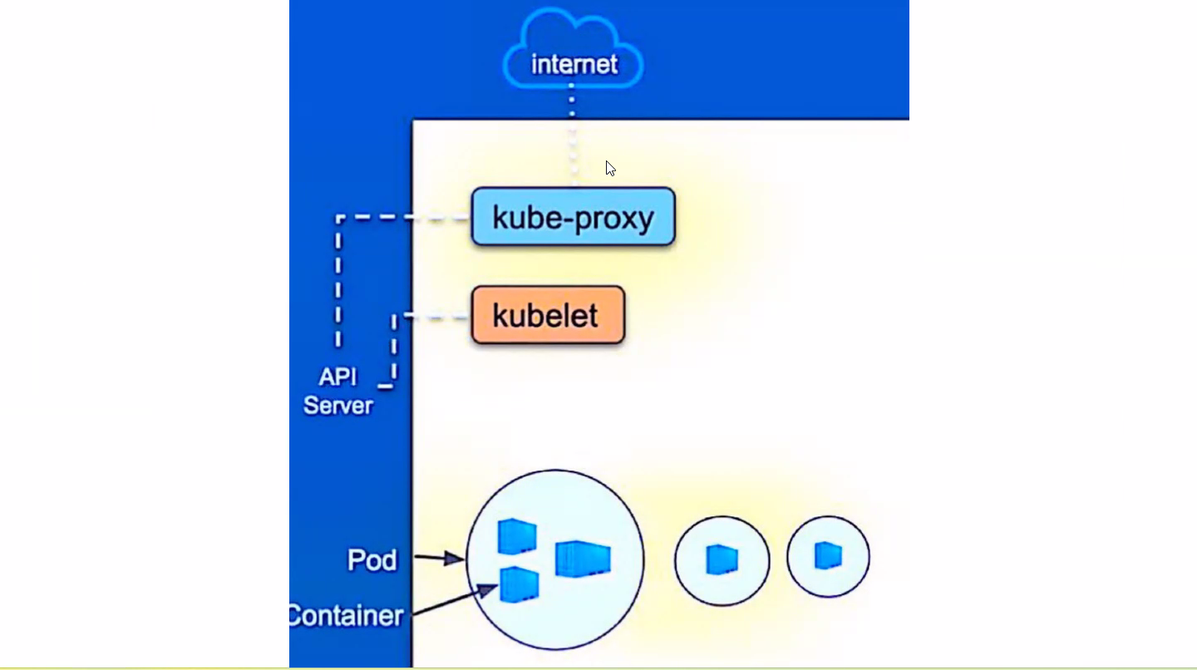

Kubelet = It’s a agent running on each node – communicates with the components with master node = does not manage the containers which has not been created using Kubernetes - worker agent

Kubeproxy – network agent – exposes services outside world – present inside k8 cluster

**Few Container Runtimes are :**

Docker

Dockerd = Rancher

Containerd

Podman

Crio

**Addons for Worker Node:**

Metrics

Ingress

Egress

Storage Plugins

Lab: <https://killercoda.com/>

<https://notepad.pw/bvr>

Playgrounds – CKA 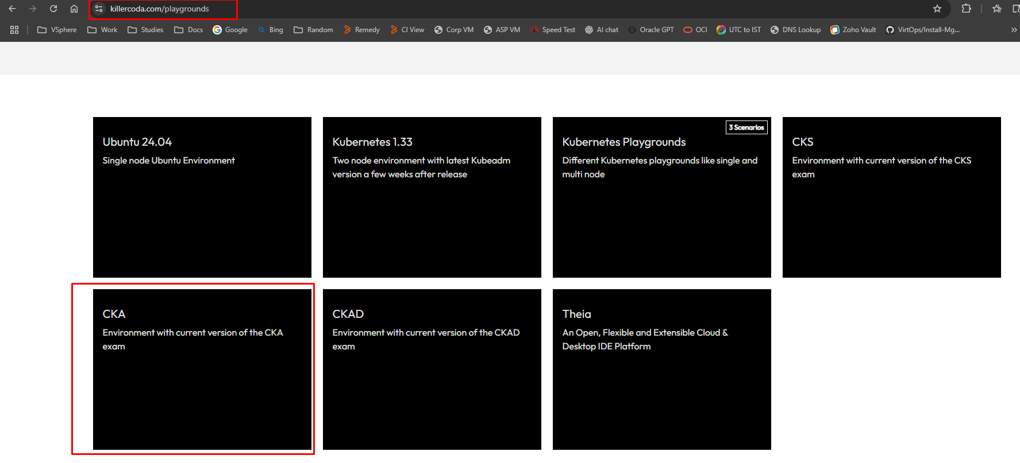

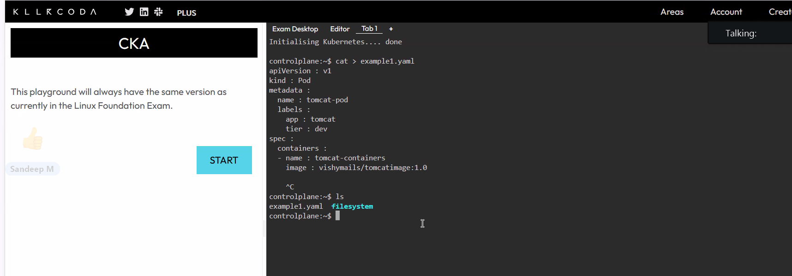

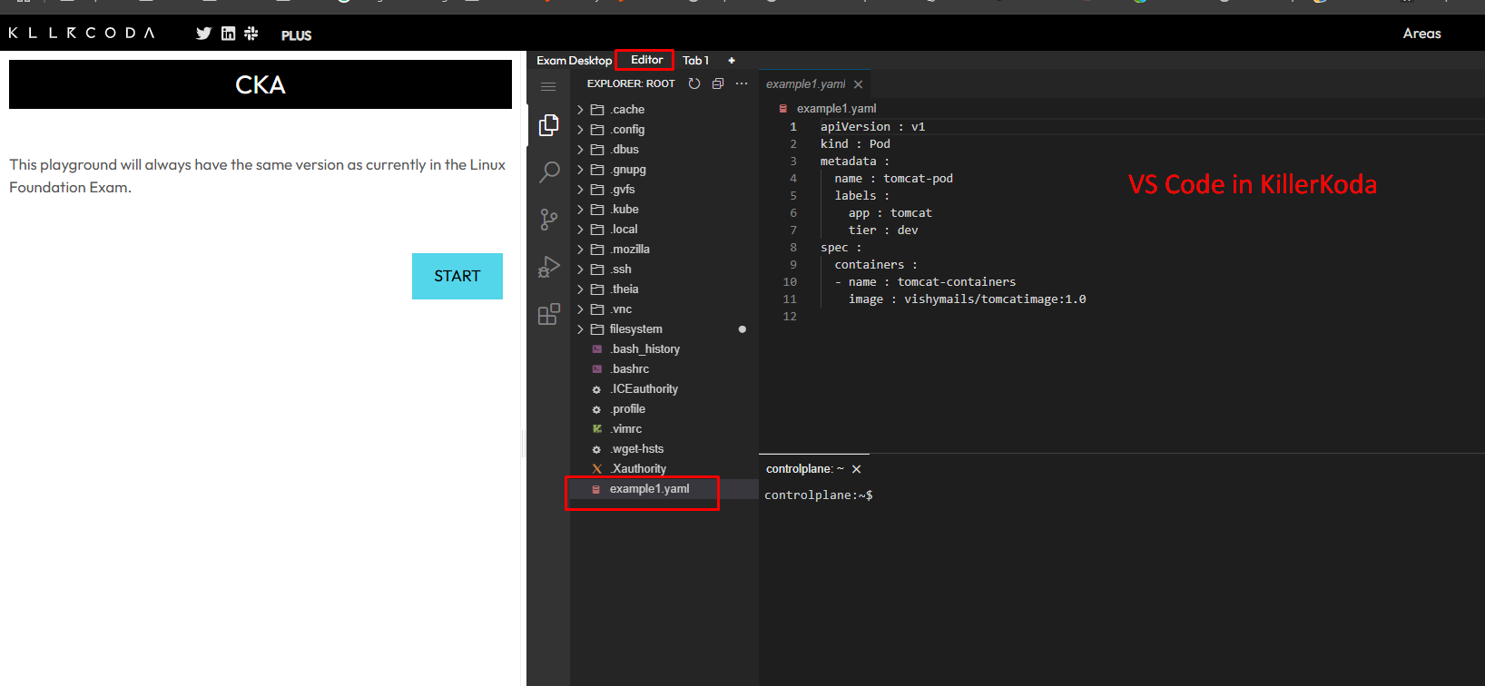

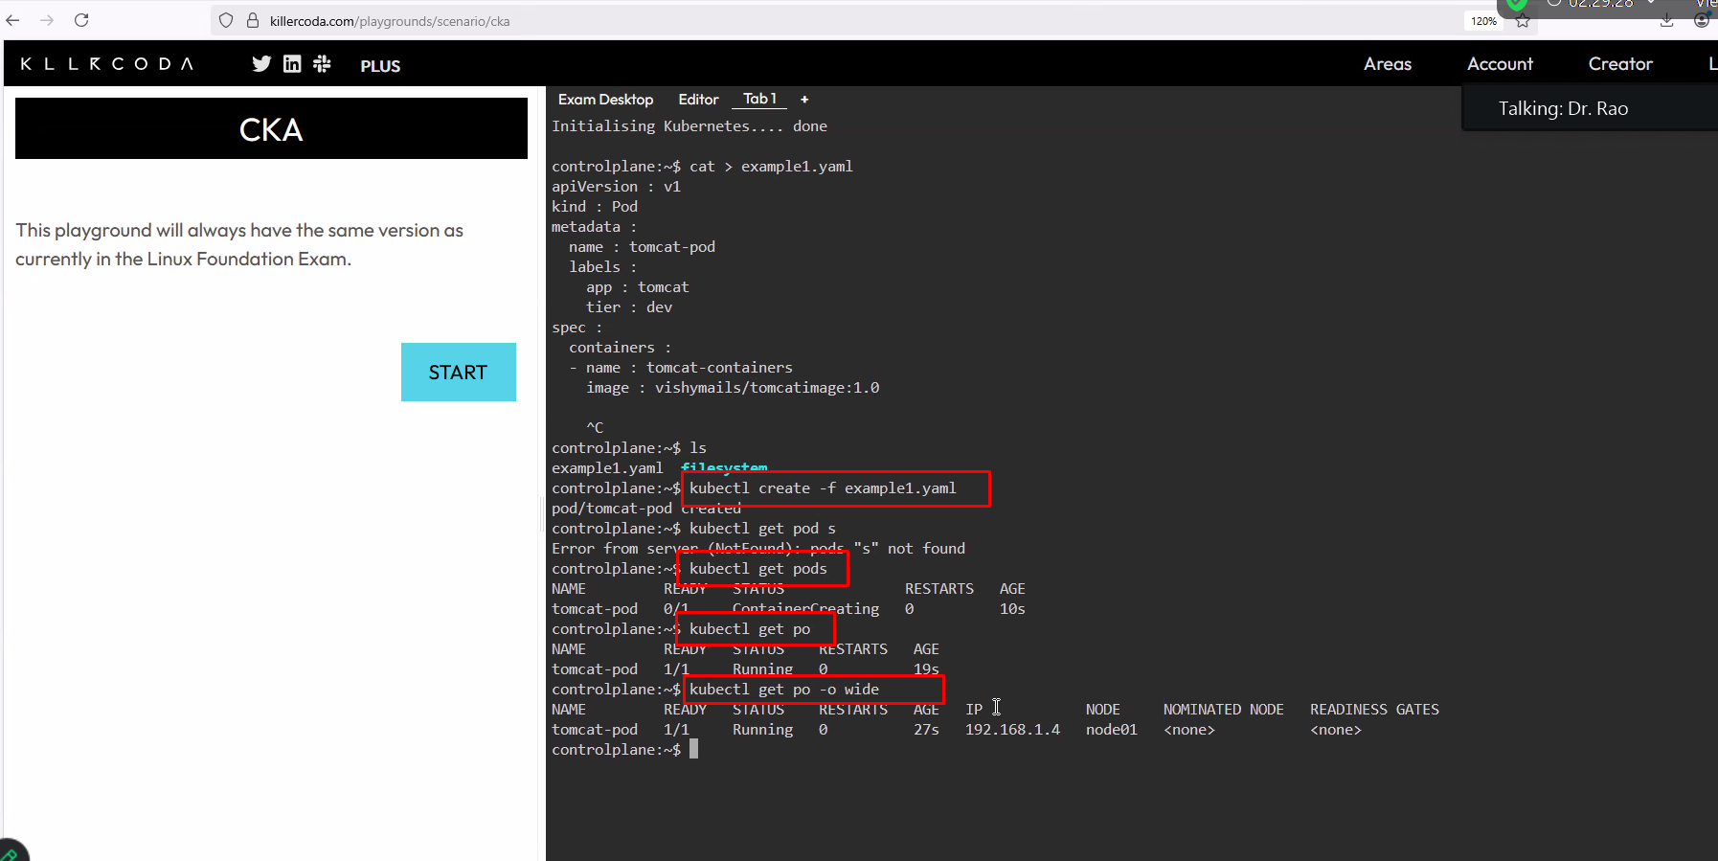

Kubectl get nodes

Kubectl describe pod tomcat-pod

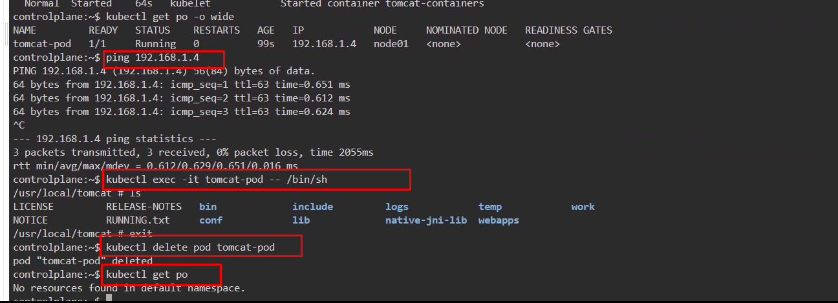

**Commands:**

cat > example1.yaml

ls

kubectl create -f example1.yaml = Create Pod using Example1.yaml file

kubectl get pods = List Pods

kubectl get po - Shortcut

kubectl get po -o wide = Shows Status , IP Address

kubectl get nodes = Shows Worker and Control Nodes

kubectl describe pod tomcat-pod = Gives more Info about Pod

kubectl get po -o wide

ping 192.168.1.4

kubectl exec -it tomcat-pod -- /bin/sh = Enters inside the container

kubectl delete pod tomcat-pod = Deletes the Pod

kubectl get po

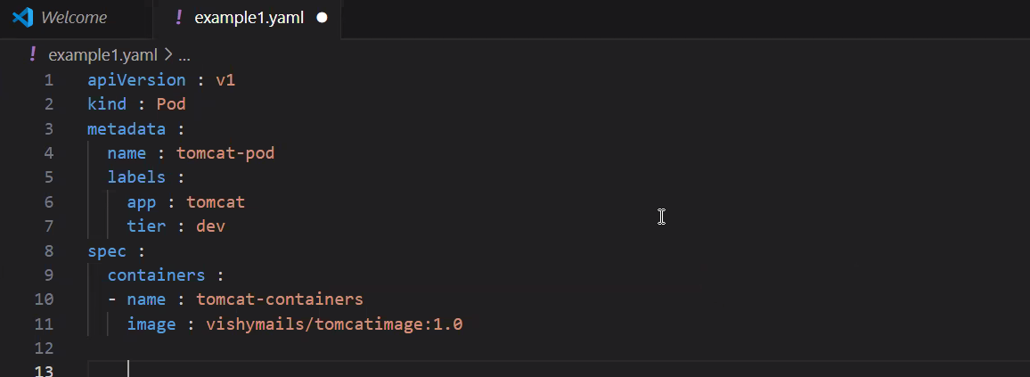

apiVersion : v1

kind : Pod

metadata :

  name : tomcat-pod

  labels :

    app : tomcat

    tier : dev

spec :

  containers :

  - name : tomcat-containers

    image : vishymails/tomcatimage:1.0

=========================================================================

**Certification Question:**

Create a new pod called admin-pod with image busybox. Allow it to be able to set system_time. Container should sleep for 3200 seconds.

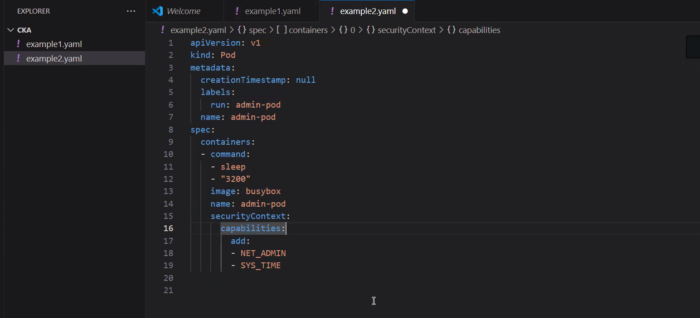

alias g=kubectl

g run admin-pod --image=busybox --command sleep 3200 --dry-run=client

g run admin-pod --image=busybox --command sleep 3200 --dry-run=client -o yaml

g run admin-pod --image=busybox --command sleep 3200 --dry-run=client -o yaml | tee example2.yaml

kubectl create -f example2.yaml

kubectl get po

kubectl get po -o wide

**Code :**

apiVersion: v1

kind: Pod

metadata:

  creationTimestamp: null

  labels:

    run: admin-pod

  name: admin-pod

spec:

  containers:

  - command:

    - sleep

    - "3200"

    image: busybox

    name: admin-pod

    securityContext:

     capabilities:

       add:

       - NET_ADMIN

       - SYS_TIME

**Replication Controller:**

cat > example3.yaml

kubectl create -f example3.yaml

kubectl get po -o wide

kubectl describe rc tomcat-rc

kubectl scale rc tomcat-rc --replicas=9

kubectl get po -o wide

kubectl scale rc tomcat-rc --replicas=3

kubectl get po -o wide

kubectl delete rc tomcat-rc

kubectl delete -f example3.yaml

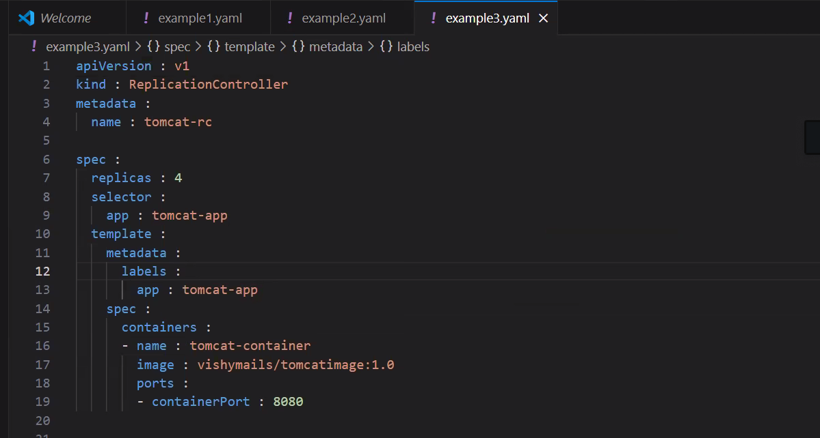

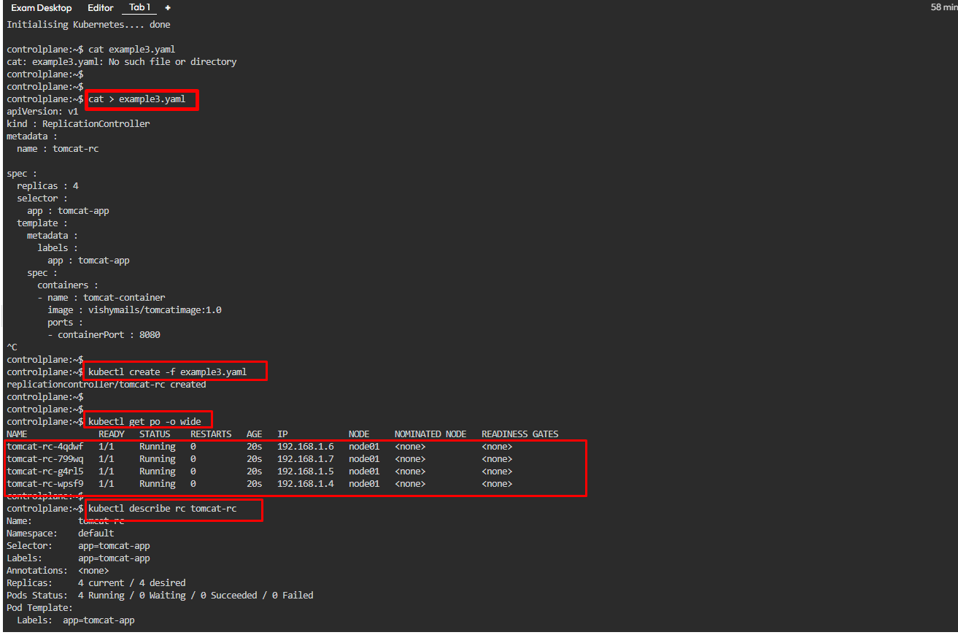

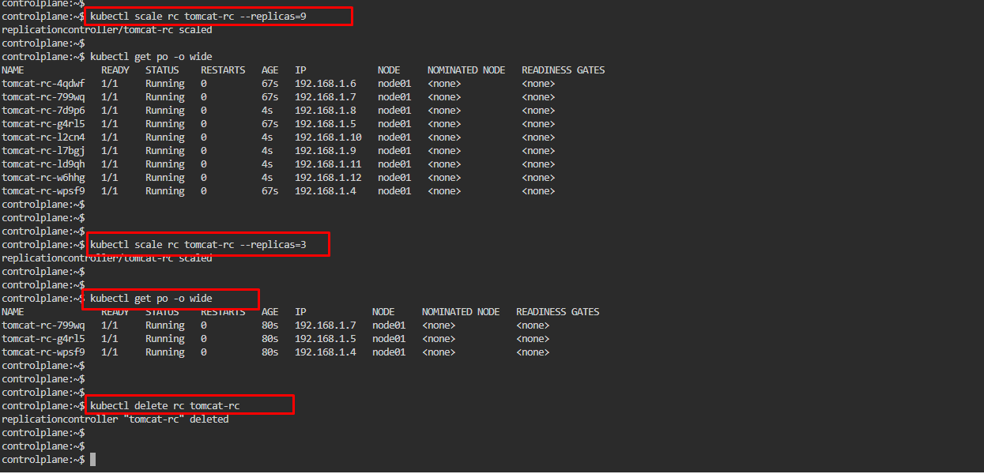

Code :

apiVersion: v1

kind : ReplicationController

metadata :

  name : tomcat-rc

spec :

  replicas : 4

  selector :

    app : tomcat-app

  template :

    metadata :

      labels :

        app : tomcat-app

    spec :

      containers :

      - name : tomcat-container

        image : vishymails/tomcatimage:1.0

        ports :

        - containerPort : 8080

= = = = = = = = = = = ================================================

**Replication Controller Labels :**

If Label Matches in both command line creation and in Manifest RC manages the Pods

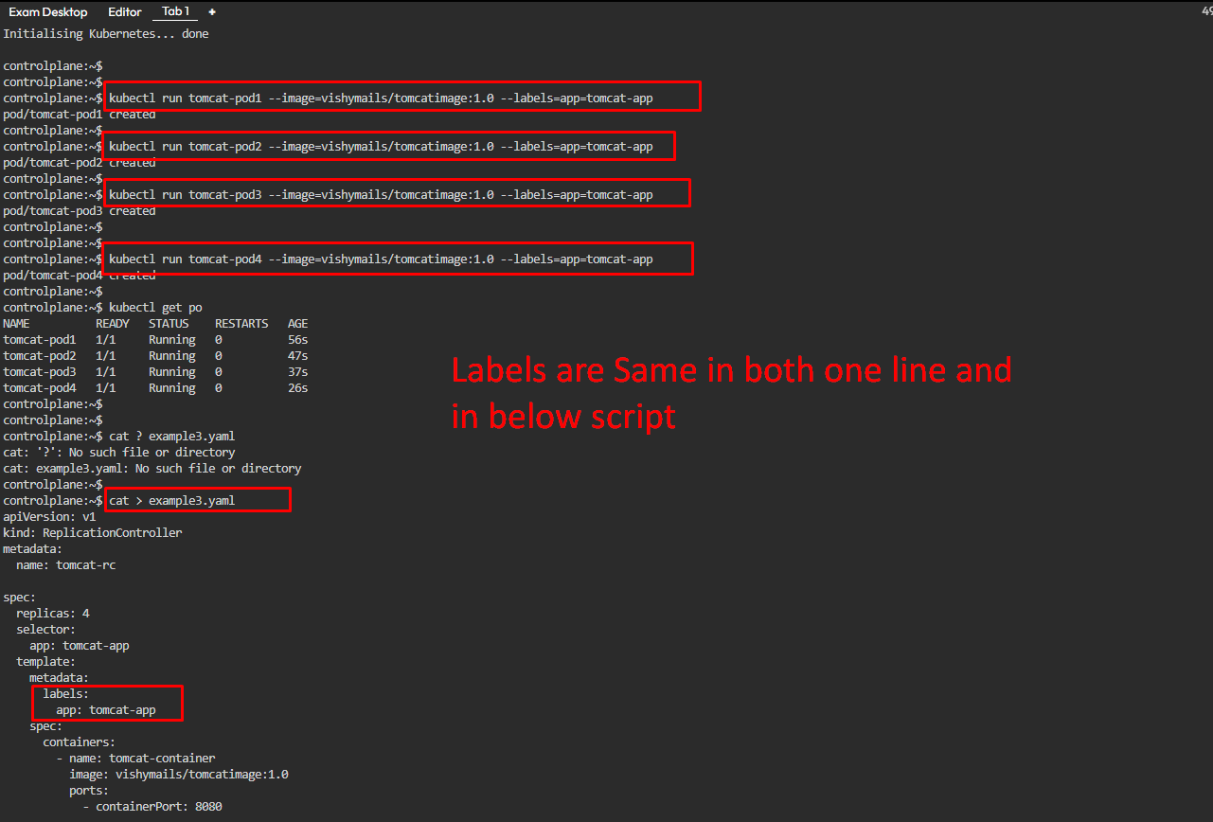

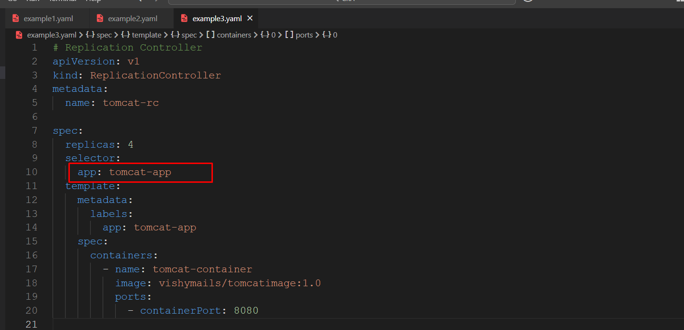

Since labels are equal Replication controller picks this up and manages them – so that’s the reason eventhough the Pods are created manually the Replication controller manages them as the Lables are same

Commands :

kubectl run tomcat-pod1 --image=vishymails/tomcatimage:1.0 --labels=app=tomcat-app --dry-run=client

kubectl run tomcat-pod1 --image=vishymails/tomcatimage:1.0 --labels=app=tomcat-app --dry-run=client -o yaml

kubectl run tomcat-pod1 --image=vishymails/tomcatimage:1.0 --labels=app=tomcat-app

kubectl run tomcat-pod2 --image=vishymails/tomcatimage:1.0 --labels=app=tomcat-app

kubectl run tomcat-pod3 --image=vishymails/tomcatimage:1.0 --labels=app=tomcat-app

kubectl run tomcat-pod4 --image=vishymails/tomcatimage:1.0 --labels=app=tomcat-app

kubectl get po

cat > example3.yaml

kubectl create -f example3.yaml

kubectl get po

kubectl get rc

kubectl describe rc tomcat-rc

kubectl delete pod tomcat-pod3

kubectl get po

kubectl delete rc tomcat-rc

kubectl get po

kubectl create -f example3.yaml

kubectl get po

kubectl describe rc tomcat-rc

**Code:**

# Replication Controller

apiVersion: v1

kind: ReplicationController

metadata:

  name: tomcat-rc

spec:

  replicas: 4

  selector:

    app: tomcat-app

  template:

    metadata:

      labels:

        app: tomcat-app

    spec:

      containers:

        - name: tomcat-container

          image: vishymails/tomcatimage:1.0

          ports:

            - containerPort: 8080

= = = = == = = = = = = = == = = = = = = == = = = = = = = = = = = = = = = = = = = = = = = = = = = = = =

**Replication Set:**

Replicate set does same job as Replication controllers

Called as Next Gen Replication controllers

**Two Types:**

1. Equality Based Selector
2. Set Based Selector

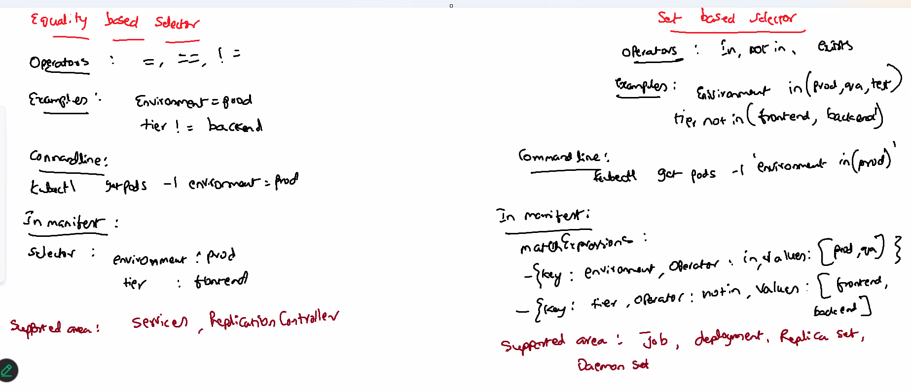

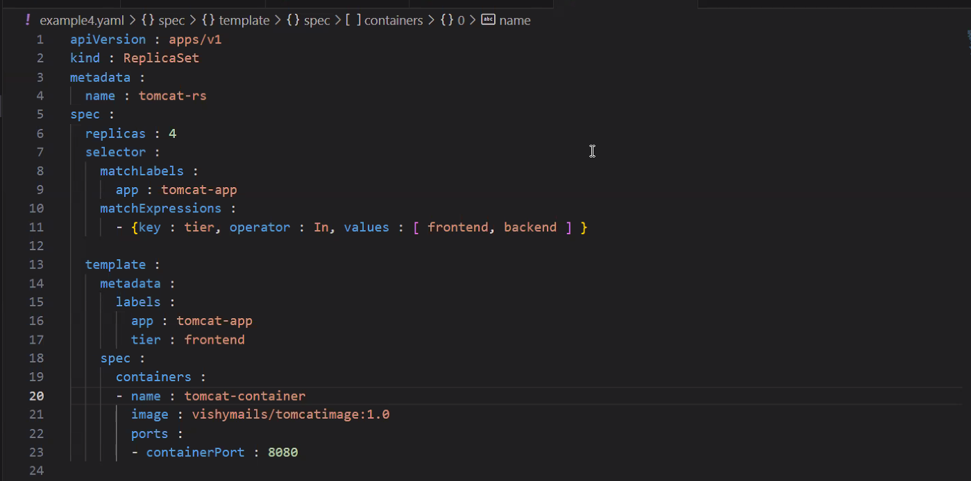

kubectl delete -f example3.yaml

cat > example4.yaml

kubectl create -f example4.yaml

kubectl get po

kubectl create -f example3.yaml

kubectl get po

kubectl get po -l tier=frontend

kubectl get rs

kubectl describe rs tomcat-rs

kubectl scale rs tomcat-rs --replicas=9

kubectl get po -l tier=frontend

kubectl scale rs tomcat-rs --replicas=3

kubectl get po -l tier=frontend

kubectl delete rs tomcat-rs

Create a replicaset (name : web-replica, image=nginx, replicas=3), there is already a pod running in our cluster.

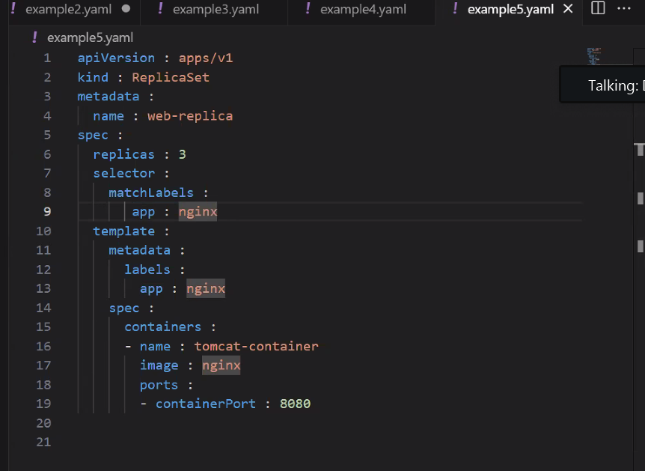

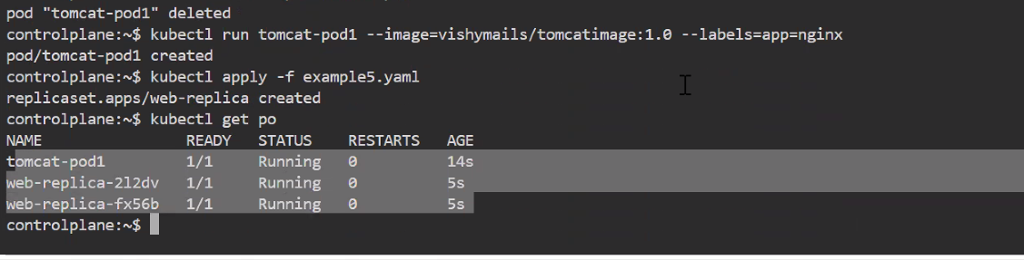

Deployment Models:

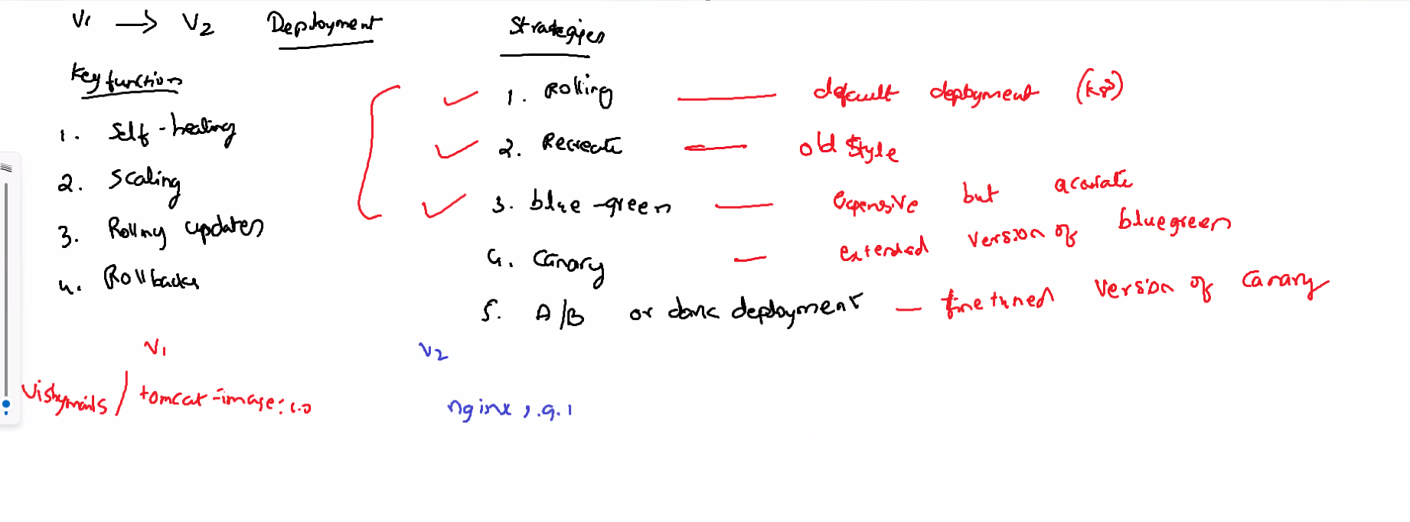 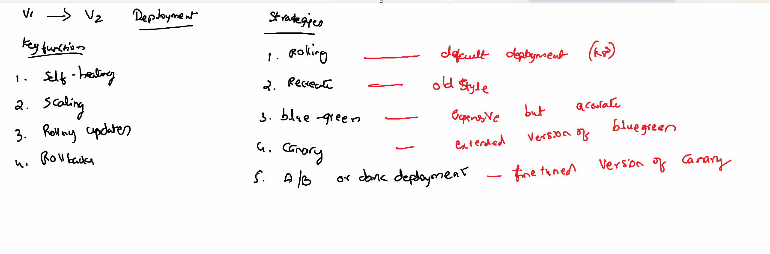

4 cat > example5.yaml

5 kubectl create -f example5.yaml

6 kubectl get po

7 kubectl get po -o wide

8 kubectl get rs

9 kubectl describe deploy tomcat-deploy

10 history

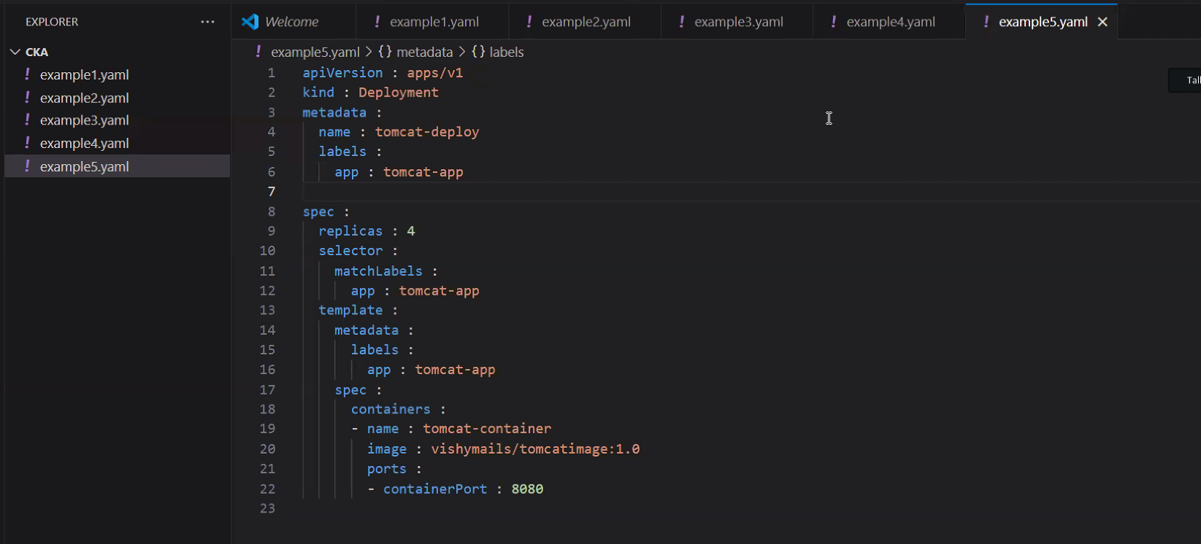

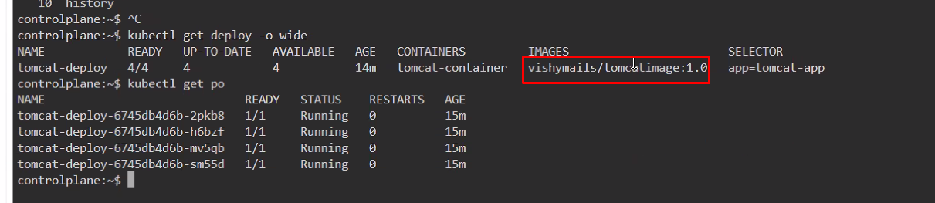

Change image

Rollouts

Changed the image from tomcatimage:1.0 to nginx:1.9.1for Rollouts

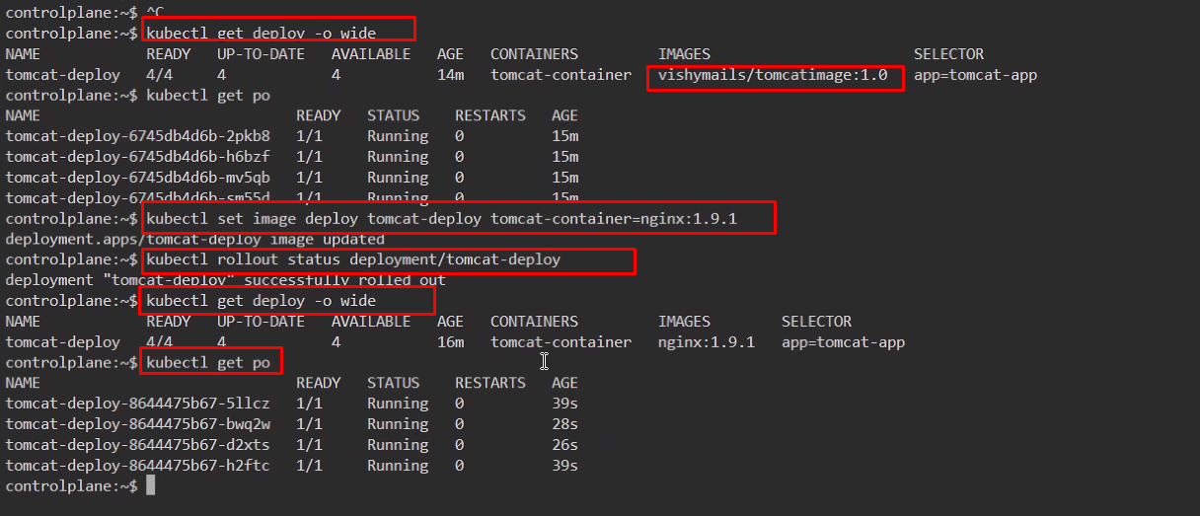

ROLLOUT

kubectl get deploy -o wide

kubectl get po

kubectl set image deploy tomcat-deploy tomcat-container=nginx:1.9.1

kubectl rollout status deployment/tomcat-deploy

1kubectl get deploy -o wide

16 kubectl get po

17 history

ROLLBACK

18 kubectl set image deploy tomcat-deploy tomcat-container=nginnnx:1.25 --record

19 kubectl rollout status deployment/tomcat-deploy

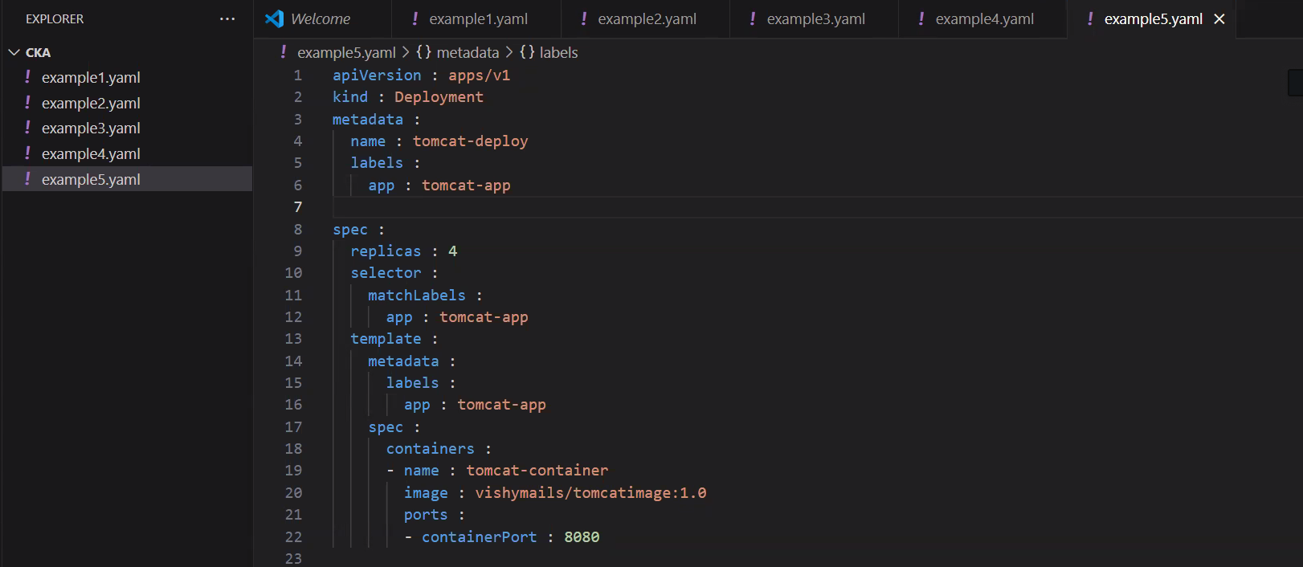

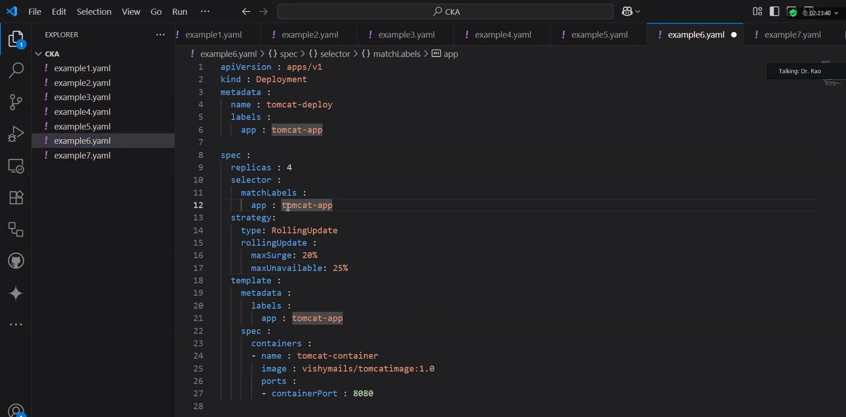

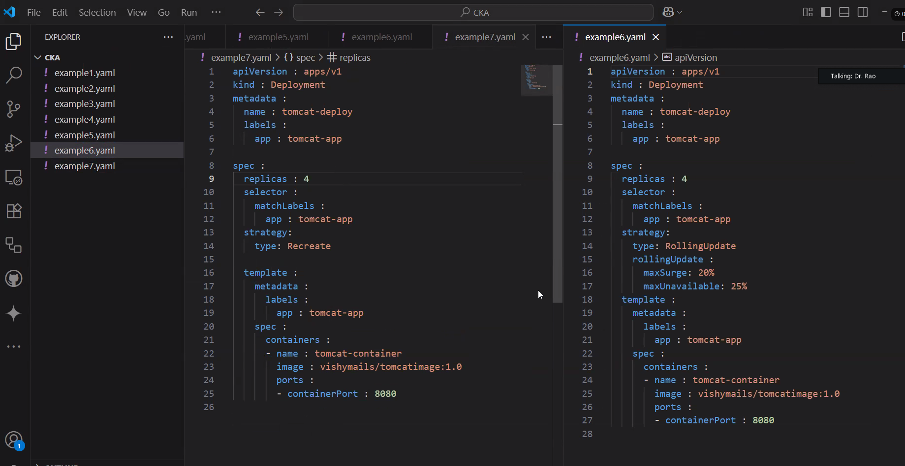

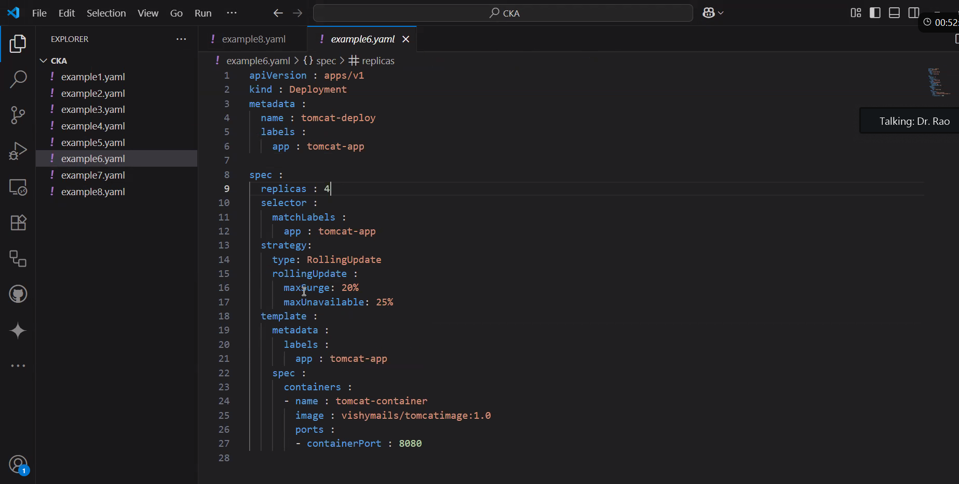

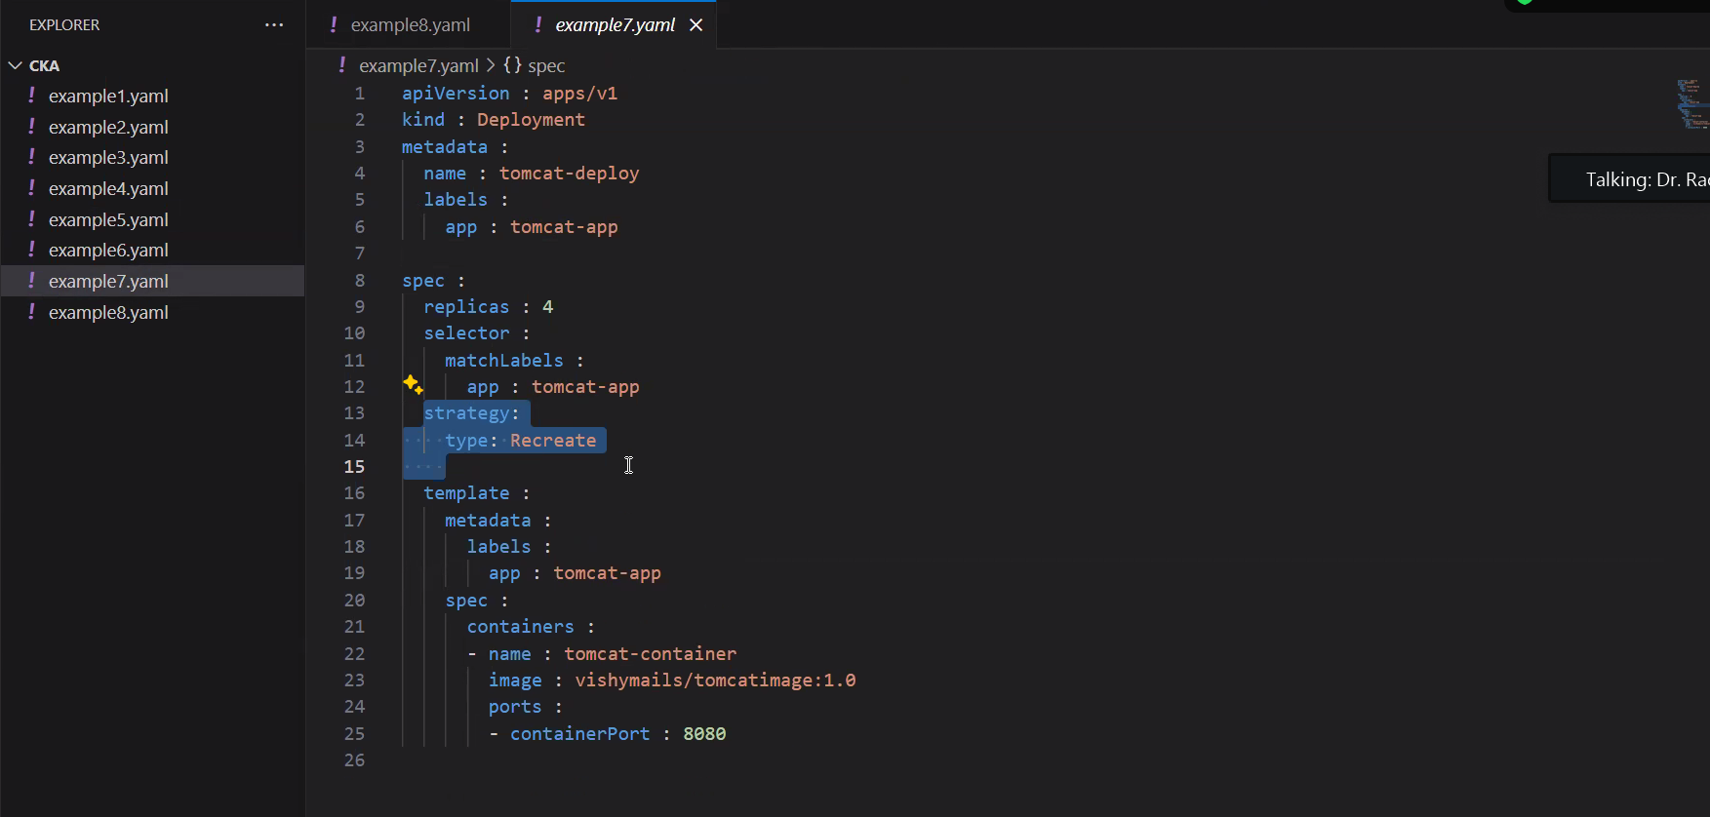

Create a new deployment called web-proj-268 with image nginx:1.16 and one replica. Next, upgrade the deployment to version 1.17 using rolling update. - MAKE SURE YOU RECORD the changes

= = = = = = = = = = = = = = = = = = = = = = = = = = = = = = = = = = = == = = = = == = = = = = = = = = =

12.08.2025 Day : 2

**Question:**

Create a Deployment named nginx with 3 replicas. The Pods should use the nginx:1.23.0 image and the name nginx. The Deployment uses the label tier=backend. The Pod template should use the label app=v1.

List the Deployment and ensure that the correct number of replicas is running.

Update the image to nginx:1.23.4.

Verify that the change has been rolled out to all replicas.

Assign the change cause "Pick up patch version" to the revision.

Scale the Deployment to 5 replicas.

Have a look at the Deployment rollout history.

Revert the Deployment to revision 1.

Ensure that the Pods use the image nginx:1.23.0.

(Optional) Discuss: Can you foresee potential issues with a rolling deployment? How do you configure a update process that first kills all existing containers with the current version before it starts with the new version?

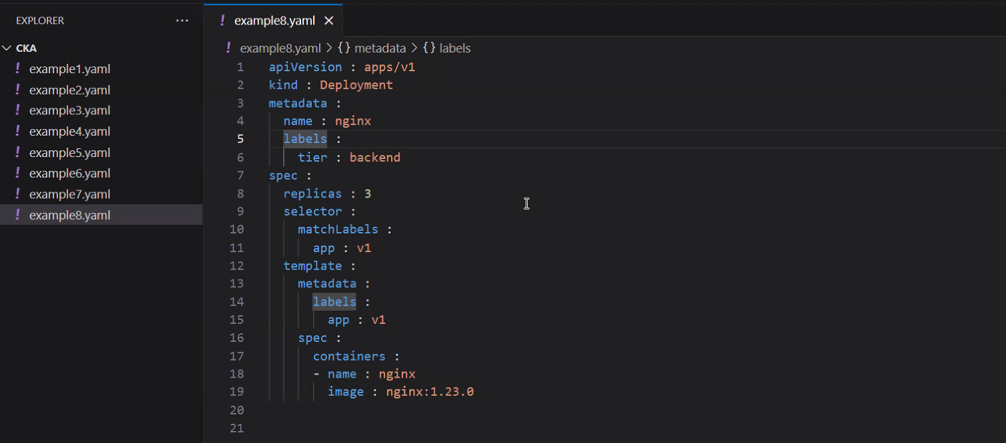

cat > example8.yaml

kubectl create -f example8.yaml

kubectl get deploy

kubectl set image deployment/nginx nginx=nginx:1.23.4

kubectl rollout history deployment nginx

kubectl get deploy

kubectl get deploy --revision=2

kubectl rollout history deployment nginx --revision=2

kubectl annotate deployment nginx kubernetes.io/change-cause="Pick up patch version"

kubectl rollout history deployment nginx

kubectl scale deployment nginx --replicas=5

kubectl get deploy

kubectl get po -o wide

kubectl rollout undo deployment/nginx --to-revision=1

kubectl rollout history deployment nginx

kubectl rollout history deployment nginx --revision=3

kubectl get deploy

kubectl get deploy -o wide

<https://github.com/vishymails>

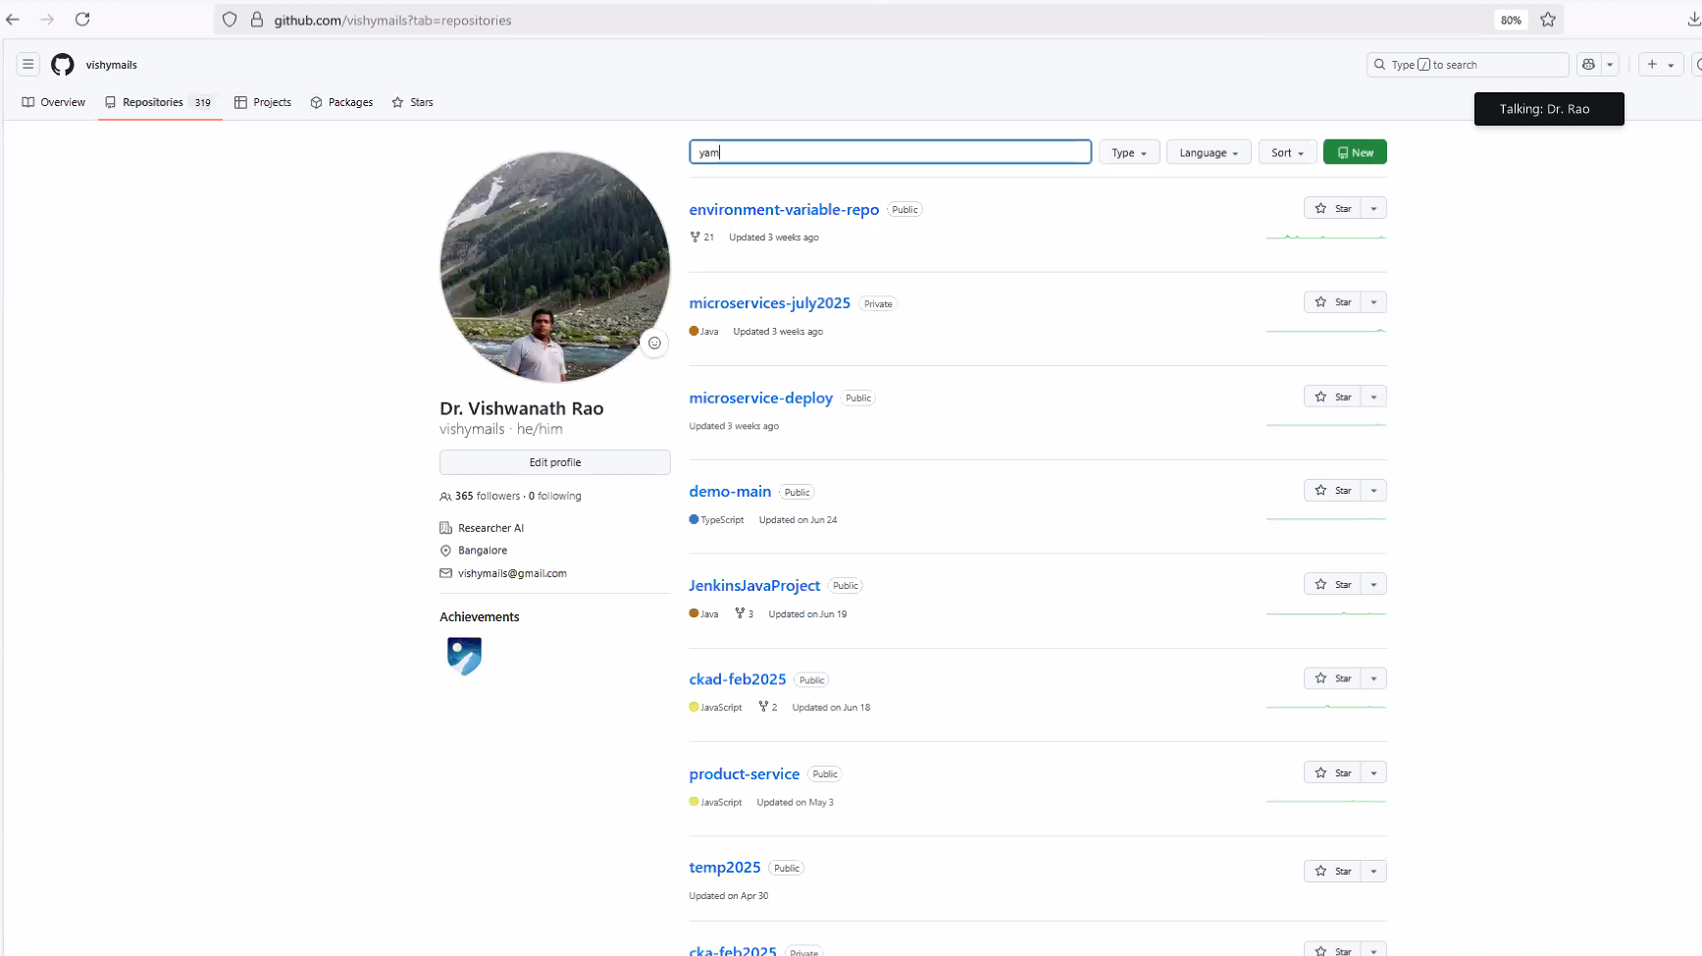

YAML – Github - <https://github.com/vishymails/YAML>

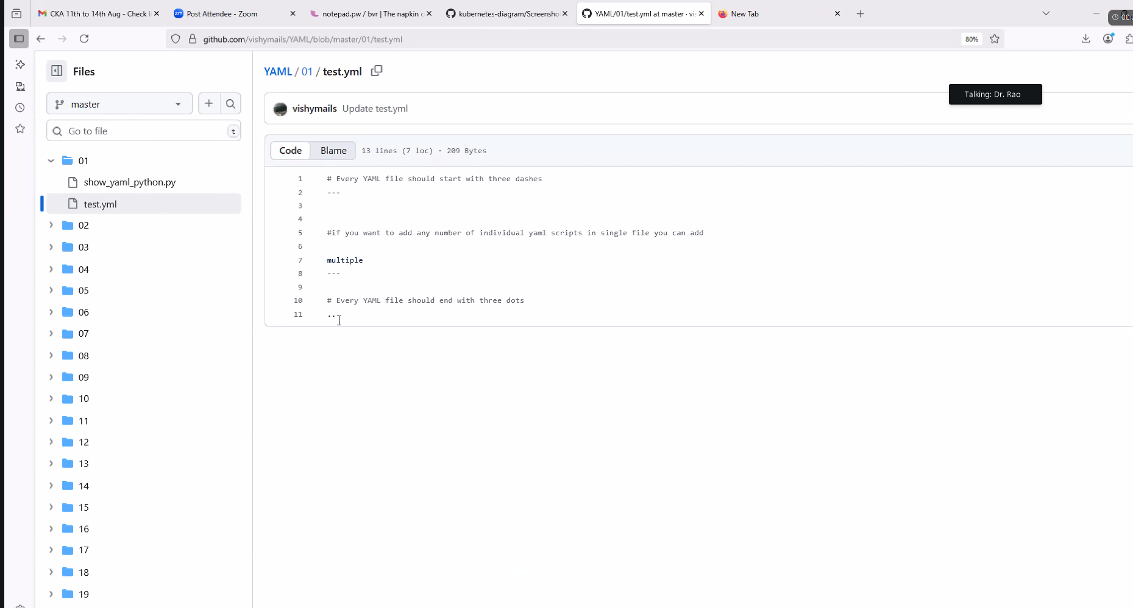

Networking :

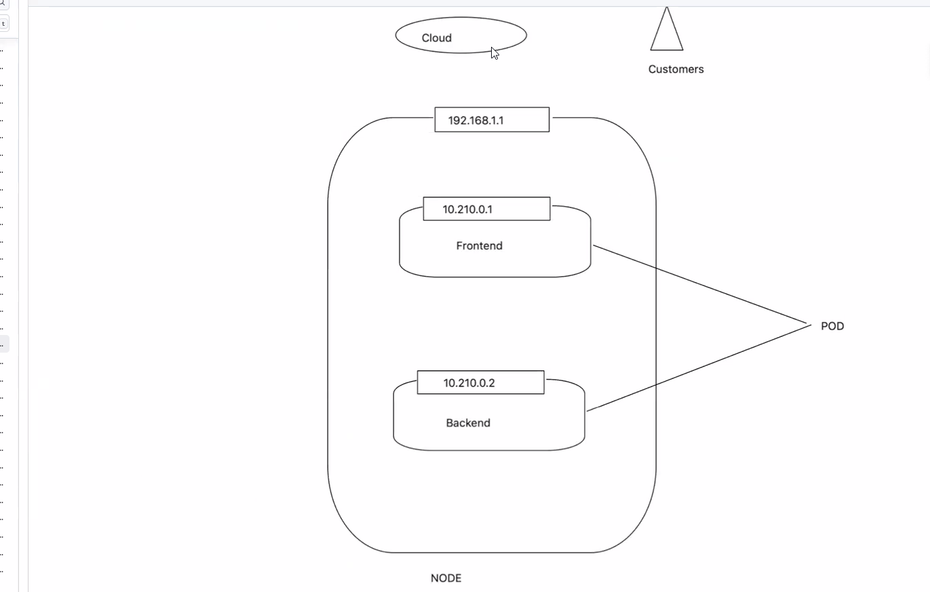

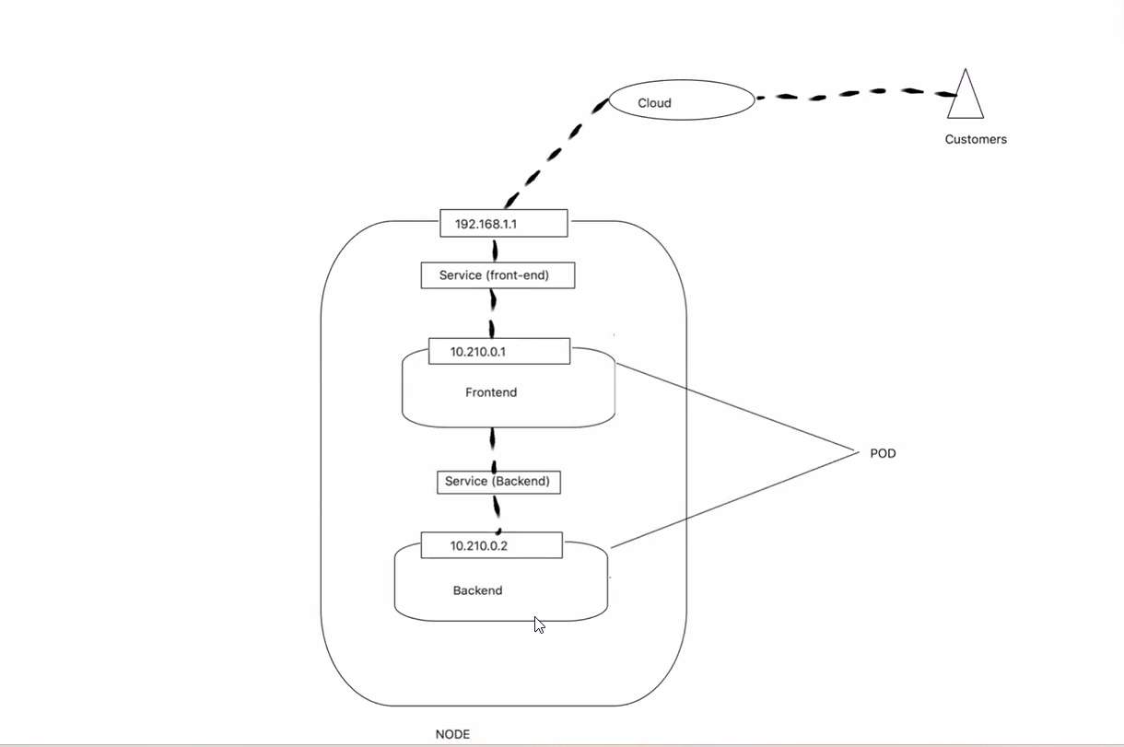

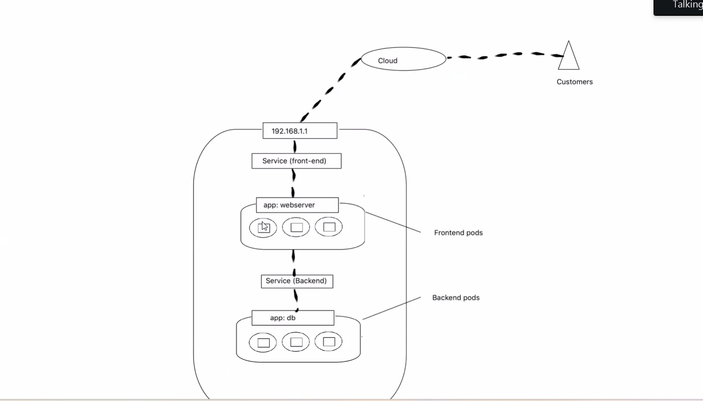

Node Port Service :

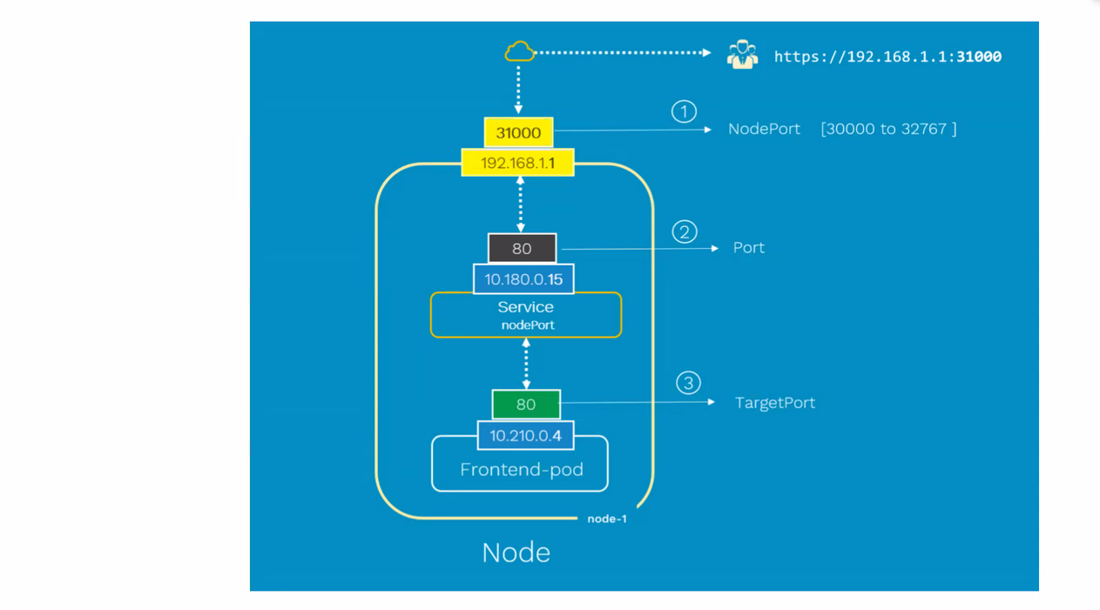

Place a request to the IP address of the Node

Directly connect to the respective node object URL

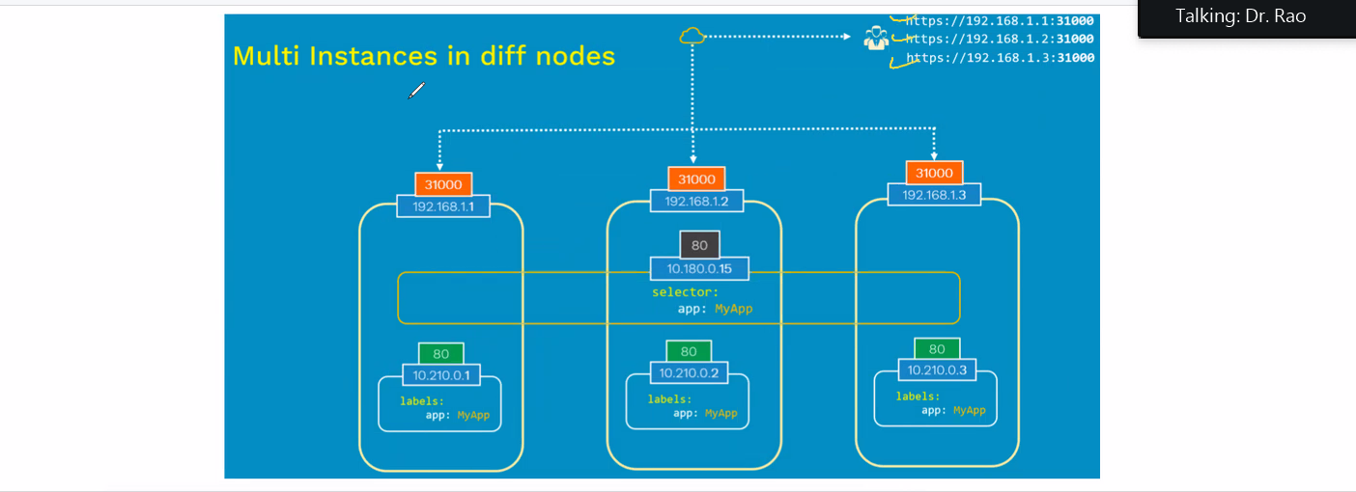

You need to remember all the URLS to connect to the Node which is a problem here

LB is an extension of Node Port – underlying it has a Node Port but LB knows

Instead of having individual URL you can have the LB URL

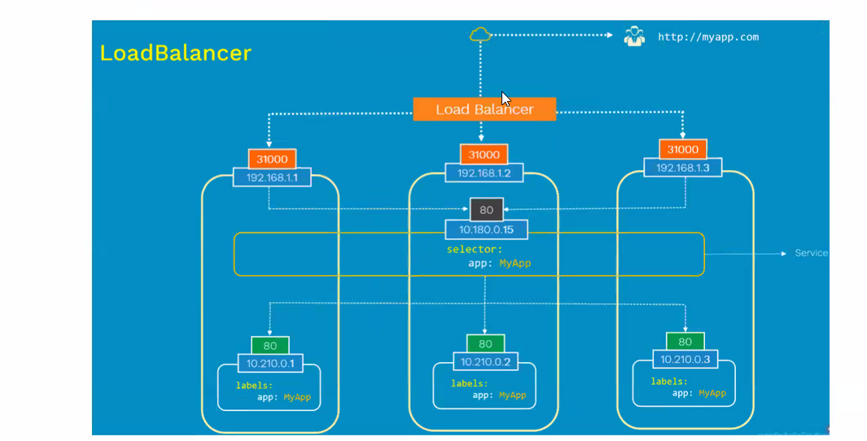

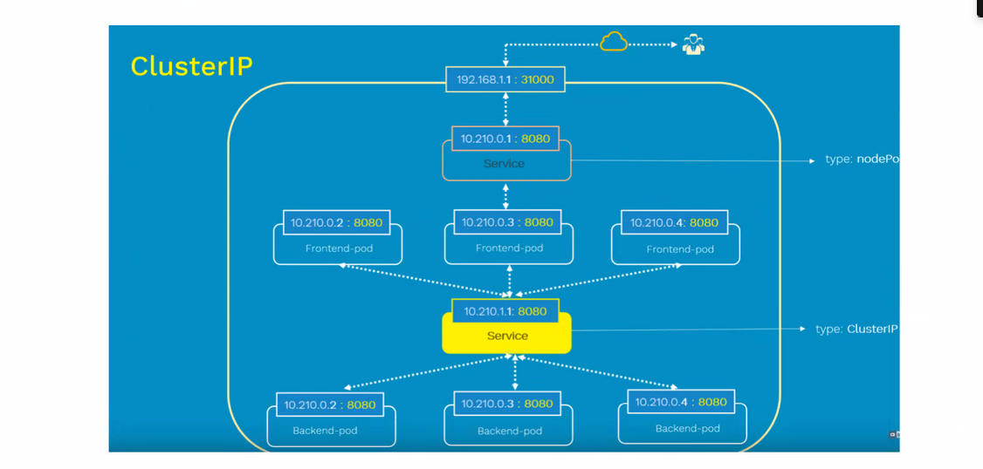

Two Scripts are Needed Here – we are using the labels here – it should match on both scripts

Example 5 – Creates Tomcat container

Example 9 – Creates Node Port for those Container

Labels should be the same on both the scripts otherwise it won’t work

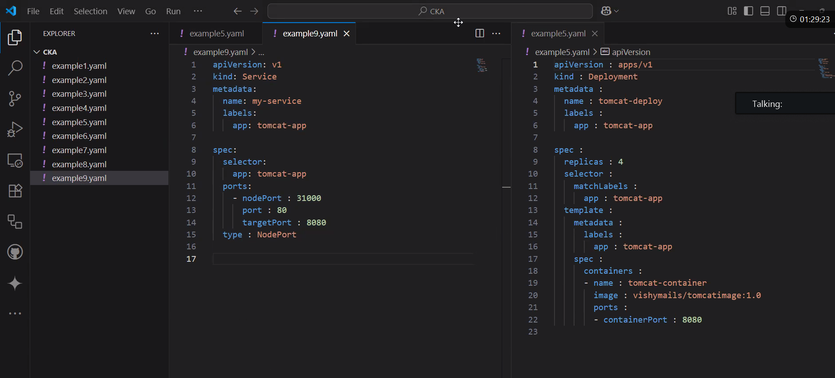

cat > example5.yaml

cat > example9.yaml

kubectl create -f example5.yaml -f example9.yaml

kubectl get po

kubectl get deploy

kubectl get svc

kubectl describe svc my-service

curl http://192.168.1.4:8080

curl http://192.168.1.5:8080

curl http://192.168.1.6:8080

curl http://192.168.1.7:8080

curl http://192.168.1.10:8080

kubectl describe svc my-service

kubectl get nodes

kubectl get nodes -o wide

curl 172.30.1.2:31000

curl 172.30.2.2:31000

curl 172.30.3.2:31000

curl 172.30.2.2:31000

kubectl get nodes -o wide

kubectl describe svc my-service

curl 10.110.78.53:31000

curl 10.110.78.53:8080

curl 10.110.78.53:80

**Blue Green Deployment :**

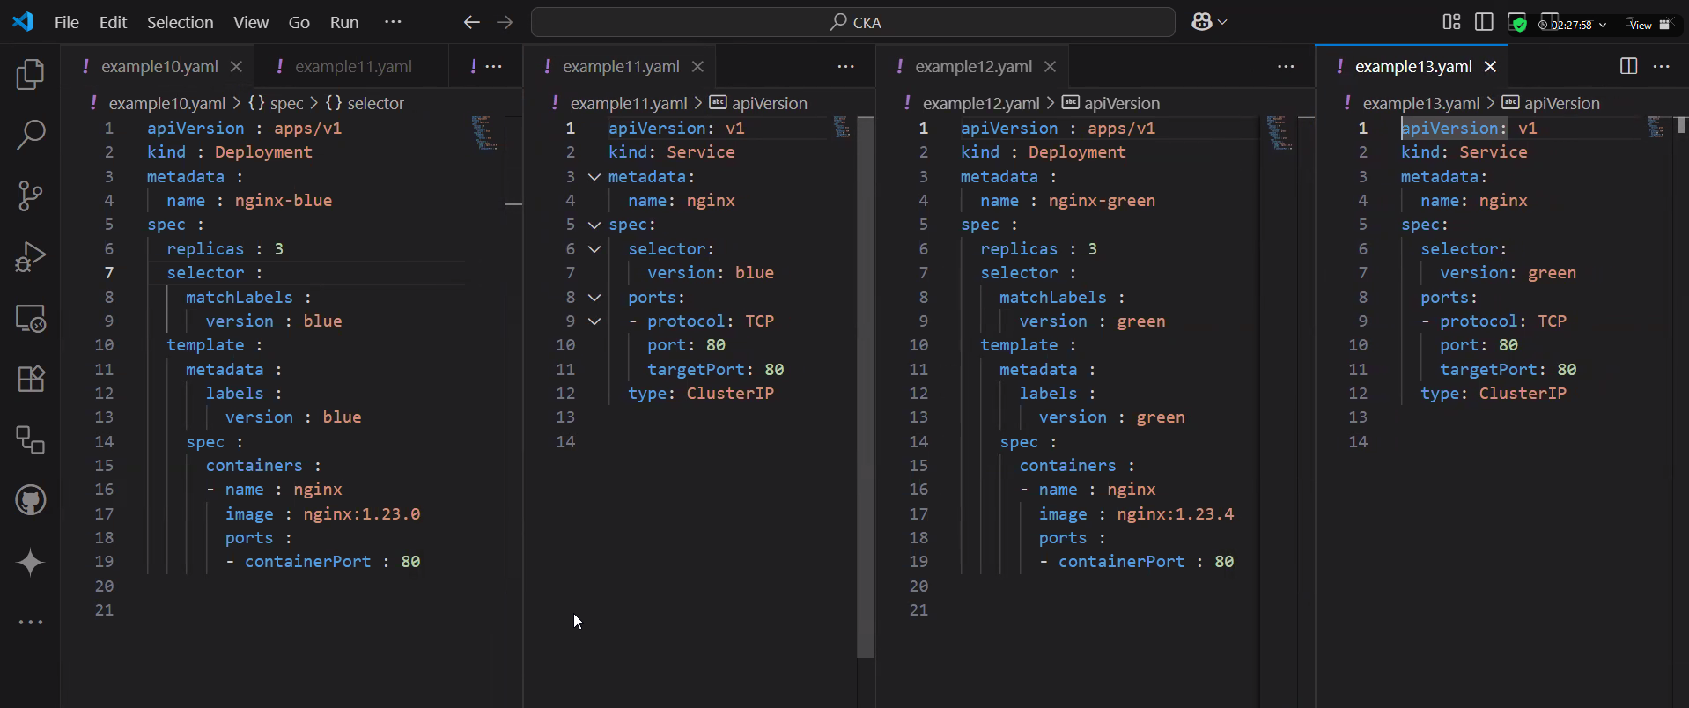

Create a Deployment named nginx-blue with 3 replicas. The Pod template of the Deployment should use container image nginx:1.23.0 and assign the label version=blue.

Expose the Deployment with a Service of type ClusterIP named nginx. Map the incoming and outgoing port to 80. Select the Pod with label version=blue.

Run a temporary Pod with the container image alpine/curl:3.14 to make a call against the Service using curl.

Create a second Deployment named nginx-green with 3 replicas. The Pod template of the Deployment should use container image nginx:1.23.4 and assign the label version=green.

Change the Service's label selection so that traffic will be routed to the Pods controlled by the Deployment nginx-green.

Delete the Deployment named nginx-blue.

Run a temporary Pod with the container image alpine/curl:3.14 to make a call against the Service.

4 cat > example10.yaml

5 kubectl apply -f example10.yaml

6 kubectl get po -o wide

7 cat > example11.yaml

8 kubectl create -f example11.yaml

9 kubectl get svc

10 kubectl run tmp --image=alpine/curl:3.14 --restart=Never -it --rm -- curl -sI nginx.default.svc.cluster.local

11 cat > example12.yaml

12 kubectl create -f example12.yaml

13 kubectl get po -o wide

14 cat > example13.yaml

15 kubectl apply -f example13.yaml

16 kubectl get svc

17 kubectl run tmp --image=alpine/curl:3.14 --restart=Never -it --rm -- curl -sI nginx.default.svc.cluster.local

18 history

Blue is version 1

Service objects point to 1

Green

service object to aq

delet service object given to qa

point to version 2

**Volumes:**

* Used to access the storage
* Can be used for Data persistence
* Volume can be used as Object or by Mounting

Two Types of Persistence:

1. Temp or Cache also called Ephemeral Storage which means when a container dies that particular storage is cleared
2. Shared Storage – Persistent storage wherever you required

**Two Volumes**

1. Ephemeral volume
2. Shared volume

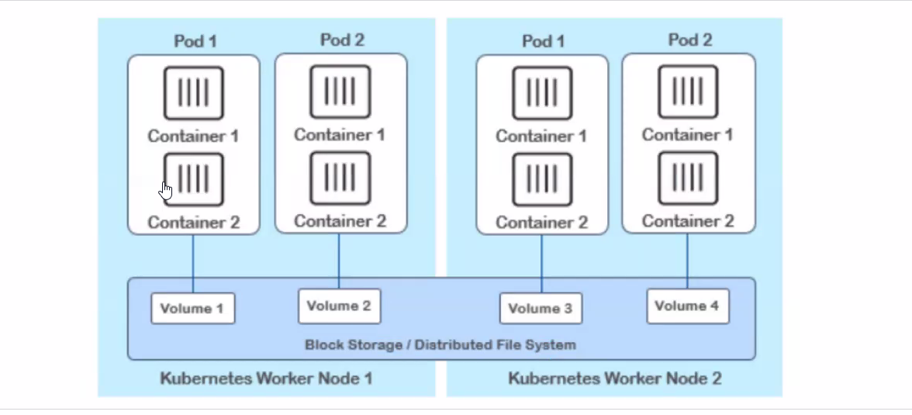

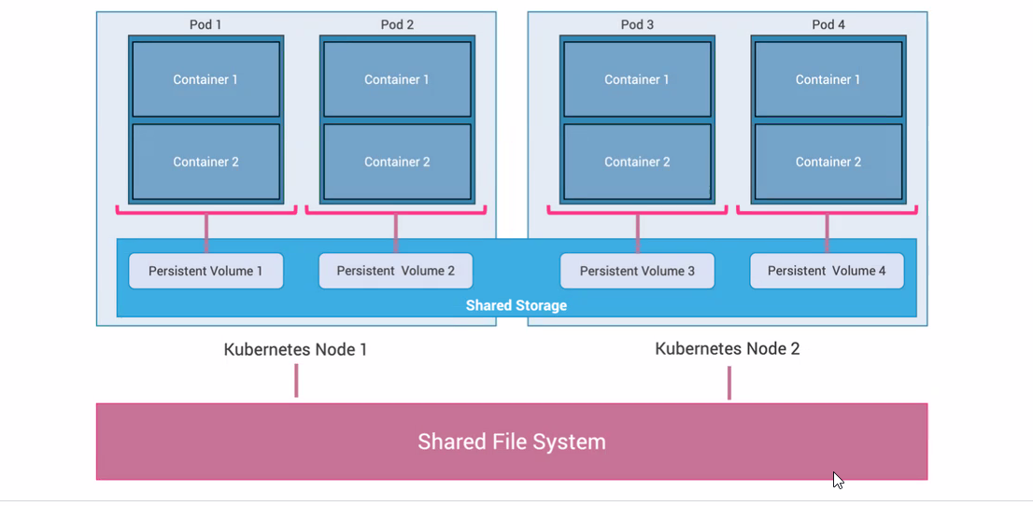

**Ephemeral volume :**

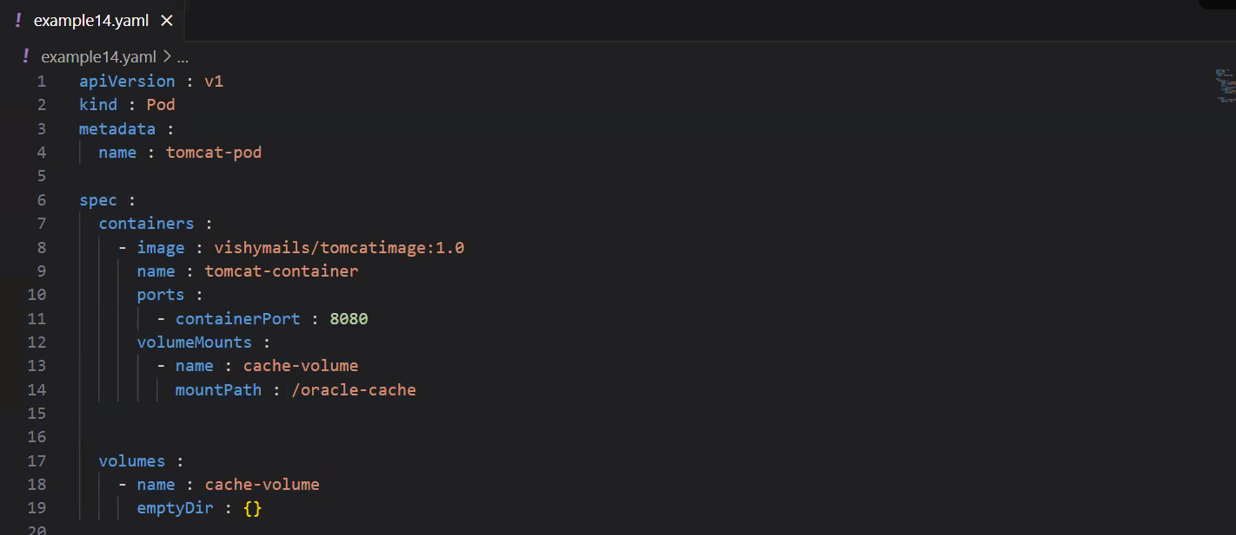

**cat > example14.yaml**

**kubectl create -f example14.yaml**

**cat > example14.yaml**

kubectl create -f example14.yaml

kubectl apply -f example14.yaml

kubectl delete -f example14.yaml

kubectl apply -f example14.yaml

kubectl get po

kubectl exec -it tomcat-pod -- /bin/sh

# Login into the container and browse to cd /oracle-cache/ and create empty files ### See Runtime Info Image for More information

kubectl delete pod tomcat-pod

kubectl apply -f example14.yaml

kubectl exec -it tomcat-pod -- /bin/sh

# After recreating the Pod the files wont be there as its a Temp Storage

**Ephemeral volume with Cache Volume Size Limit**

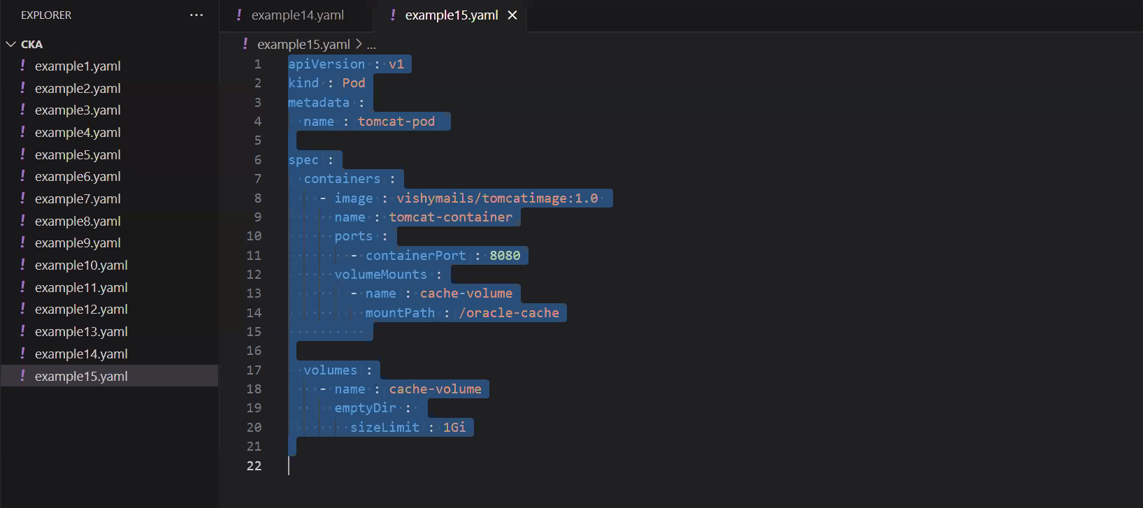

**Host Volume – Permanent Storage**

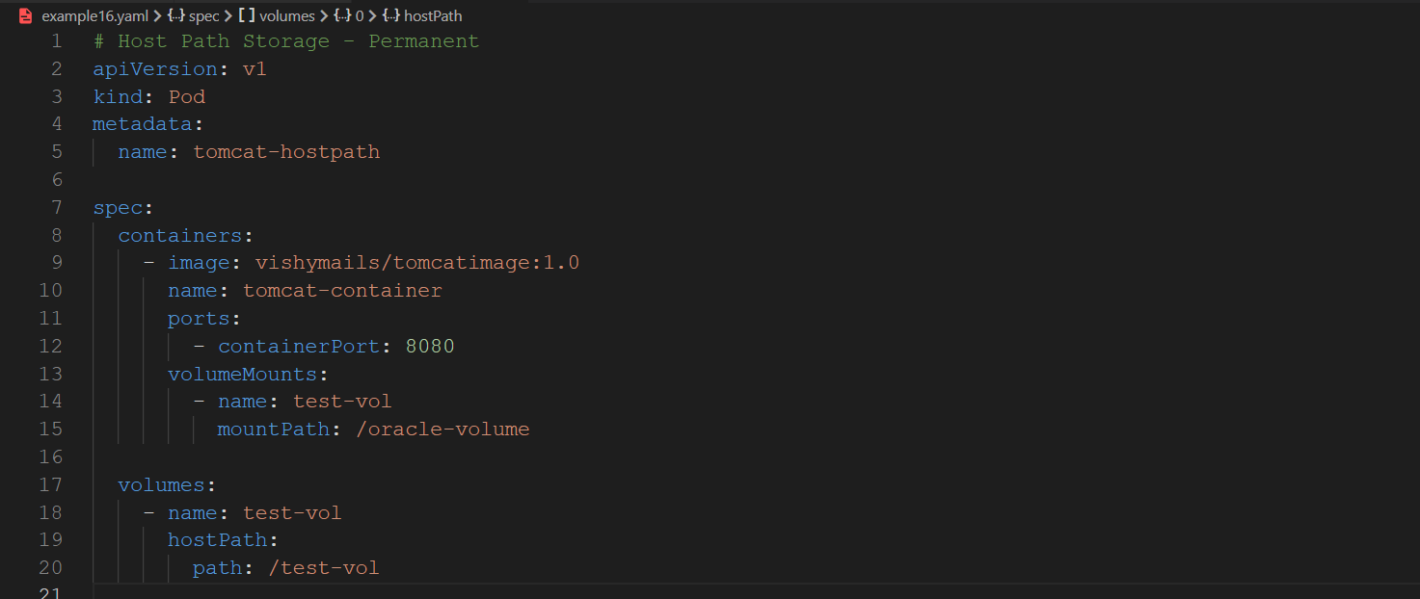

kubectl create -f example16.yaml

kubectl get po

kubectl exec -it tomcat-hostpath -- /bin/sh

kubectl delete pod tomcat-hostpath

#Connect to the Host Node to find the Files there - See Info Pic For More Info

kubectl exec -it tomcat-hostpath -- /bin/sh

kubectl create -f example16.yaml

kubectl exec -it tomcat-hostpath -- /bin/sh

history

**MultiContainer Pod :**

* Under Huge pod containers and storage object will be available
* Two containers shares the same volume object

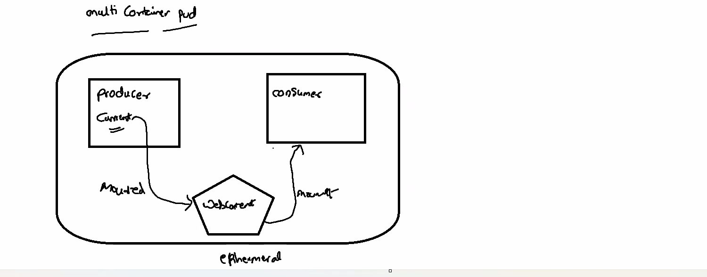

* Data generated by the producer will be feeded to the consumer

Requirement :

Pod containing 2 containers called Producer and Consumer where pod also has a Storage object which will be accessed by both Containers

Data Generated by producer Container will be Feeded to the Consumer Container

# Multicontainer pod

apiVersion: v1

kind: Pod

metadata:

  name: multicontainer-pod

spec:

  containers:

    - name: producer

      image: ubuntu

      command: ["/bin/bash"]

      args:

        [

          "-c",

          "while true; do echo $(hostname) $(date) >> /var/log/index.html; sleep 5; done",

        ]

      volumeMounts:

        - name: webcontent

          mountPath: /var/log

    - name: consumer

      image: nginx

      ports:

        - containerPort: 80

      volumeMounts:

        - name: webcontent

          mountPath: /usr/share/nginx/html

  volumes:

    - name: webcontent

      emptyDir: {}

Commands :

cat > example17.yaml

kubectl create -f example17.yaml

kubectl get po

# Login into the producer container

kubectl exec -it --container=producer multicontainer-pod -- /bin/bash

cd /var/log/

Verify files are being generated

# Login into the Consumer container

kubectl exec -it --container=consumer multicontainer-pod -- /bin/bash

cd /usr/share/nginx/html/

Verify files are being here

Next Question:

deploy a simple application consisting of a main container and a sidecar container. The main container is a basic web server that generates a timestamped "hello world" message every 5 seconds and writes it to a file. The sidecar container is a log processor that reads this file and prints its contents to standard output. Both containers must share the same file using a directory on the host node.

Requirements:

Pod Configuration:

Create a Pod named my-multicontainer-app.

The Pod should have two containers: web-generator and log-reader.

The Pod must have a shared volume named shared-data-volume.

hostPath Volume:

The shared-data-volume must be a hostPath volume.

It should point to a directory on the host machine at /tmp/app-data.

The hostPath volume must be configured with a type of DirectoryOrCreate to ensure the directory is created if it doesn't already exist on the host.

Container Configuration:

web-generator Container:

Use the alpine image.

The container's command should be a shell script that continuously echoes the current timestamp and a message to a file named output.log within the /data directory inside the container. An example command would be sh -c 'while true; do echo "$(date): Hello from the web-generator!" >> /data/output.log; sleep 5; done'.

Mount the shared-data-volume to the /data directory inside this container.

log-reader Container:

Use the alpine image.

The container's command should be tail -f /data/output.log to continuously read the file as it's being written.

Mount the shared-data-volume to the /data directory inside this container.

apiVersion: v1

kind: Pod

metadata:

name: my-multicontainer-app

spec:

volumes:

- name: shared-data-volume

hostPath:

path: /tmp/app-data

type: DirectoryOrCreate

containers:

- name: web-generator

image: alpine

command: ["sh", "-c", "while true; do echo \"$(date): Hello from the web-generator!\" >> /data/output.log; sleep 5; done"]

volumeMounts:

- name: shared-data-volume

mountPath: /data

- name: log-reader

image: alpine

command: ["tail", "-f", "/data/output.log"]

volumeMounts:

- name: shared-data-volume

mountPath: /data

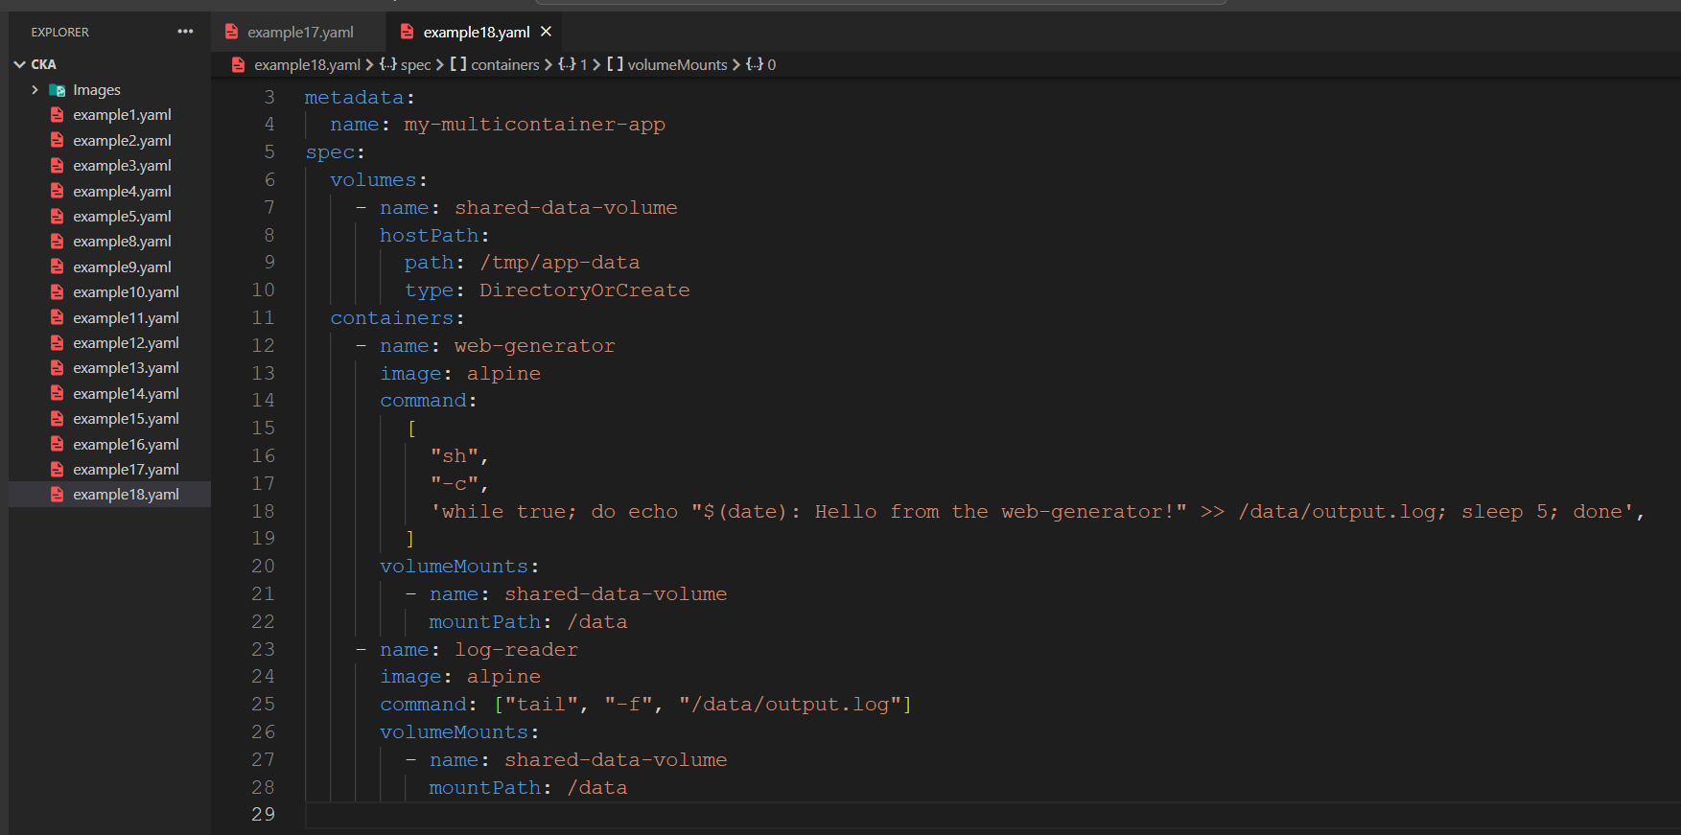

Persistent Storage :

PV Claim – if you want to utilize you need to claim for that content

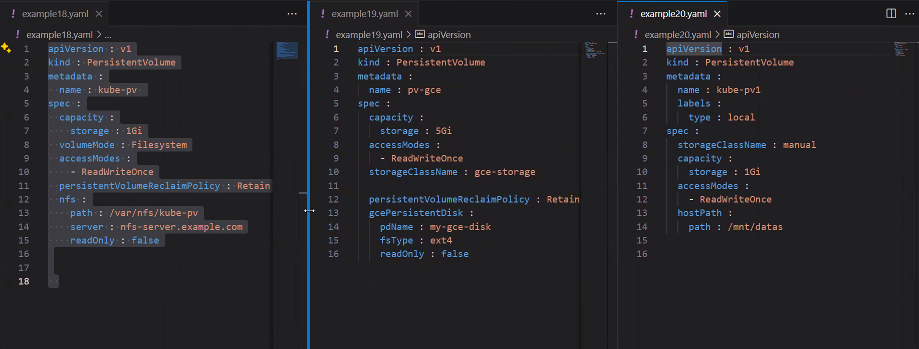

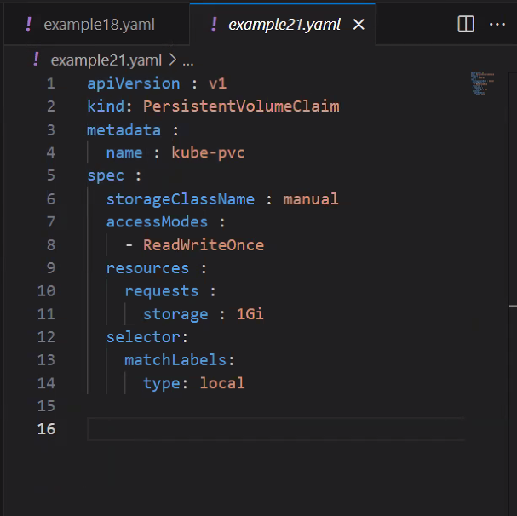

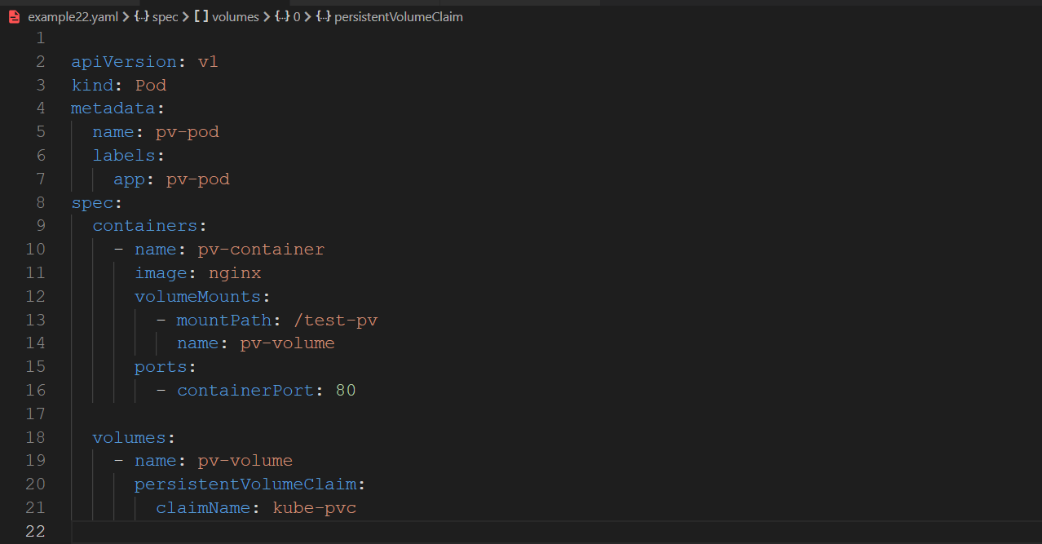

= = = = = = = == = = = = = == = = = = = = = = = = == = = = = = = = = = = = = = = = = == = = = = = =

13.08.2025 Day : 3

Single Script for Persistent Volume Claim

Refrence : <https://github.com/mr-tgokul/certified-kubernetes-administrator-cka/tree/main/Persistent%20Volume%20and%20Persistent%20Volume%20Claim>

apiVersion: v1

kind: PersistentVolume

metadata:

  name: kube-pv

  labels:

    type: local

spec:

  storageClassName: manual

  capacity:

    storage: 1Gi

  accessModes:

    - ReadWriteOnce

  hostPath:

    path: /mnt/data # Make sure this folder exists on the node

---

apiVersion: v1

kind: PersistentVolumeClaim

metadata:

  name: kube-pv1

spec:

  storageClassName: manual

  accessModes:

    - ReadWriteOnce

  resources:

    requests:

      storage: 1Gi

  selector:

    matchLabels:

      type: local

---

apiVersion: v1

kind: Pod

metadata:

  name: pv-pod

  labels:

    app: pv-pod

spec:

  containers:

    - name: pv-container

      image: nginx

      volumeMounts:

        - mountPath: /test-pv

          name: pv-volume

      ports:

        - containerPort: 80

  volumes:

    - name: pv-volume

      persistentVolumeClaim:

        claimName: kube-pv1 # Matches the PVC name above

Commands :

cat > per.yaml

kubectl create -f per.yaml

kubectl get po -o wide

kubectl exec -it pv-pod -- /bin/sh

# Login and create few files

cd test-pv

kubectl get nodes

ssh node01

browse to cd /mnt/data/

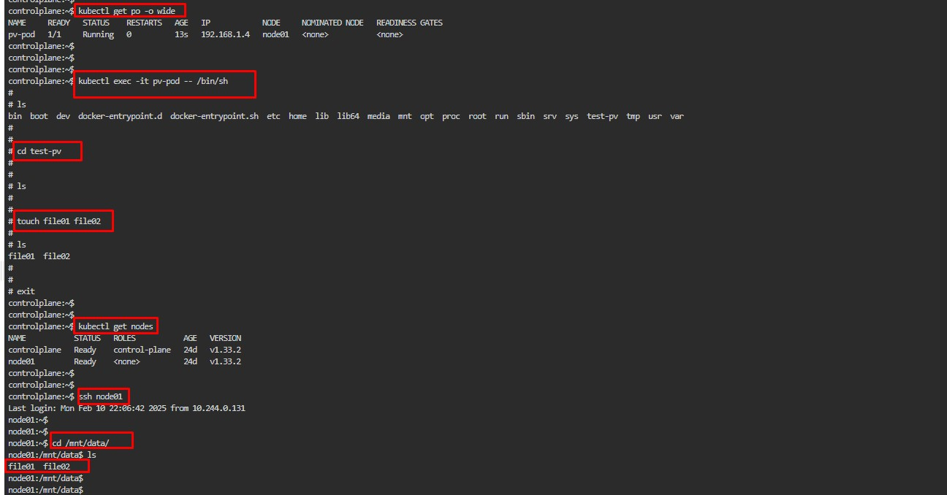

Storage Class :

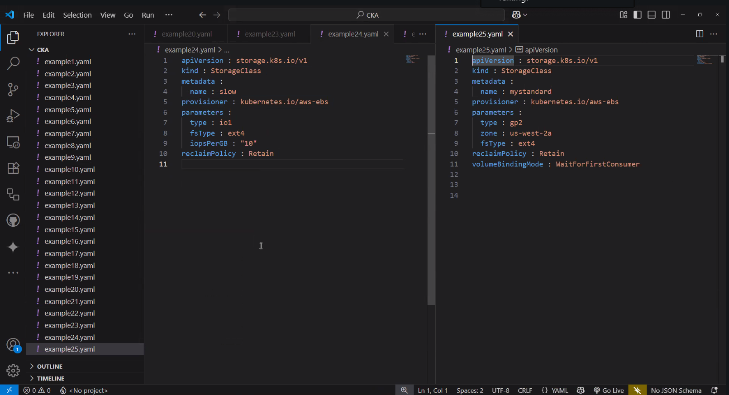

**Daemon Set:**

DS is a Workload resource that ensures copies of pods are deployed in each node

Ensure One Copy of Pod per Node

No of pods are equal to No of nodes

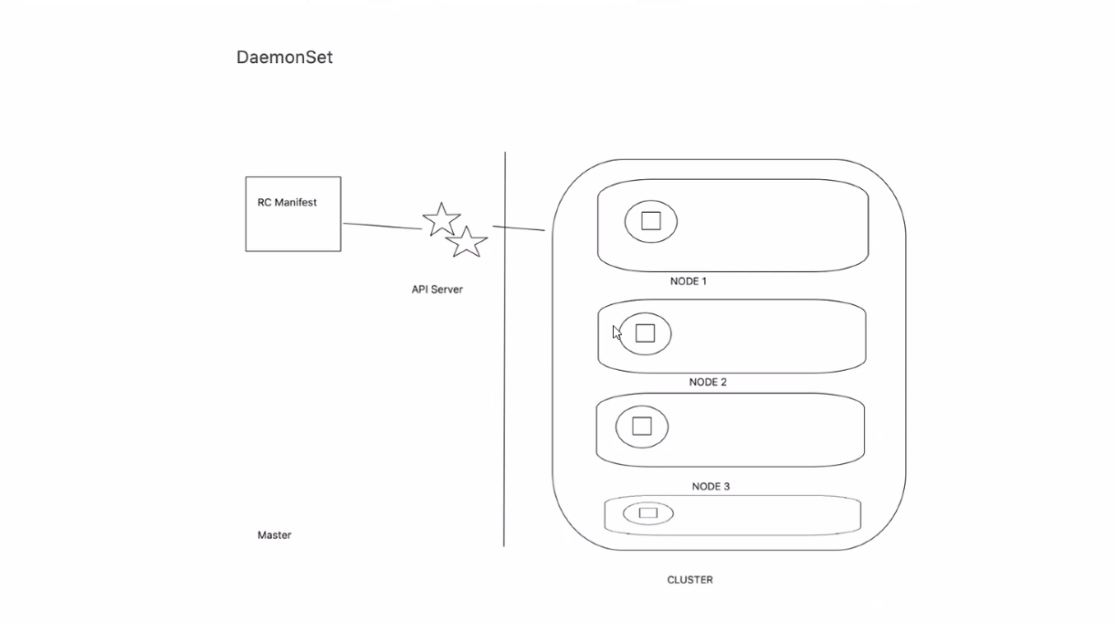

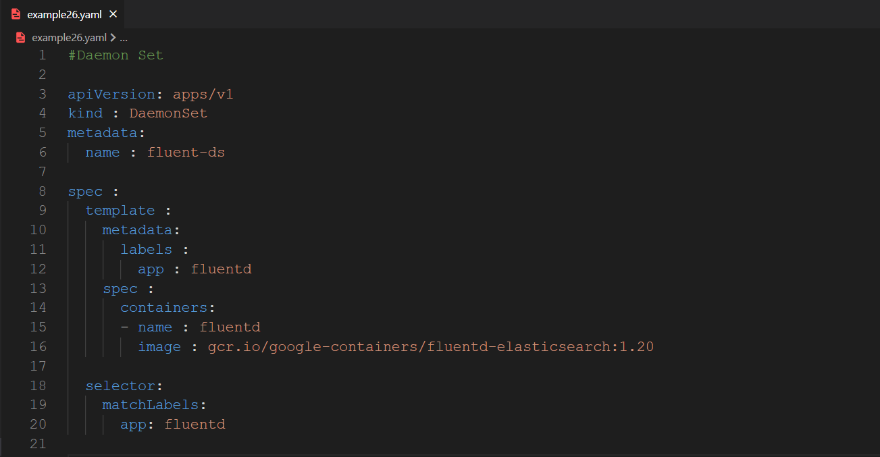

<https://github.com/mr-tgokul/certified-kubernetes-administrator-cka/tree/main/Daemon%20Set>

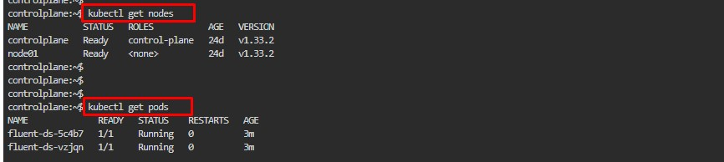

**Secrets :**

Sensitive information stored in etcd – not in pods or containers

Etcd is a key value pair database

Can be consumed by multiple pods

Whenever you try to take a secret copy pod takes a absolute copy of the secret and even if a modification is done on the main secret it wont get updated here you need to recreate the pod to get the updated secret

Delete and recreate the pod if you want to get the updated secret

Cannot exceeed 1 MB size

Consumed in two ways –

1. Volume mounts
2. Environmental variables

Two Way to create Secrets :

1. Commands
2. Manifest

Different Types of secret Object :

1. Opaque – default type – username , password
2. Service account token secret - used for saving tokens – ex ,
3. Docker config secrets - used to access image registry
4. Basic authentication secret
5. SSH authentication secret
6. Tls Secret
7. Boot strap Secret

Opaque secret Creation :

Command Line Creation

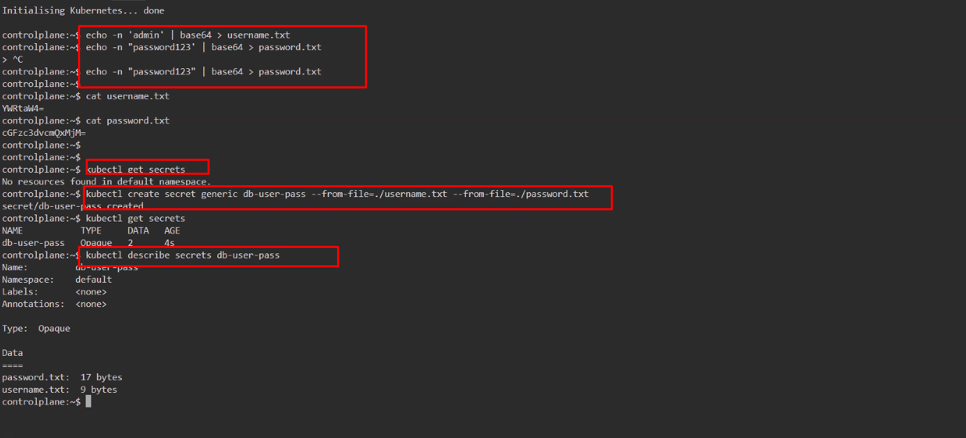

Manifest

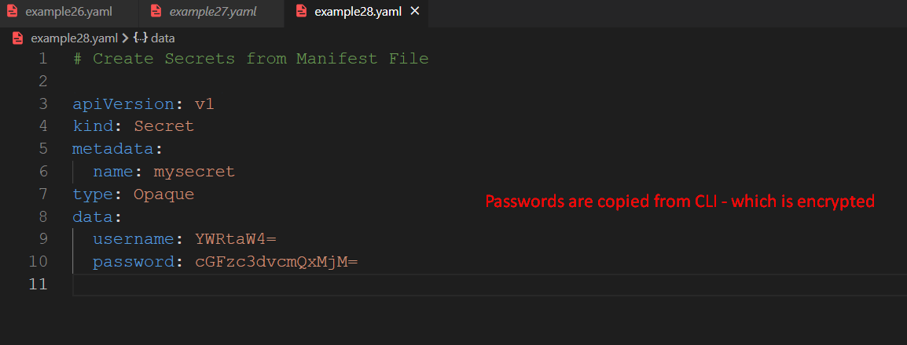

echo -n 'admin' | base64 > username.txt

echo -n "password123' | base64 > password.txt

echo -n "password123" | base64 > password.txt

cat username.txt

cat password.txt

kubectl get secrets

kubectl create secret generic db-user-pass --from-file=./username.txt --from-file=./password.txt

kubectl get secrets

kubectl describe secrets db-user-pass

cat > example28.yaml

kubectl create -f example28.yaml

kubectl get secrets

history

### The Encrypted password will be decrypted when consuming by the Pod

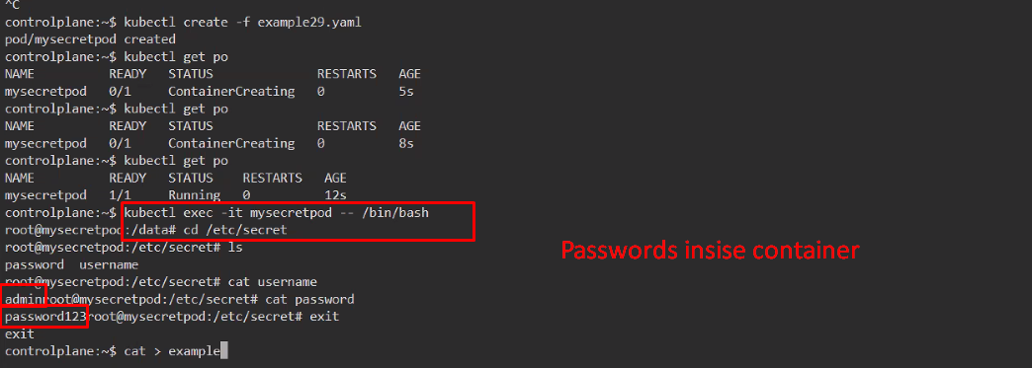

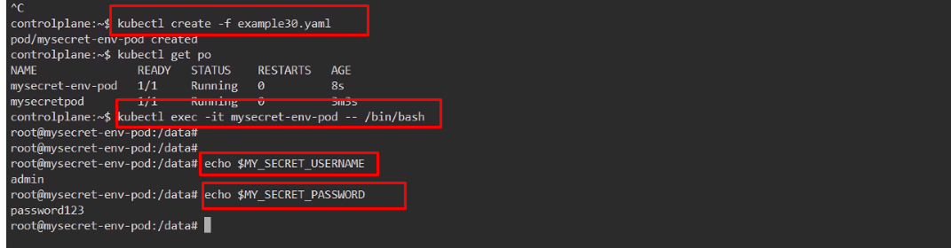

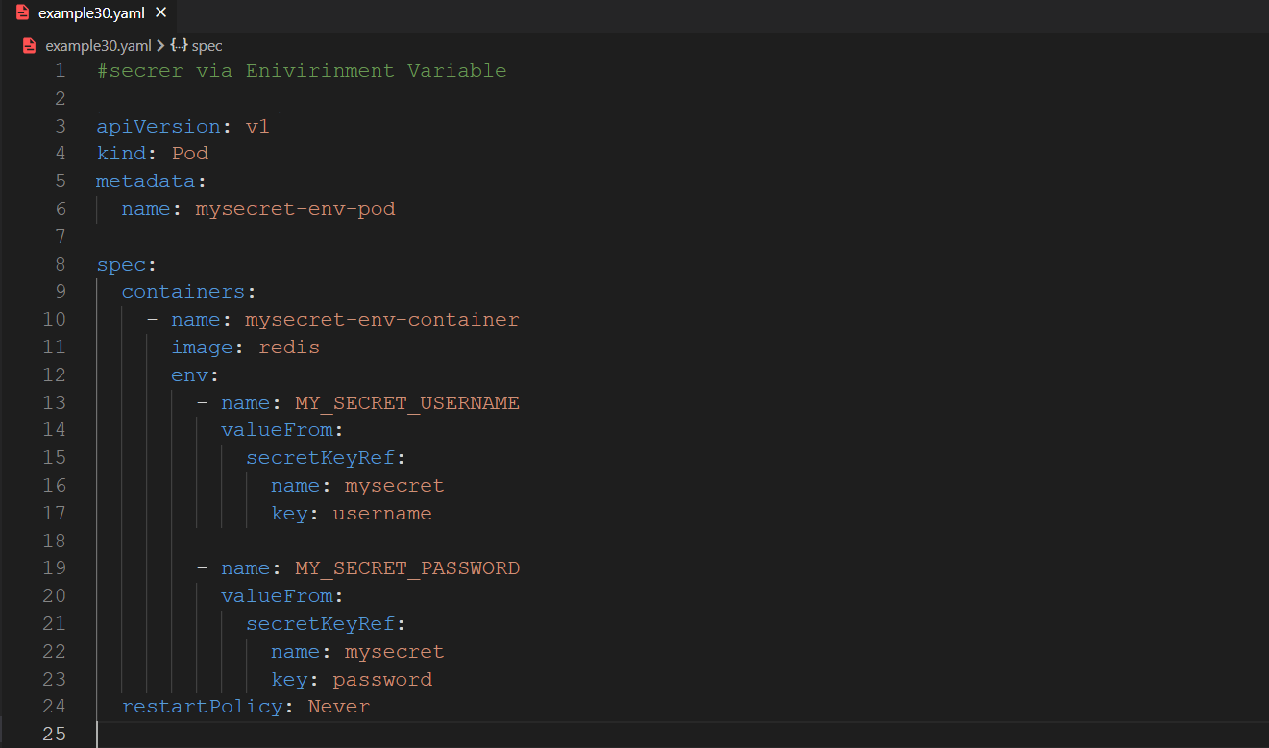

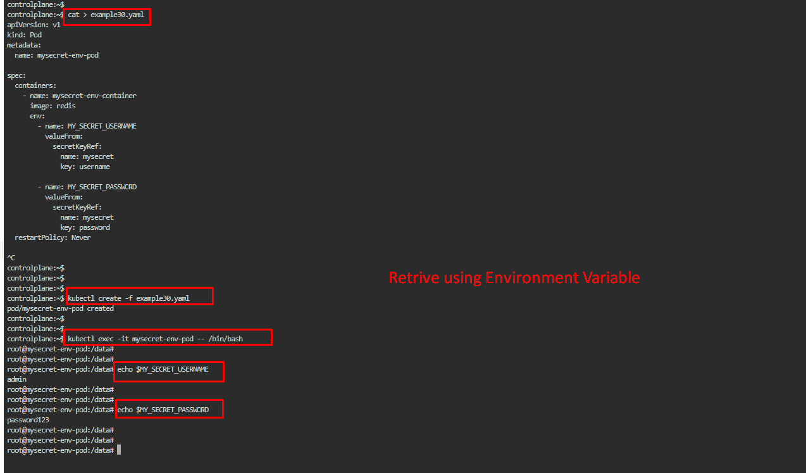

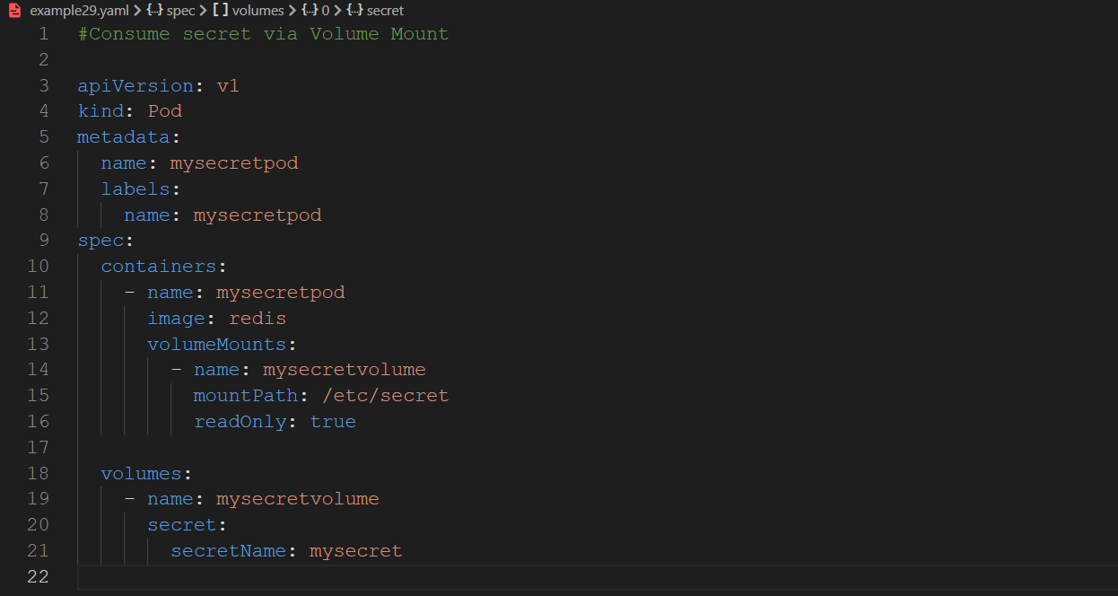

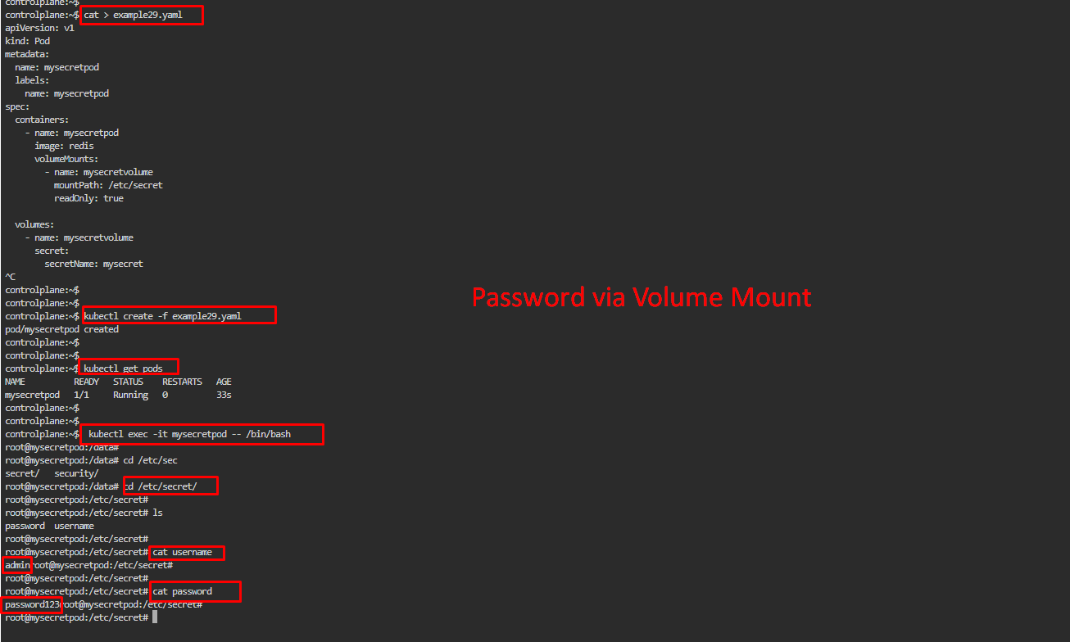

Question :

Create static pod on node07 called static-nginx with image nginx and you have to make sure that it is recreated/restarted automatically in case of any failure happens.

CONTROL PLANE

ps -ef | grep kubelet

sudo grep static /var/lib/kubelet/config.yaml

ls /etc/kubernetes/manifests/

kubectl run static-nginx --image=nginx --dry-run=client -o yaml

kubectl run static-nginx --image=nginx --dry-run=client -o yaml > static-pod.yaml

cat static-pod.yaml | ssh node01 "tee static-pod.yaml"

kubectl get po

kubectl get po -o wide

kubectl delete pod static-nginx-node01

kubectl get po -o wide

history

ssh node01

WORKER NODE

ps -ef | grep kubelet

sudo grep static /var/lib/kubelet/config.yaml

sudo cp static-pod.yaml /etc/kubernetes/manifests/

ls /etc/kubernetes/manifests/

history

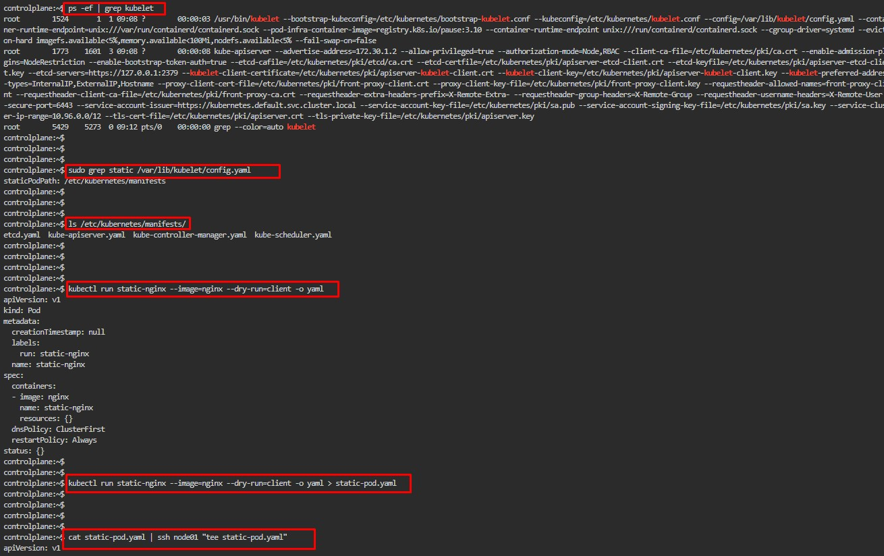

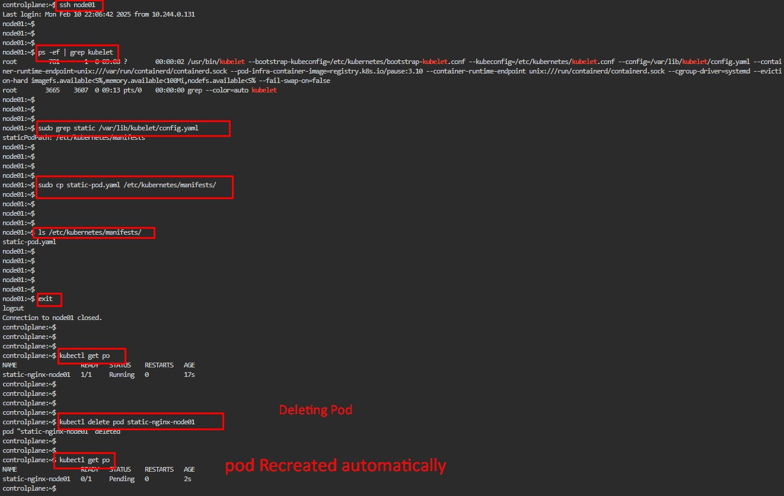

**STATEFULSETS :**

It’s a kubernets workload API object

Similar to deployemet

Used to manage stateful applicasions like database, messging servers

Provide stable unique network identififer

Persistent storage for each and every pod

Every pod gets pvc

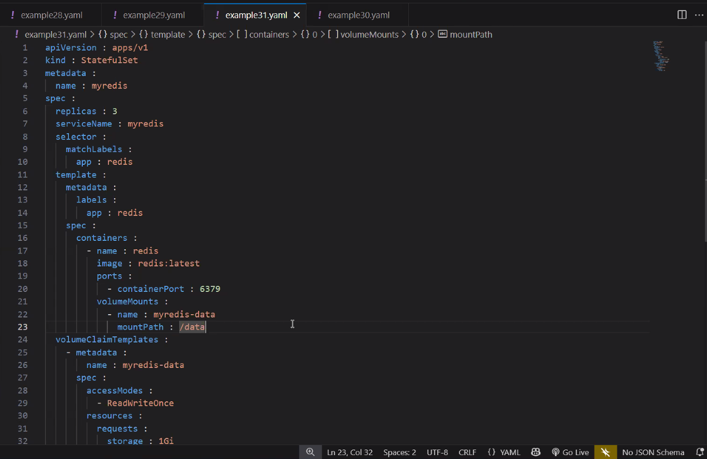

4 cat > example31.yaml

5 kubectl create -f example31.yaml

6 kubectl get po -o wide

7 kubectl get pv

8 kubectl get pvc

9 kubectl delete pod myredis-1

10 kubectl get po -o wide

11 kubectl get pvc

12 history

**Config Map:**

* Similar to Secret
* Gives key value pair information
* Can be used wherever required
* Can be used as Mount as volume or Environmental variables

Cofig Maps Via CLI:

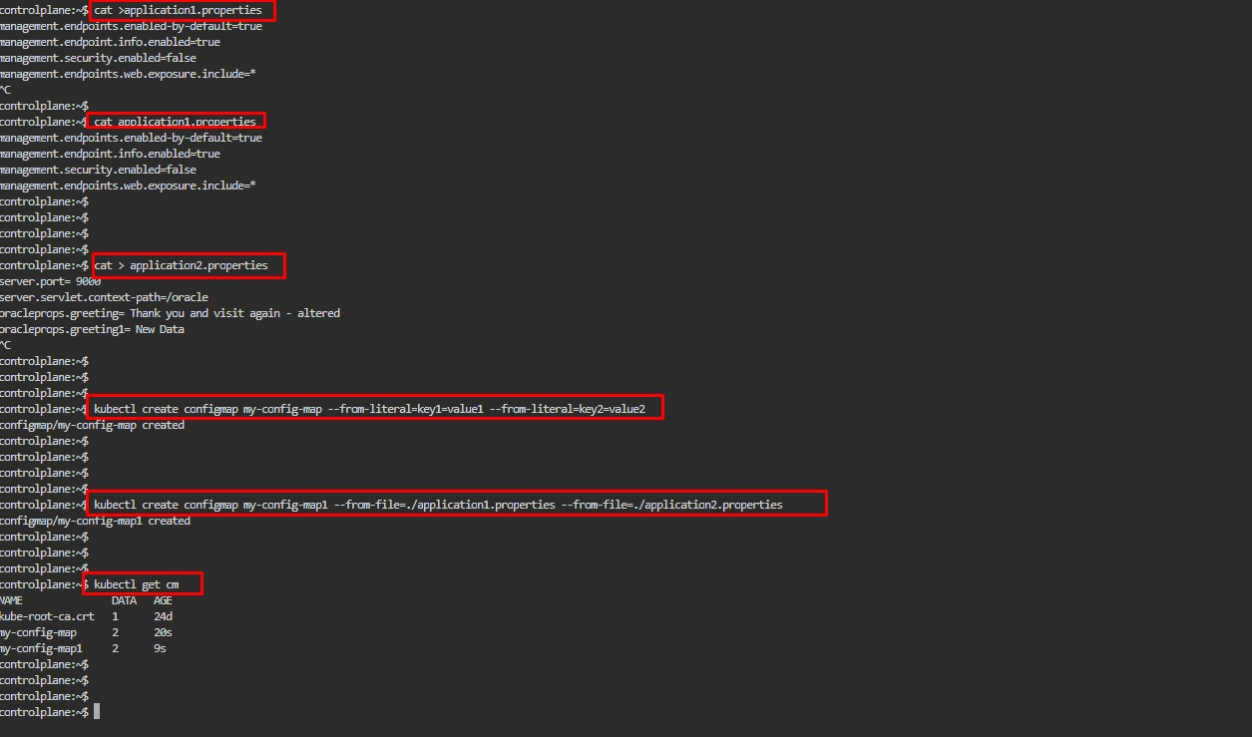

Config Map via Manifest

# Config Map Manifest

apiVersion: v1

kind: ConfigMap

metadata:

  name: myconfig

data:

  db_url: jdbc:mysql://localhost:3306/mydb

  db_user: admin

  db_password: password123

  db_port: "3306"

  db_name: mydatabase

  db_driver: com.mysql.jdbc.Driver

  service-details: |

    serviceName: myservice

    servicePort: "8080"

    serviceType: NodePort

    serviceSelector: app=myapp

  css-properties: |

    body {

      background-color: #fefefe;

      color: #333;

    }

    h1 {

      font-size: 24px;

      color: #007bff;

    }

    p {

      font-size: 16px;

      line-height: 1.5;

    }

---

apiVersion: v1

kind: Pod

metadata:

  name: myconfigpod

  labels:

    name: myconfigpod

spec:

  containers:

    - name: myconfigcontainer

      image: redis

      volumeMounts:

        - name: myconfigvolume

          mountPath: /etc/config

          readOnly: true

  volumes:

    - name: myconfigvolume

      configMap:

        name: myconfig

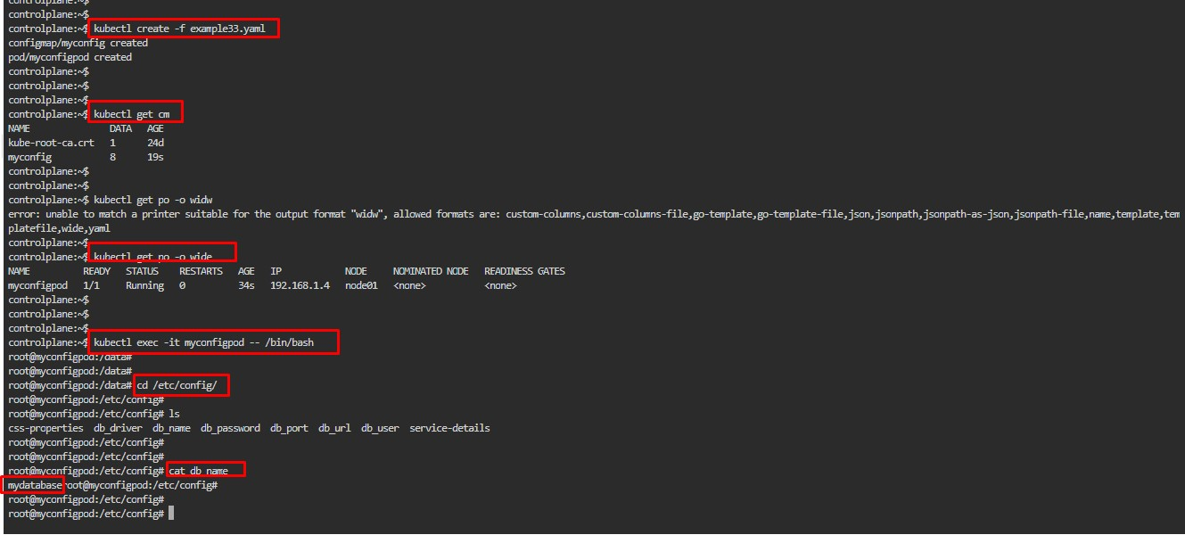

Logs :

In Kubernetes, logs are the textual output generated by containers (and sometimes the cluster itself) that record what’s happening inside an application or component.

14 cat > example1.yaml

15 cat > example17.yaml

16 kubectl create -f example1.yaml -f example17.yaml

17 kubectl get po

18 kubectl logs tomcat-pod

19 kubectl logs multicontainer-pod -c consumer

20 kubectl logs multicontainer-pod -c producer

21 kubectl logs tomcat-pod --tail=2

22 kubectl logs tomcat-pod --tail=5

23 kubectl logs --limit-bytes=100 tomcat-pod

26 kubectl logs --limit-bytes=1000 tomcat-pod

27 history

14.08.2025 Day : 4

Batch Execution:

* Similar to Cron Jobs
* Designed to manage jobs that runs to completion
* Job creates one or more pods, it ensures to terminate the pods once the job is completed
* If the pod fails it ensures to create a new pod until completion

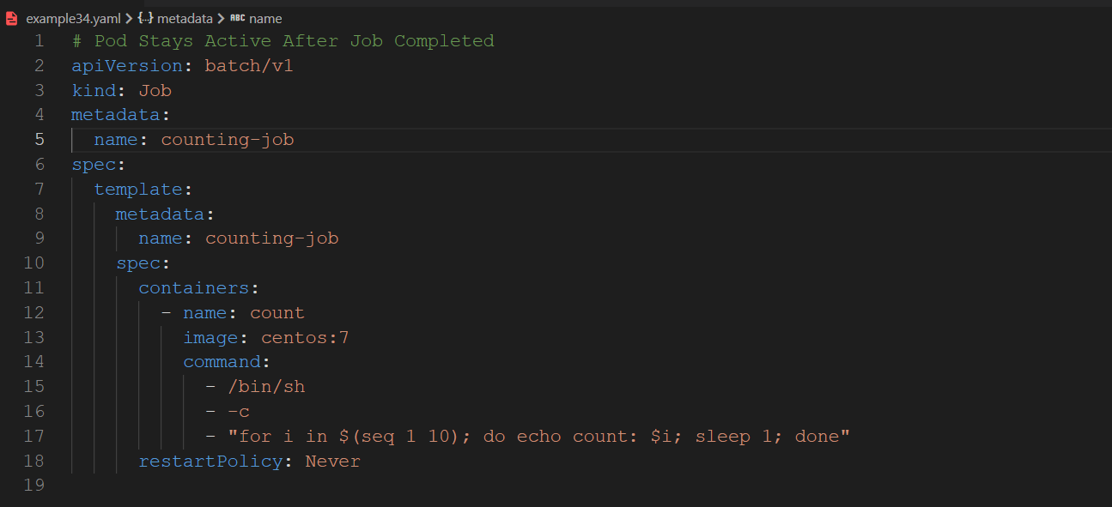

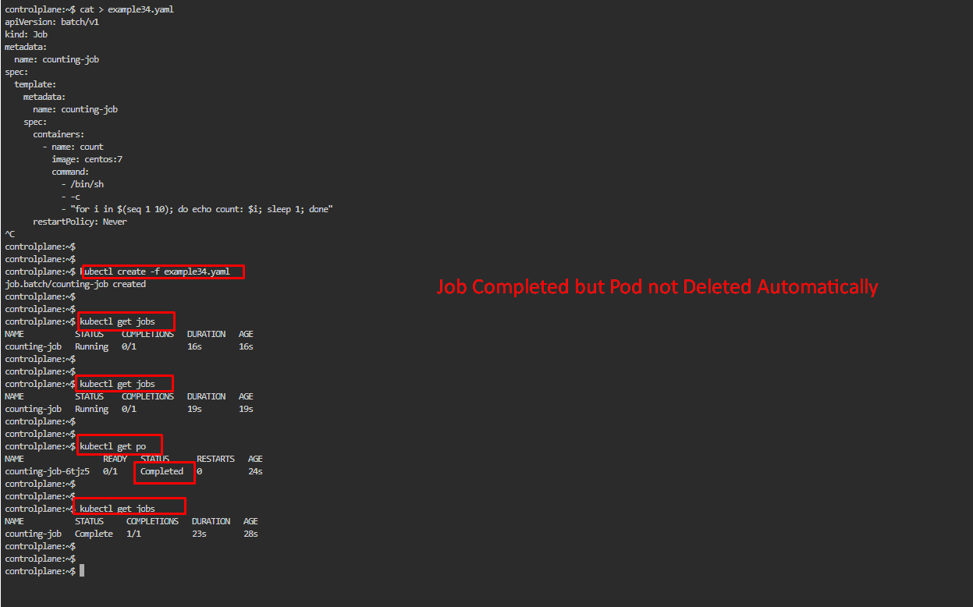

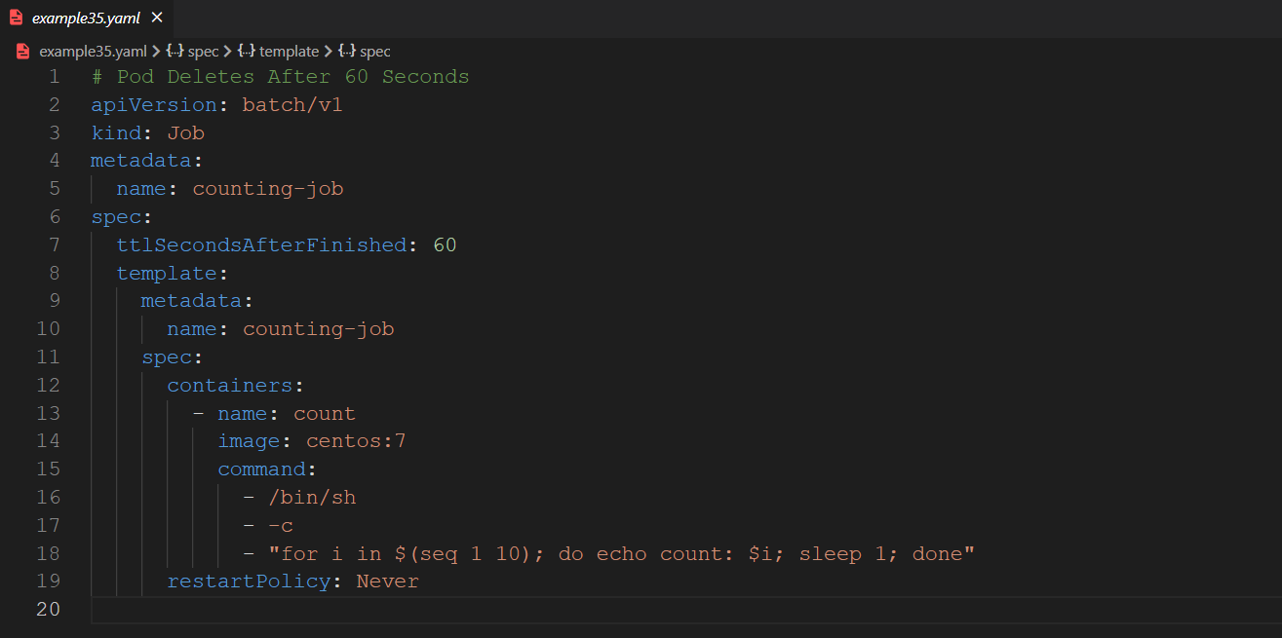

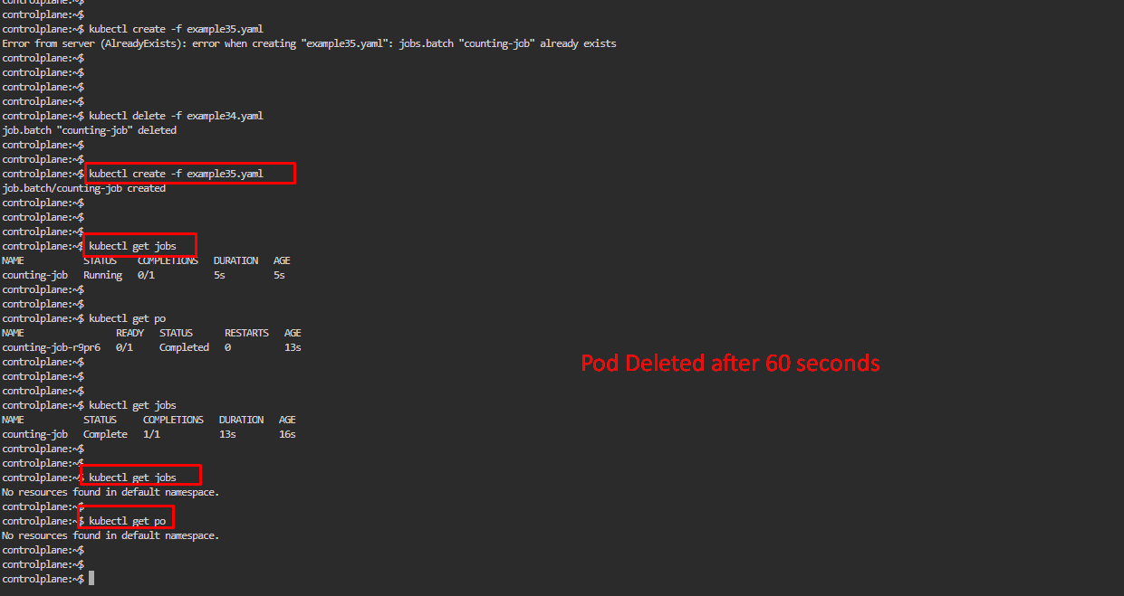

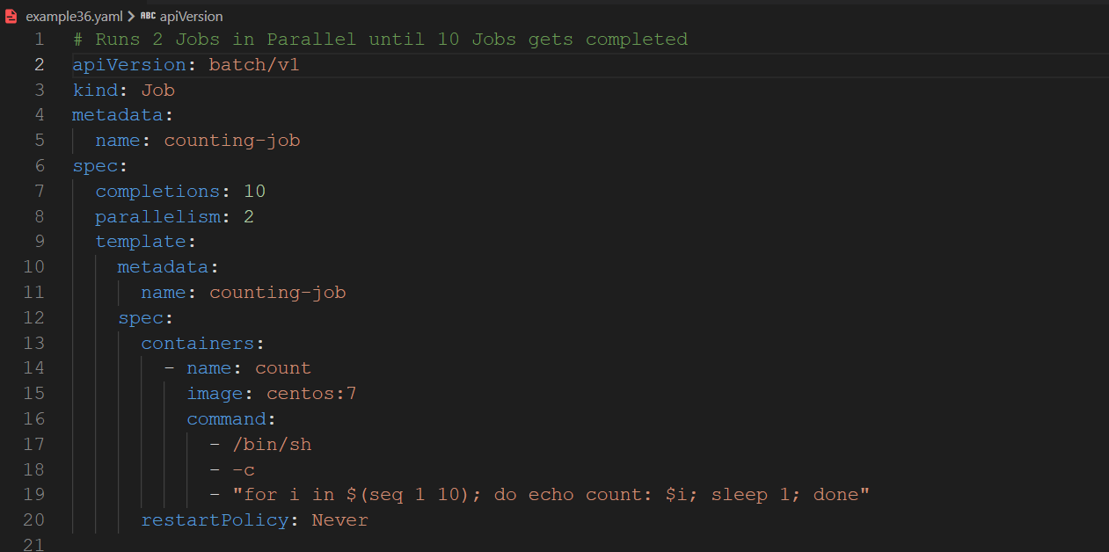

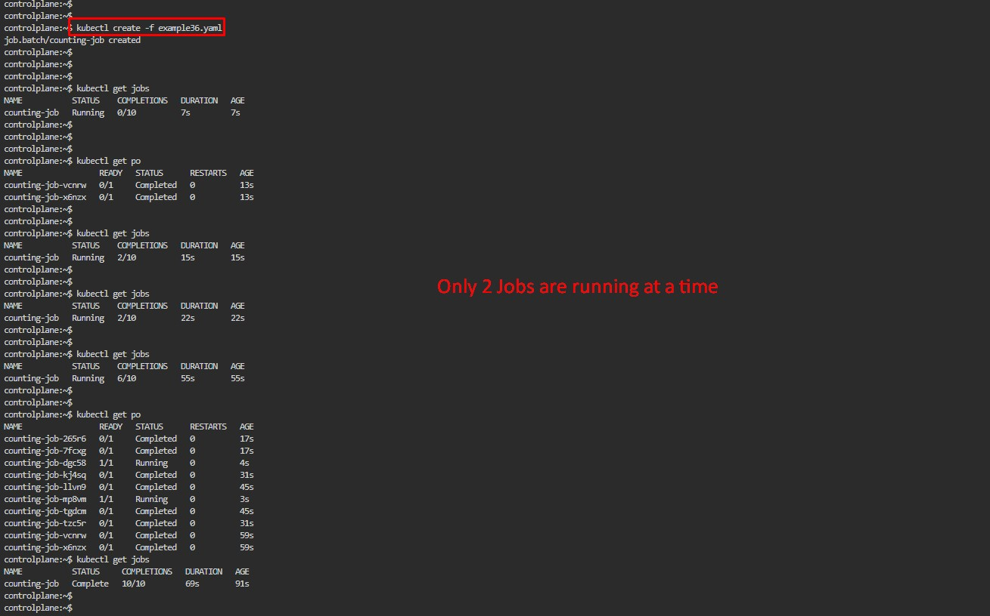

Cron Jobs :

* Recurring Jobs by nature

Create Job executes at every one minute

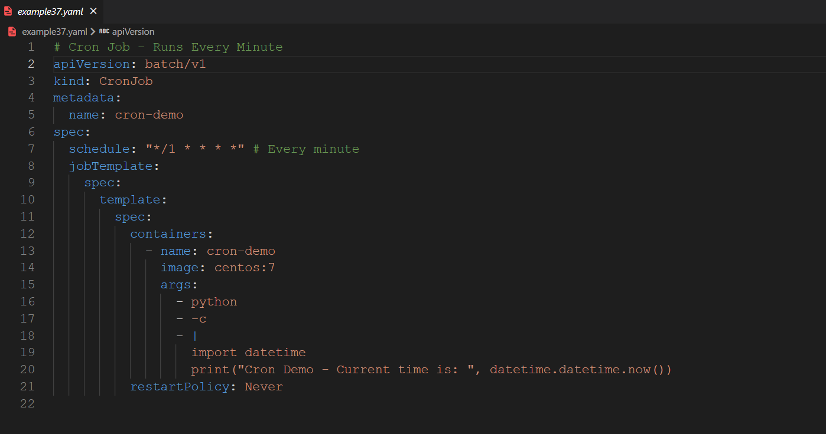

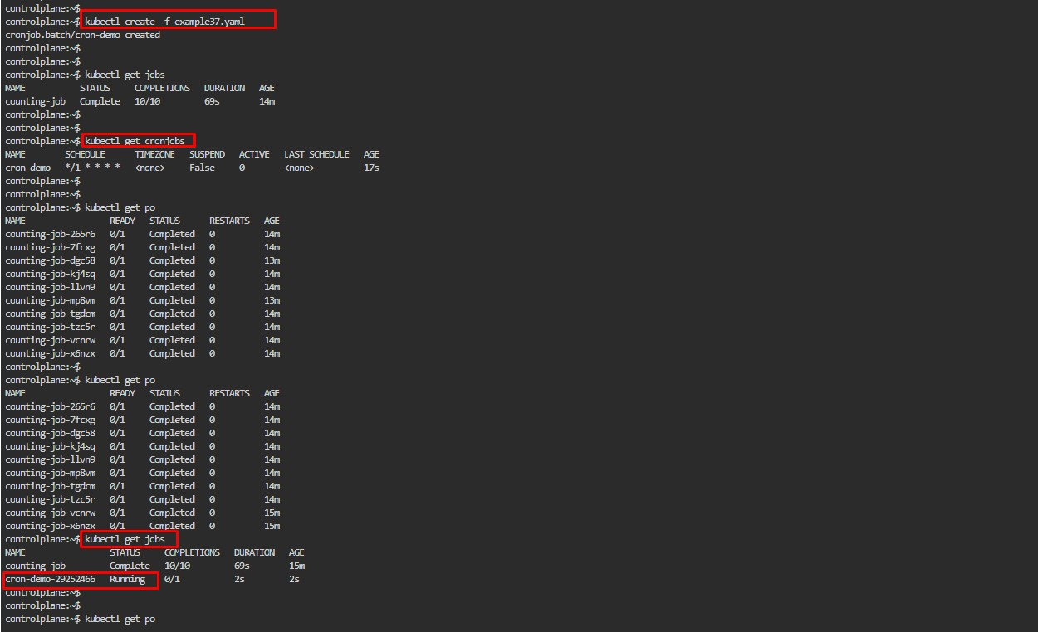

Namespaces:

* Used for logical grouping of resources
* Divide a isolated subclusters we use namespace
* Allows to organize group of resources like pod,
* Namespaces are the foundation of Role based access
* resource quota applies per namespace
* predefined name spaces are available – kube-system , kube-public

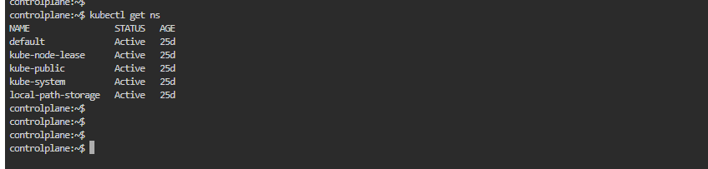

Two ways to create Namespace

* command
* Manifest

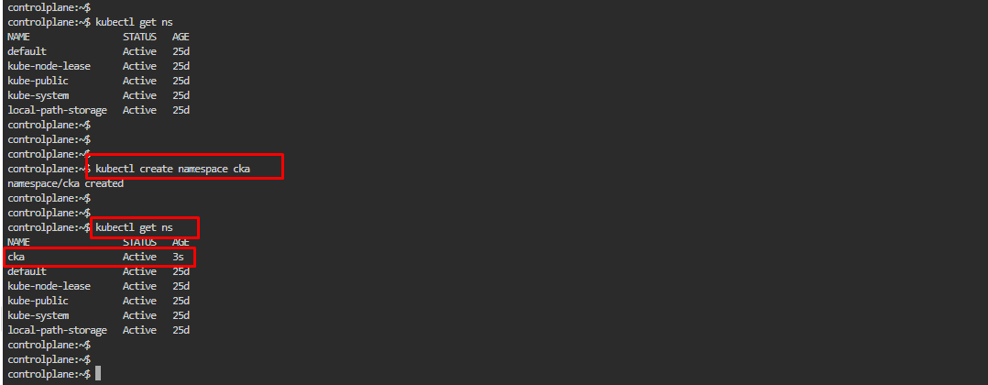

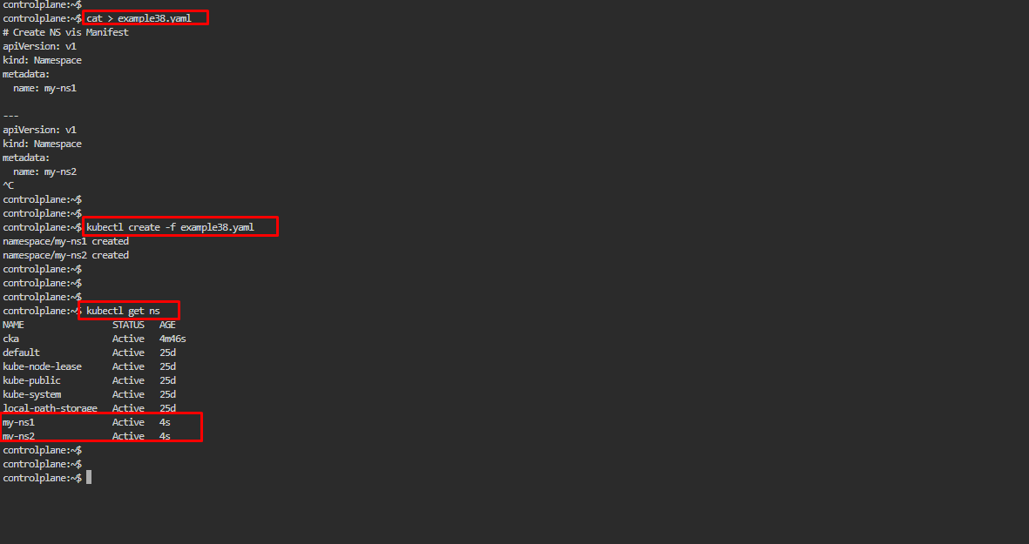

Create Pod in Custom NS

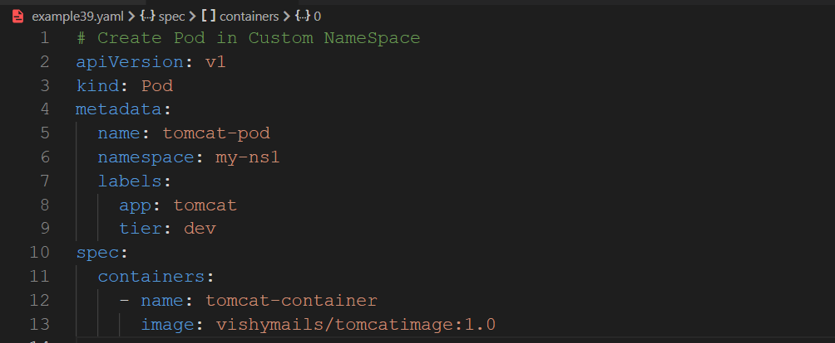

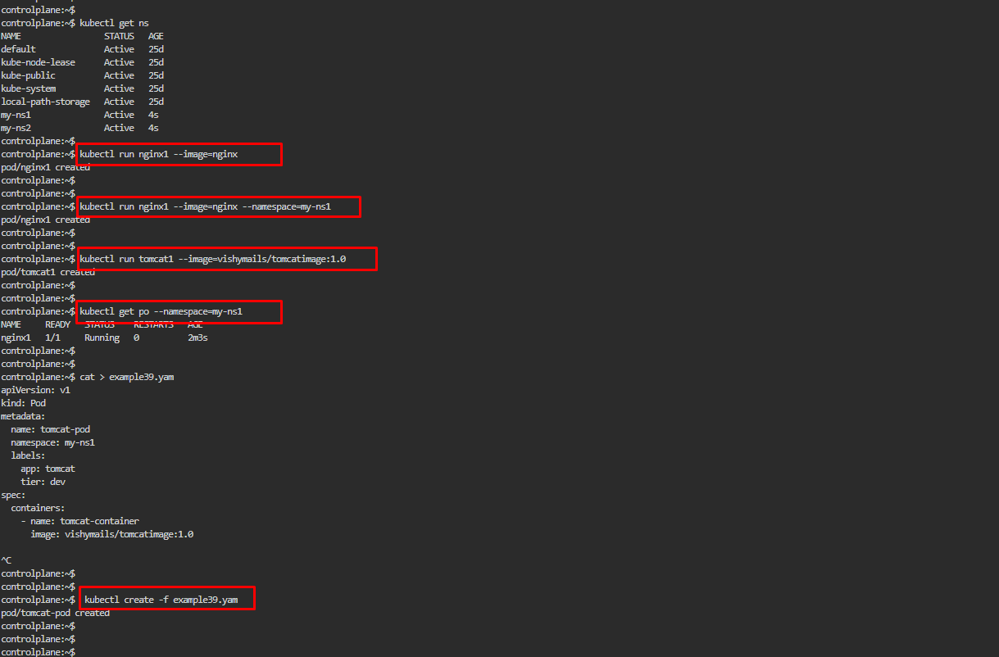

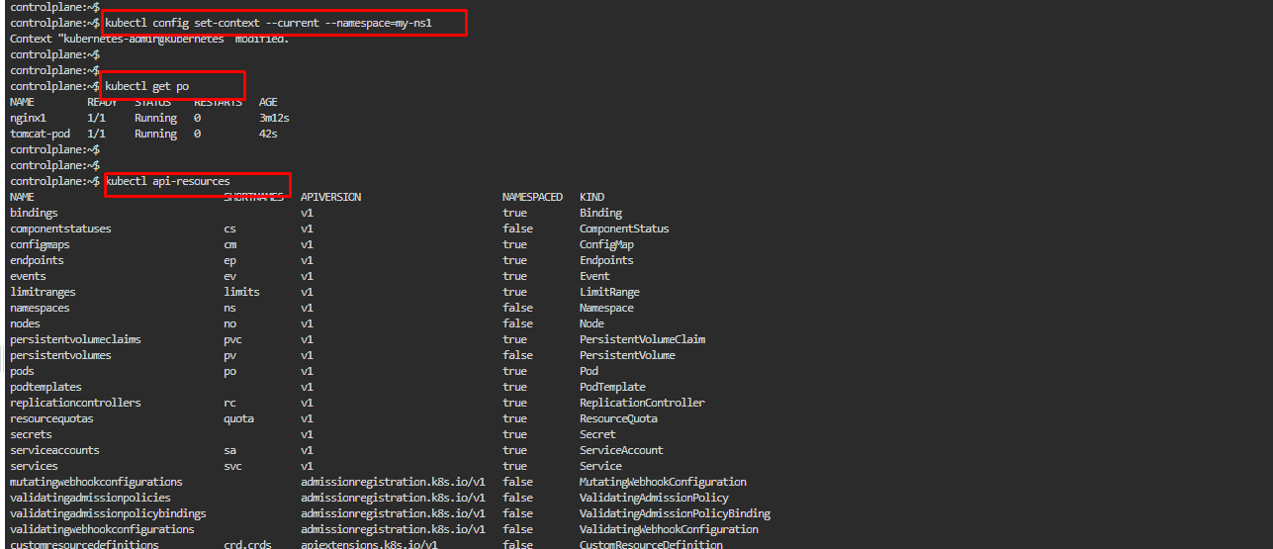

cat > example38.yaml

kubectl create -f example38.yaml

kubectl get ns

kubectl run nginx1 --image=nginx

kubectl run nginx1 --image=nginx --namespace=my-ns1

kubectl run tomcat1 --image=vishymails/tomcatimage:1.0

kubectl get po

kubectl get po --namespace=my-ns1

cat > example39.yaml

kubectl create -f example39.yaml

kubectl get po --namespace=my-ns1

kubectl get po

kubectl get po --namespace=my-ns1

kubectl config set-context --current --namespace=my-ns1

kubectl get po

kubectl api-resources

kubectl api-resources --namespaced=true

kubectl api-resources --namespaced=flase

kubectl api-resources --namespaced=false

kubectl get po

kubectl get po --all-namesapces

kubectl get po --all-namespaces

kubectl get deployments --all-namespaces

history

Init Containers:

Main container will only run after the completion of other containers

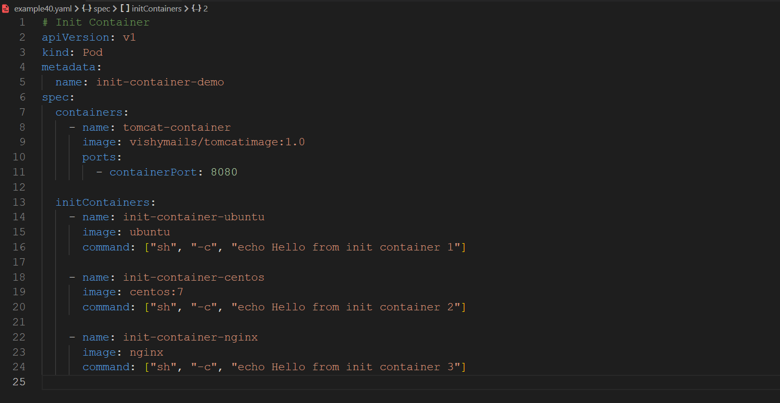

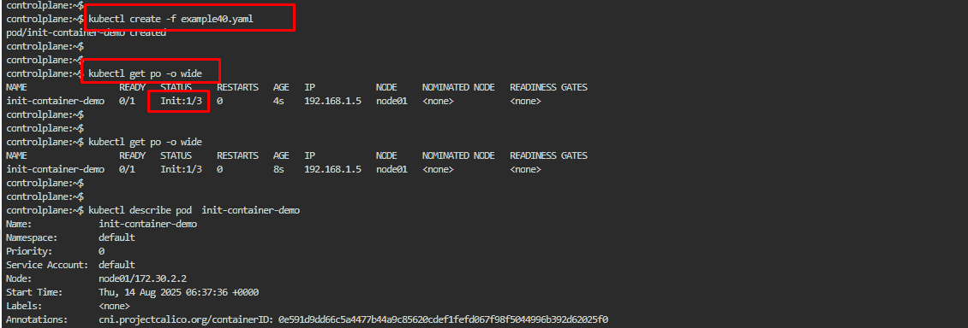

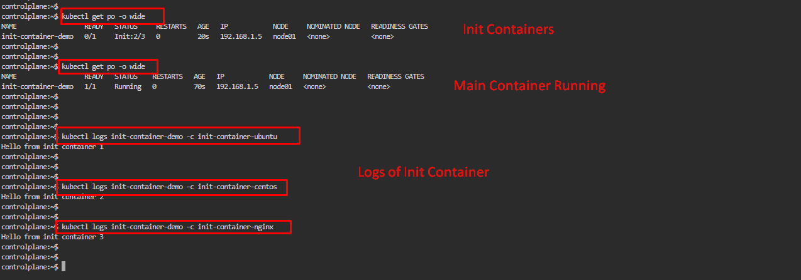

**Side Car Container**

Both running in parallel

**RBAC: Role Based Access Control**

5 Important parts of RBAC

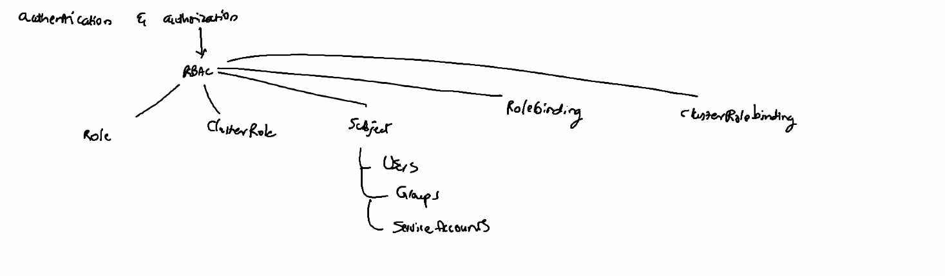

**To apply this RBAC we required Certificate**

Certificate is a collection of two important keys

* Public Key
* Private Key

**Only Two people can authorize Certificate**

* Self-signed - If anything goes wrong, we are responsible
* CA Authorized

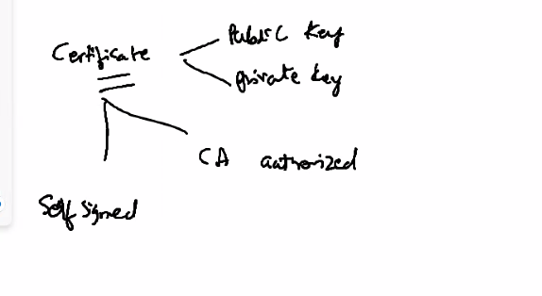

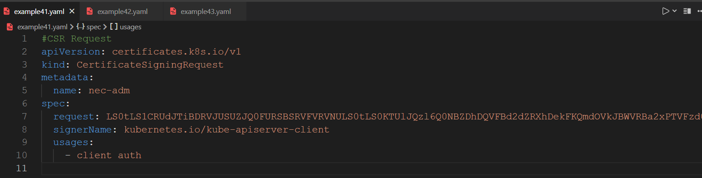

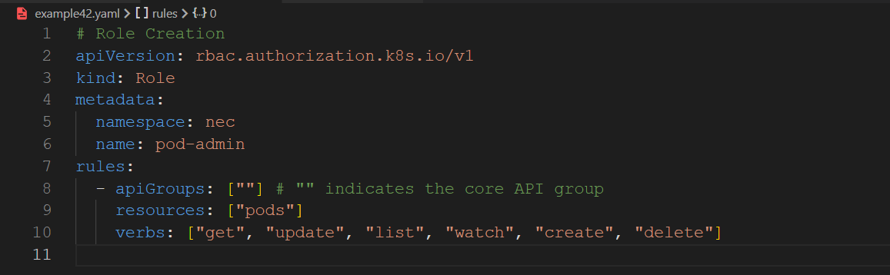

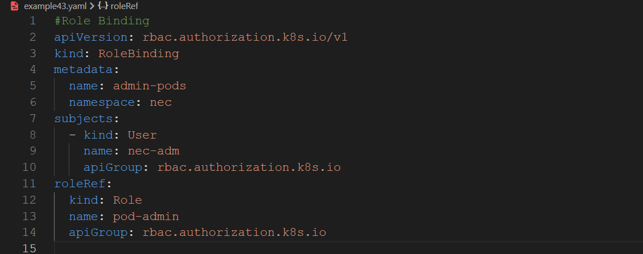

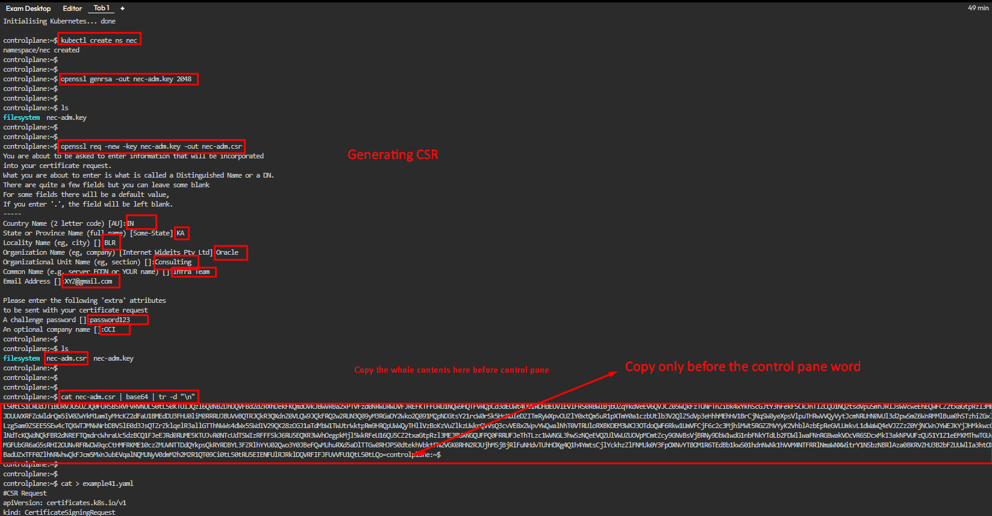

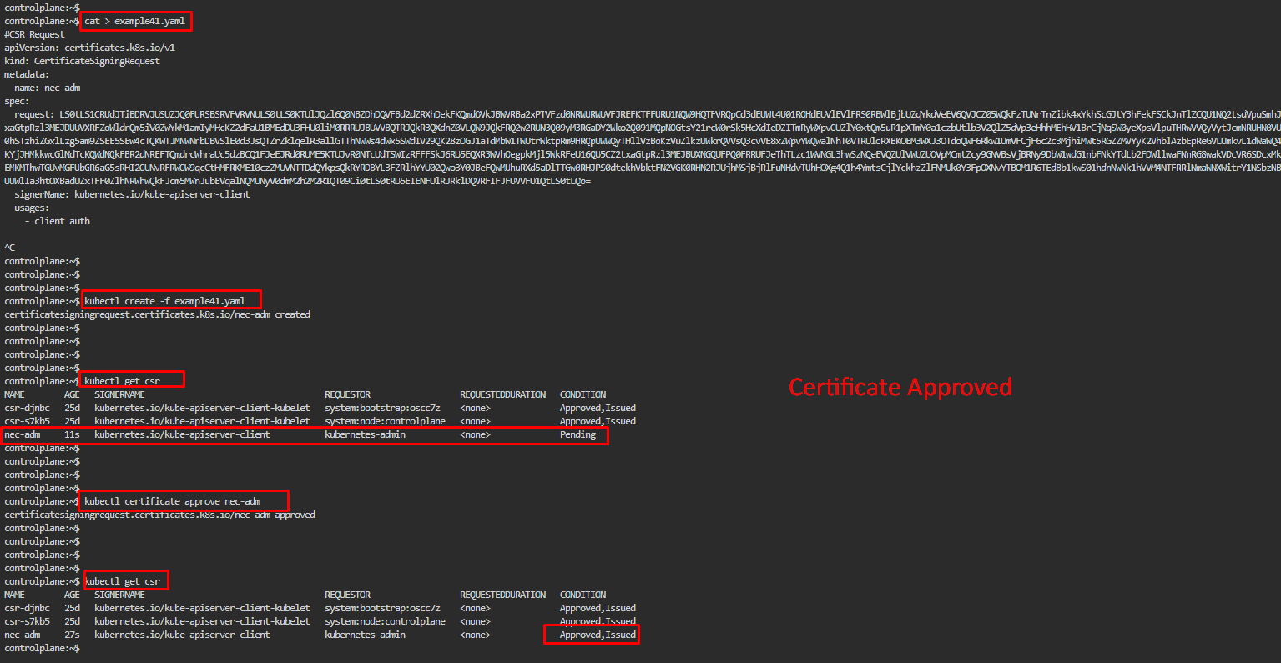

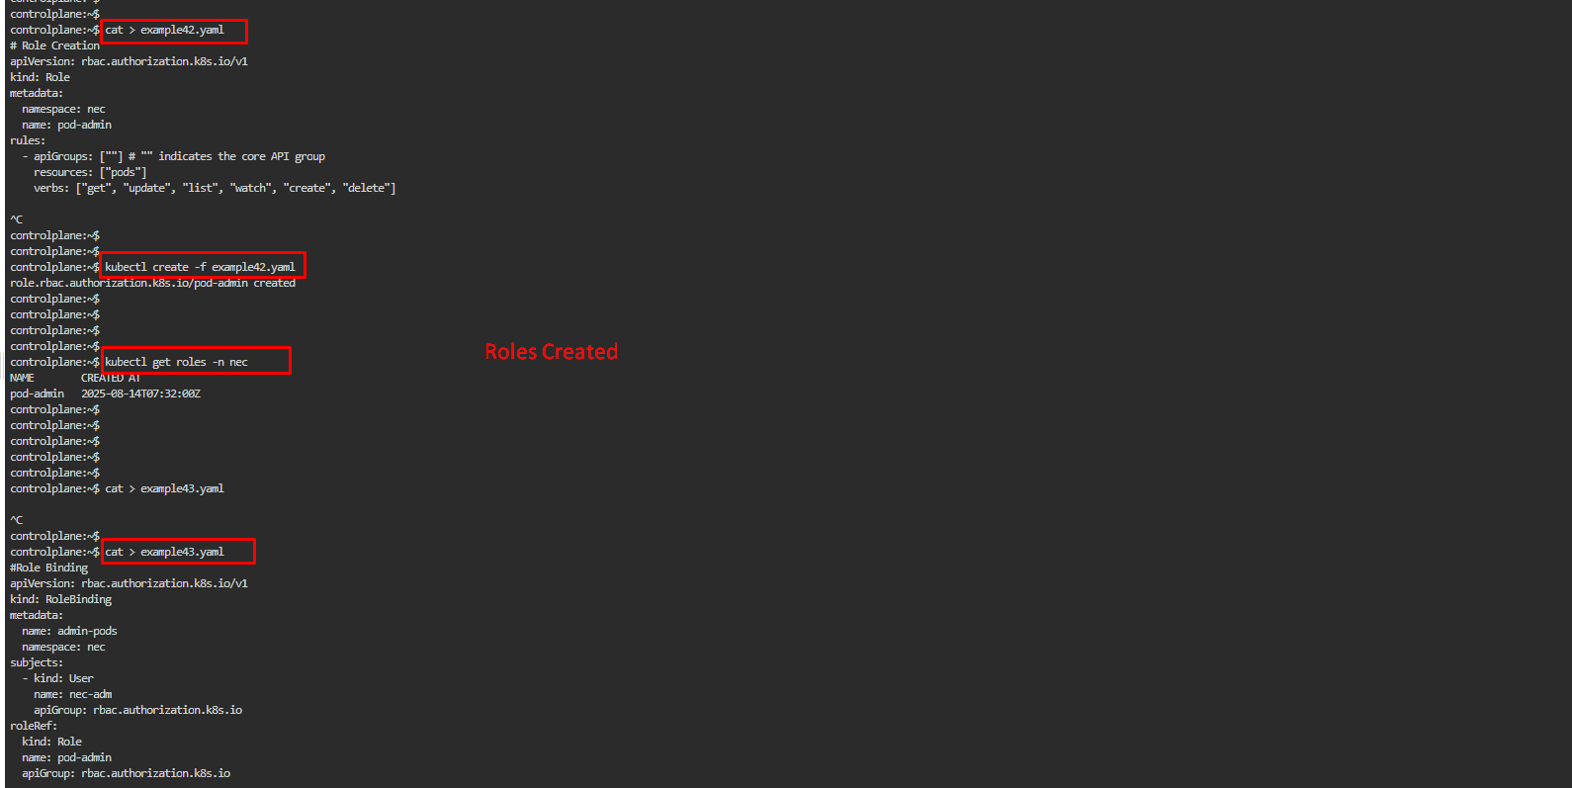

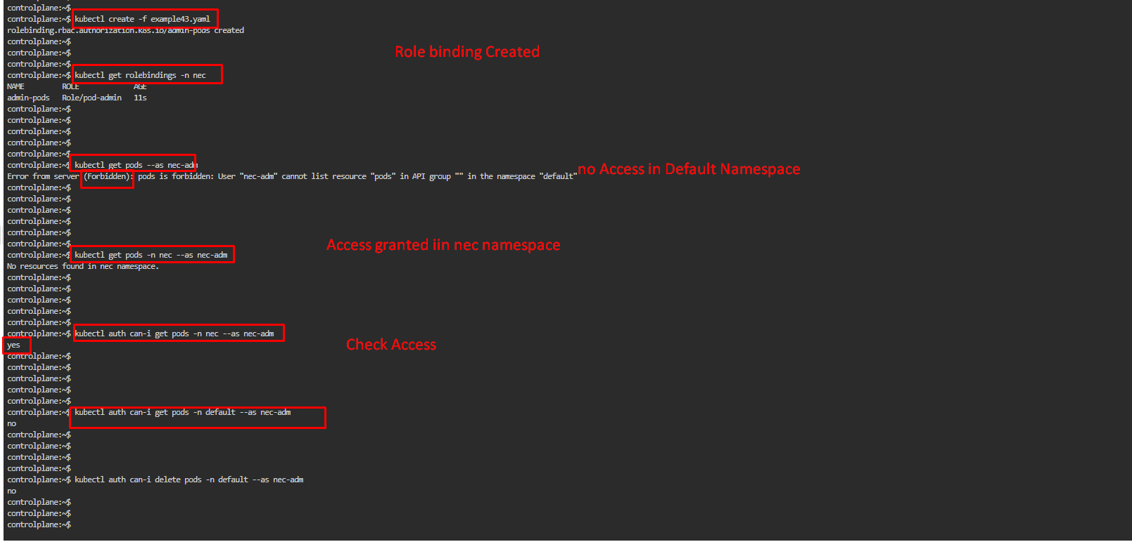

Commands :

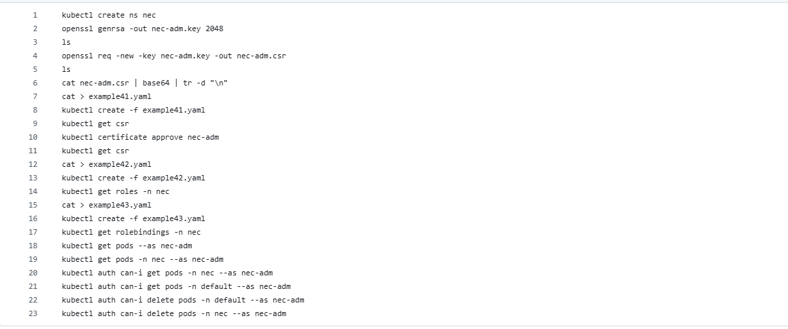

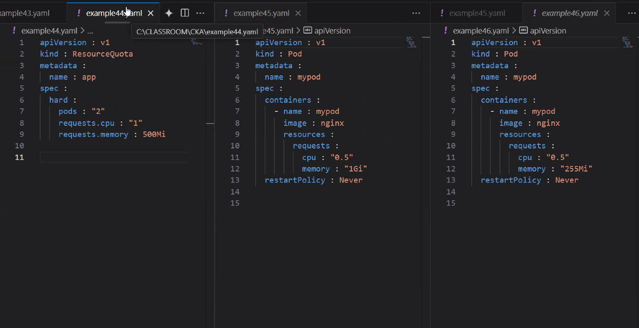

Resource Quota;

Create a new Pod that exceeds the limits of the resource quota requirements e.g. by defining 1Gi of memory but stays below the CPU e.g. 0.5. Write down the error message.

Change the request limits to fulfill the requirements to ensure that the Pod could be created successfully. Write down the output of the command that renders the used amount of resources for the namespace.

4 cat > example44.yaml

5 kubectl create ns rq-demo

6 kubectl create -f example44.yaml --namespace=rq-demo

7 kubectl describe quota --namespace=rq-demo

8 kubectl describe quota

9 kubectl describe quota --namespace=rq-demo

10 cat > example45.yaml

11 kubectl create -f example45.yaml --namespace=rq-demo

12 cat > example45.yaml

13 kubectl create -f example45.yaml --namespace=rq-demo

14 history

15 kubectl describe quota --namespace=rq-demo

16 history

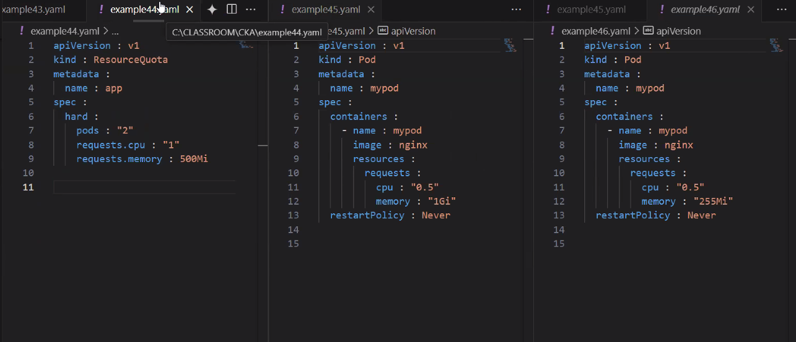

**Cluster upgrade :**

Upgrade given cluster (master and worker node) from 1.24.8-00 to 1.28.4-00. Make sure to first drain respective node prior to update and make it available post update.

**Commands to Run IN CONTROLPLANE**

6 kubectl drain controlplane --ignore-daemonsets

7 apt-cache madison kubeadm | head

8 sudo apt install kubeadm=1.33.4-1.1

9 sudo kubeadm upgrade apply v1.33.4

10 sudo apt install kubelet=1.33.4-1.1

11 sudo systemctl restart kubelet

12 kubectl uncordon controlplane

13 kubectl get nodes

14 history

Control Plane

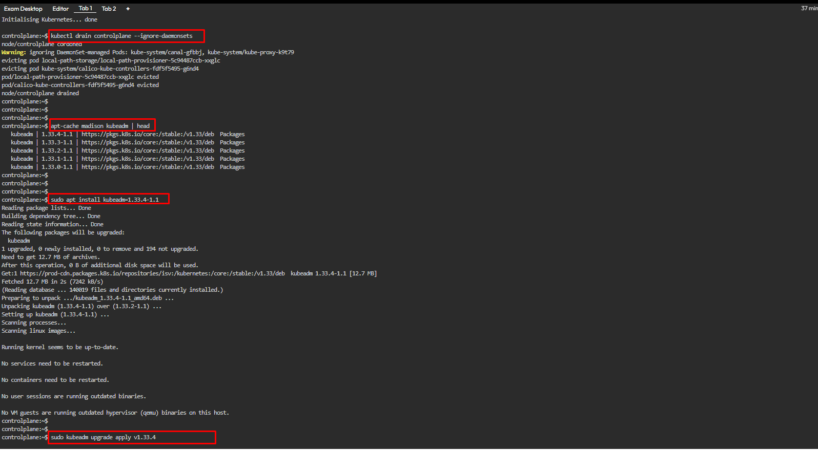

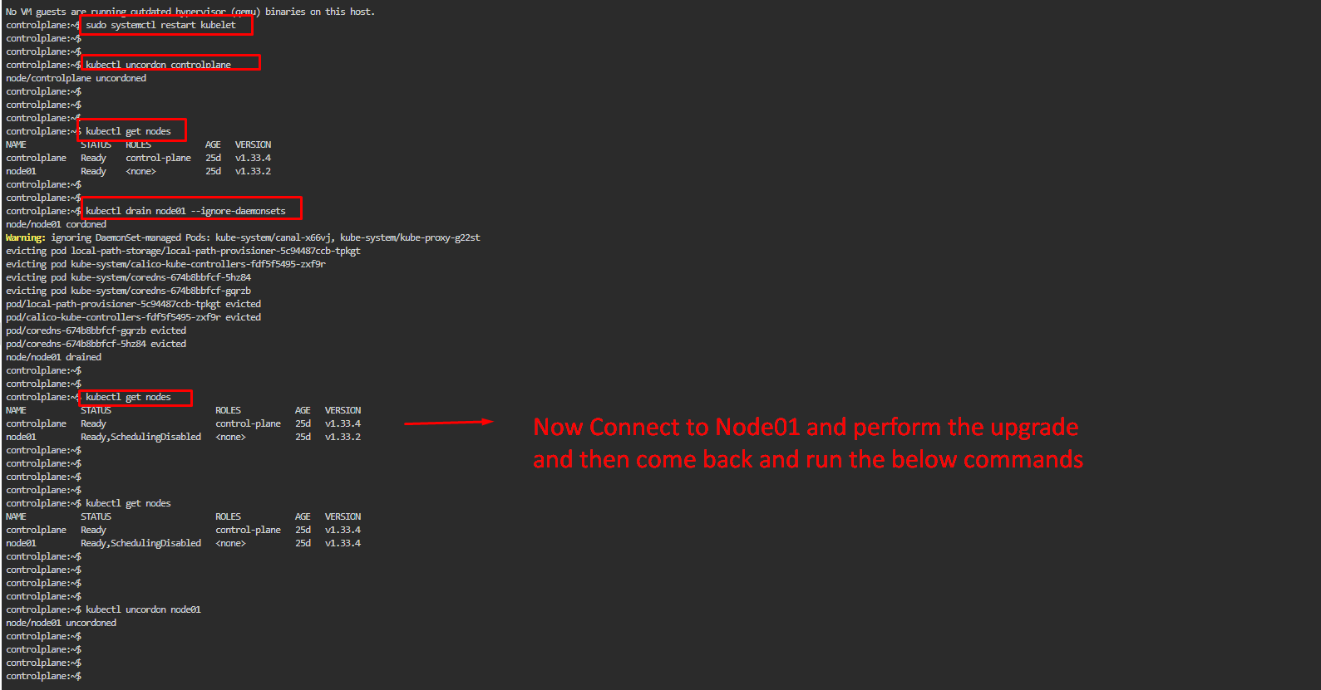

You an see both control plane and worker node are upgraded

Node 01:

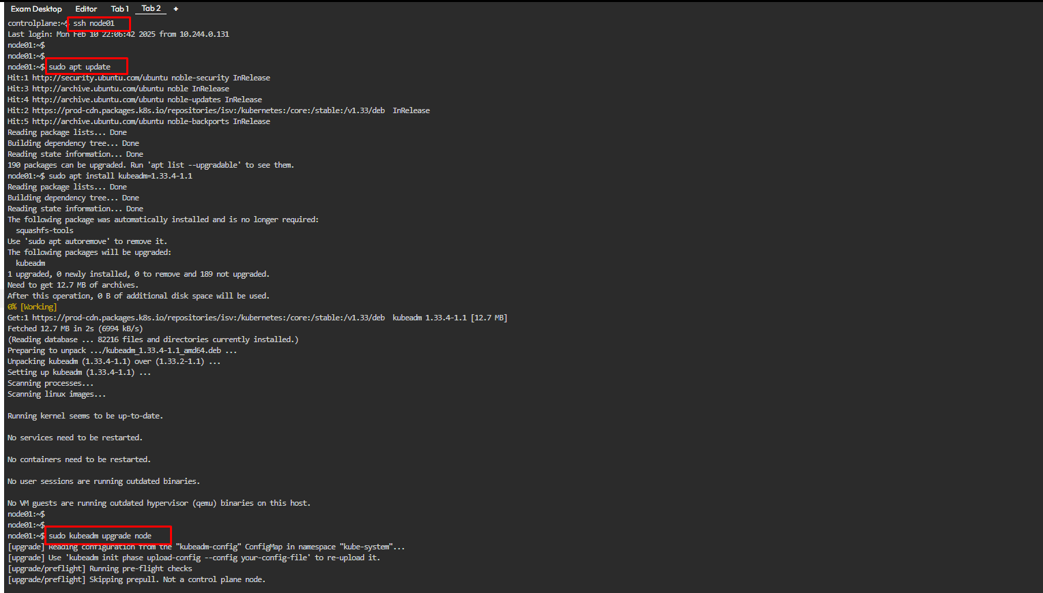

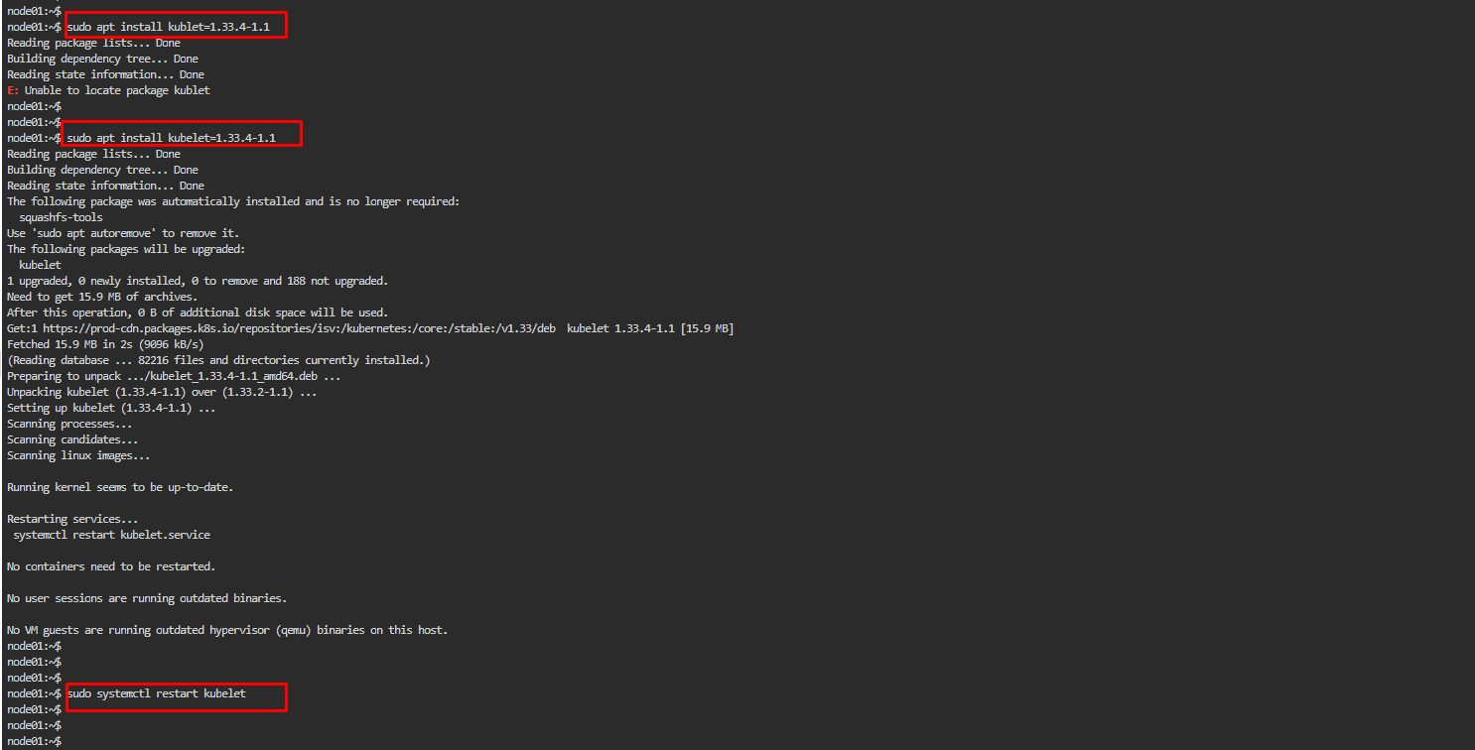

Question :

Get web-load-5461 pod details in json format and store it in a file at /opt/output/web-load-5461-j070822n.json

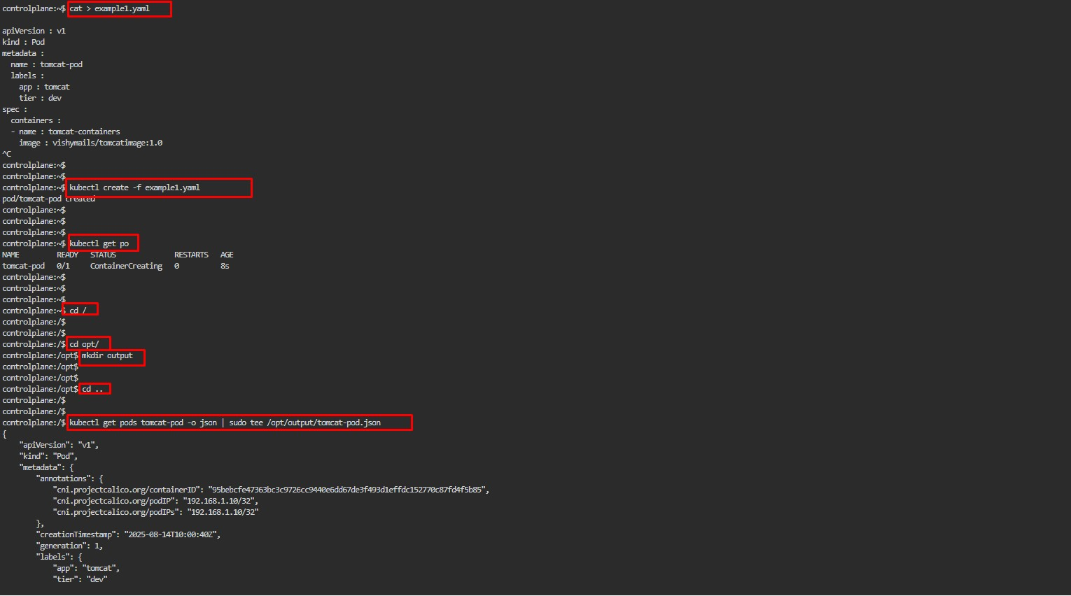

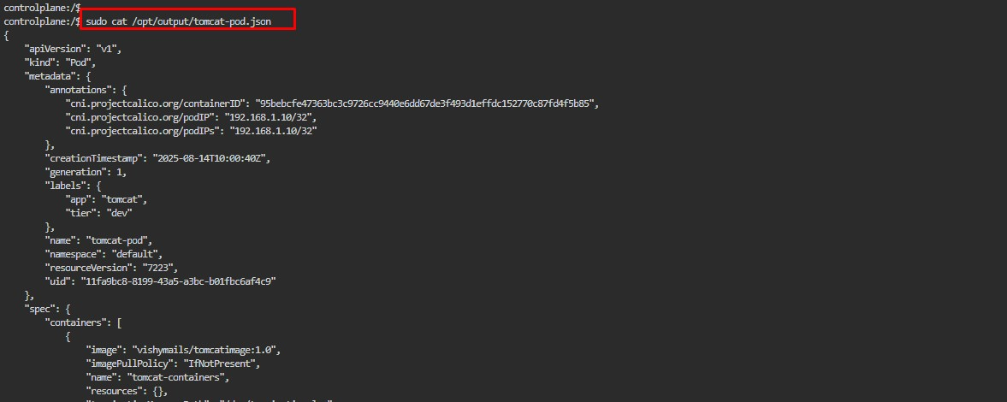

cat > example1.yaml

kubectl create -f example1.yaml

kubectl get po

cd /

cd opt

mkdir output

cd ..

kubectl get pods tomcat-pod -o json | sudo tee /opt/output/tomcat-pod.json

sudo cat /opt/output/tomcat-pod.json

history

**ETCD Backup:**

Backup ETCD database and save it root with name of backup "etcd-backup.db"

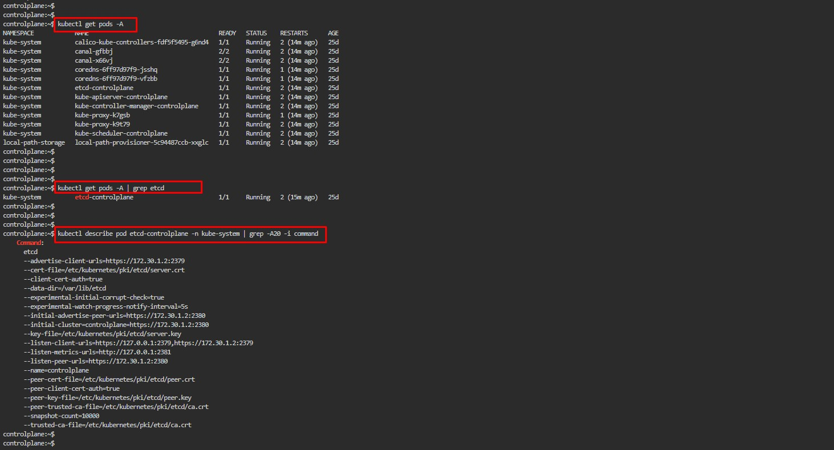

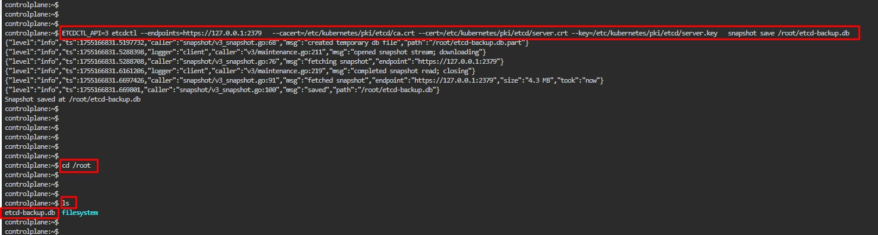

Backup :

kubectl get pods -A

kubectl get pods -A | grep etcd

kubectl describe pod etcd-controlplane -n kube-system | grep -A20 -i command

ETCDCTL_API=3 etcdctl --endpoints=https://127.0.0.1:2379 --cacert=/etc/kubernetes/pki/etcd/ca.crt --cert=/etc/kubernetes/pki/etcd/server.crt --key=/etc/kubernetes/pki/etcd/server.key snapshot save /root/etcd-backup.db

cd /root

ls

Restore :

etcdctl --data-dir <data-dir> snapshot restore etcd-backup.db

= = = = = = = = = = = = = = = = = = = = = = = = = = = = = = = = = = = = = = = = = = = = = = = = = = = = =